**MINISTRY OF EDUCATION AND TRAINING**

**FPT UNIVERSITY**

Capstone Project Document

Football Pitches Booking

|  |  |
| --- | --- |
| **Group 10** | |
| **Group Members** | Nguyễn Duy Phương – SE60761 – [phuongndse60761@fpt.edu.vn](mailto:phuongndse60761@fpt.edu.vn)  Nguyễn Hữu Hoàng Giang – SE60606 – [giangnhhse60606@fpt.edu.vn](mailto:giangnhhse60606@fpt.edu.vn)  Nguyễn Đức Thịnh – 60398 – [thinhnd60398@fpt.edu.vn](mailto:thinhnd60398@fpt.edu.vn)  Nguyễn Quốc Khánh – 60556 – [khanhnq60556@fpt.edu.vn](mailto:khanhnq60556@fpt.edu.vn) |
| **Supervisor** | Lại Đức Hùng |
| **Ext Supervisor** |  |
| **Capstone Project code** | FPB |

- Ho Chi Minh, 01/2014 –

Table of Contents

Definitions, Acronyms, and Abbreviations 4

Report No.1: Introduction 5

1.1. Initial idea of group: 5

1.2. Overview of existing system: 5

1.3. Benefit of expected system: 5

Report No.2: Introduction 6

2.1. Initial idea of group: 6

2.2. Overview of existing system: 6

2.3. Benefit of expected system: 6

Report No.3: System Requirements Specifications (SRS) 7

3.1. User requirement specification 7

3.1.1. Guest 7

3.1.2. Member 7

3.1.3. Stadium Owner 7

3.1.4. Stadium Staff 7

3.1.5. Website Master 7

3.1.6. Website Staff 8

3.1.7. System 8

3.2. System requirement specification (Specific Requirements) 8

3.2.1. External Interface Requirements 8

3.2.2. Functional Requirements 9

3.2.3. Non-Functional Requirements 57

3.2.4. Entity Relationship Diagram 58

Report No.4: System Design Description (SDD) 59

4.1. Design Overview 59

4.2. System Architectural Design 60

4.2.1. Choice of System Architecture 60

4.2.2. Discussion of Alternative Designs 61

4.2.3. Description of System Interface 61

4.3. Component Diagram 62

4.4. Detailed Description of Components 63

4.4.1. Class Diagram 63

4.4.2. Class Diagram Explanation 63

4.5. Sequence Diagram 81

4.5.1. Create Stadium 81

4.5.2. Suggest Stadium 81

4.5.3. Delete Member Rank 81

4.5.4. Add Field To Stadium 82

4.5.5. Create Price Table 82

4.5.6. Update Price Table 83

4.5.7. Create Reservation 83

4.5.8. Update Reservation 84

4.5.9. Find Available Stadium 84

4.5.10. Create Promotion 85

4.5.11. Book Field 86

4.5.12. Cancel Reservation 86

4.5.13. Find Rival 86

4.5.14. Join Match 87

4.5.15. Reference Sequence Diagrams 87

4.6. User Interface Design/ Hardware Interface Design (if any) 88

4.7. Database Design 89

4.7.1. Tables description 89

4.7.2. Advertisement 90

4.7.3. Field 90

4.7.4. FieldPrice 91

4.7.5. JoinSystemRequest 91

4.7.6. MemberRank 92

4.7.7. Promotion 92

4.7.8. Reservation 92

4.7.9. Role 93

4.7.10. Stadium 94

4.7.11. StadiumImage 94

4.7.12. StadiumRating 94

4.7.13. StadiumReview 95

4.7.14. StadiumStaff 95

4.7.15. User 95

4.8. Algorithm Of Business Intelligence 96

4.8.1. Overview: 96

4.8.2. Implement: 96

4.8.3. Algorithm 97

Report No.5: System Implementation & Test (SIT) 99

5.1. Introduction 99

5.1.1. System Overview 99

5.1.2. Test Approach 99

5.2. Test Plan 99

5.2.1. Functions 99

5.2.2. Features not to be tested 99

5.3. Test Cases 100

5.3.1. Role ‘Website Master’ 100

5.3.2. Role ‘Stadium Owner’ 105

5.3.3. Role ‘Member’ 129

5.3.4. Role “StadiumStaff” 133

5.4. Reference Test Cases: 144

5.5. Checklist 145

5.5.1. Checklist validation 145

5.5.2. Submission Checklist 145

5.6. Other material (if any) 145

Report No.6: Report No.6 : System User’s Manual 146

6.1. Installation Guide 146

6.1.1. System requirements 146

6.1.2. Installation 146

6.2. User’s Guide 152

6.2.1. Website Master 152

6.2.2. Website Staff 161

6.2.3. Stadium Staff 163

6.2.4. Stadium Owner 168

6.2.5. Member 184

6.2.6. Reference Guide: 189

6.2.7. Other [Optional] 189

## Definitions, Acronyms, and Abbreviations

|  |  |  |
| --- | --- | --- |
| No. | Keyword | Definition |
| 1 | B2B2C | Stand for Business to business to customer.  In this system, first business is the organization that provides stadium owner to register their stadiums. The second business is stadium owner, who provides hire stadium service, and customer is the user, who want to hire field by this system. |
| 2 | FPB | Football Pitches Booking |
| 3 | ERD | Entity Relationship Diagram |
| 4 | API | Application Programmable Interface |
| 5 |  |  |

## Introduction

### Initial idea of group:

Football Pitches Booking is a B2B2C (Business to Business to Customer) website that allows customers to book field online. Besides it helps the stadium owners with advertising football stadiums and managing reservation. In addition, the website enables its admin to manage customers and stadiums.

In this situation, the Website Master is the first “Business” who provides market. And the stadium owners are the second “Business” who provide service.

### Overview of existing system:

For customers: existing systems just provide customers with address and contact information of stadiums, then customers have to contact the stadium owners to make a reservation. They have to call each stadium owner individually to check whether the field is available or not. Moreover, the current systems do not have either functions to make statistics of customers' habits or some smart functions like offering options/suggestion to customers, which is time-consuming and inconvenient to customers.

For the stadium owners, sometimes they make mistakes in management such as duplicate reservation, which leads to bad result: they could lose their customers as well as profit. When the management is executed manually and the players want to find a friendly match, the stadium owners have to help them by calling other players to arrange a game.

For the website masters, the shortage of functions of the website is the obstacle to persuade stadium owners to pay for the services.

### Benefit of expected system:

Football Pitches Booking makes the reservation easier and saves time for customers. Once they have booked, they don’t have to worry there will be a duplicate reservation caused by stadium owners' mistake. The website's smart functions help users to find the appropriate field by searching stadiums nearby their address, stadiums which are frequently booked, and the stadiums which are on discount. The benefits to customers are saving time, getting more information and enjoying discount of stadiums, beside that players find rivals easily if they do not have enough players to create a game.

This system helps stadium owners to manage their fields easily, reducing the implementing process of business operations, saving time and costs. The automatic system helps to prevent the risk of duplicate booking. Furthermore, stadium owners can use the website as a channel to advertise their services as well as communicate with their customers; hence, they can win more customers and gain more prestige through rating-feedback functions.

For the website master, with many smart and outstanding functions of the new system, they have more chances to increase the profit by attracting stadium owners to use this service.

## Introduction

### Initial idea of group:

Football Pitches Booking is a B2B2C (Business to Business to Customer) website that allows customers to book field online. Besides it helps the stadium owners with advertising football stadiums and managing reservation. In addition, the website enables its admin to manage customers and stadiums.

In this situation, the Website Master is the first “Business” who provides market. And the stadium owners are the second “Business” who provide service.

### Overview of existing system:

For customers: existing systems just provide customers with address and contact information of stadiums, then customers have to contact the stadium owners to make a reservation. They have to call each stadium owner individually to check whether the field is available or not. Moreover, the current systems do not have either functions to make statistics of customers' habits or some smart functions like offering options/suggestion to customers, which is time-consuming and inconvenient to customers.

For the stadium owners, sometimes they make mistakes in management such as duplicate reservation, which leads to bad result: they could lose their customers as well as profit. When the management is executed manually and the players want to find a friendly match, the stadium owners have to help them by calling other players to arrange a game.

For the website masters, the shortage of functions of the website is the obstacle to persuade stadium owners to pay for the services.

### Benefit of expected system:

Football Pitches Booking makes the reservation easier and saves time for customers. Once they have booked, they don’t have to worry there will be a duplicate reservation caused by stadium owners' mistake. The website's smart functions help users to find the appropriate field by searching stadiums nearby their address, stadiums which are frequently booked, and the stadiums which are on discount. The benefits to customers are saving time, getting more information and enjoying discount of stadiums, beside that players find rivals easily if they do not have enough players to create a game.

This system helps stadium owners to manage their fields easily, reducing the implementing process of business operations, saving time and costs. The automatic system helps to prevent the risk of duplicate booking. Furthermore, stadium owners can use the website as a channel to advertise their services as well as communicate with their customers; hence, they can win more customers and gain more prestige through rating-feedback functions.

For the website master, with many smart and outstanding functions of the new system, they have more chances to increase the profit by attracting stadium owners to use this service.

## System Requirements Specifications (SRS)

### User requirement specification

Football Pitches Booking is a website that allows customers to book field online. Beside that it helps the stadium owners with advertising football stadiums and managing reservation. In addition, the website enables its admin to manage customers and stadiums. More detail, the system should have list of features below:

#### Guest

* Find and view the stadium’s detail
* Find available stadium at specific date, time and duration
* Find and view rival’s detail
* Register to become a member of website
* Login
* Recovery password

#### Member

* Update account profile
* Book a field
* Cancel reservation
* View booking history
* Rate stadium
* Review stadium
* Feedback website
* Join rival
* Request for stadium to join into system
* Report user

#### Stadium Owner

* Update stadium profiles
* Manage fields of stadium:
  + Add field to stadium
  + Update field’s information
  + View list field of stadiums
  + View list of price tables
  + Create price table
  + Update price table

#### Stadium Staff

* Manage reservation of stadium:
  + Create new reservation
  + Edit reservation
  + List reservations
  + Approve reservation
  + Decline reservation
* Manage promotion of stadium
  + List promotions
  + Create promotion
  + Edit promotion

#### Website Master

* Manage stadium:
  + List join system requests
  + Handle join system request
  + List stadiums
  + Edit stadium
  + Create stadium
* Manage rank
  + List ranks
  + Edit rank
  + Create rank
* Manage configuration
  + Update configuration value

#### Website Staff

* Manage advertising
  + List advertising
  + Create advertising
  + Edit advertising
  + Delete advertising
* Manage user
  + List users
  + Edit user
  + Punish user

#### System

* Suggest Stadium
* Suggest Rival

### System requirement specification (Specific Requirements)

#### External Interface Requirements

##### User Interfaces

* The interface of website is simple and friendly
* Main function with multistep should be careful note, easy to understand
  + - 1. Hardware Interfaces

N/A

##### System Interfaces

N/A

##### Communications Protocol

Website using HTTP protocol for communication with the web browser and the web server

#### Functional Requirements

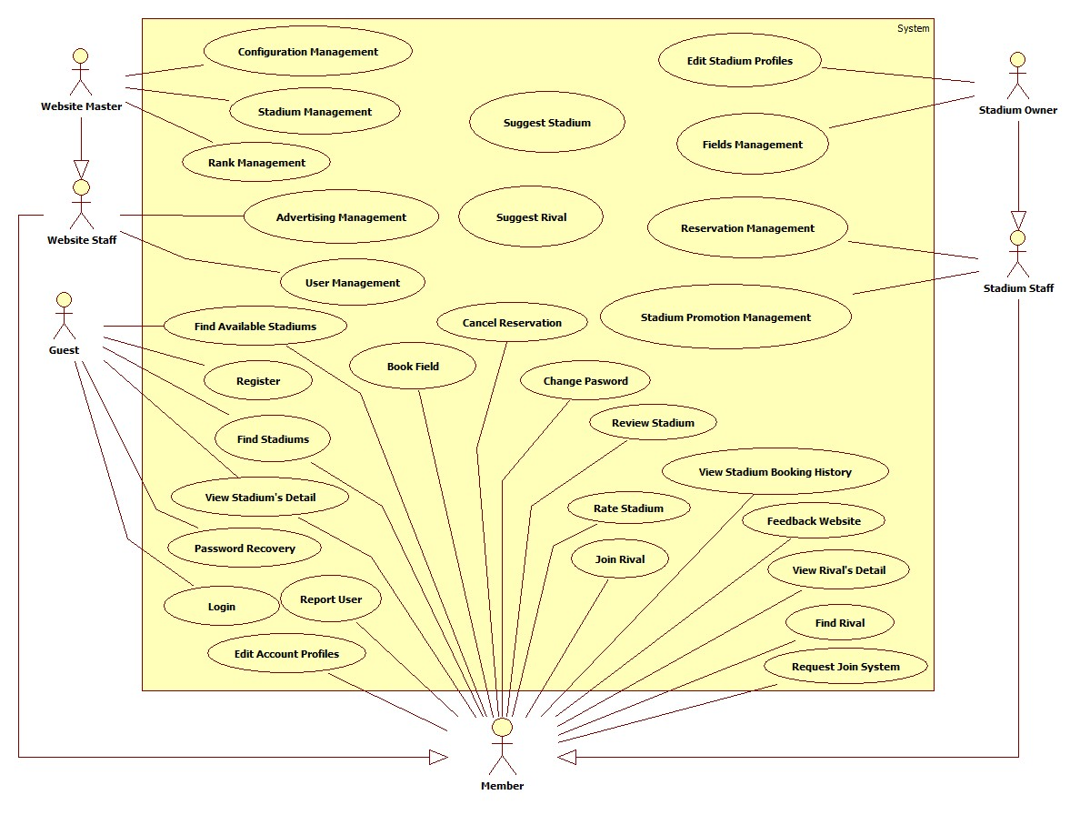

Figure 1: Use Case Summary

##### Stadium Management

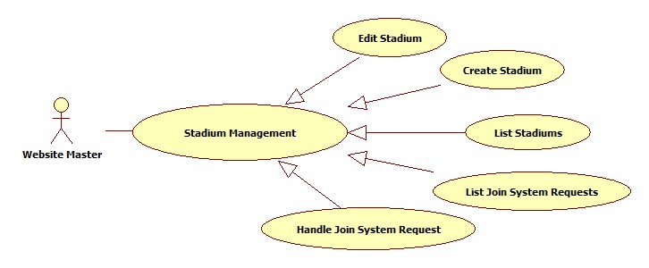

Figure 2: Stadium Management

###### List Stadiums

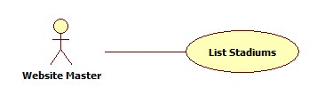

Figure 3: List Stadiums

|  |  |  |  |  |
| --- | --- | --- | --- | --- |
| **USE CASE-001 SPECIFICATION** | | | | |
| **Use-case No.** | UC_001 | **Use-case Version** | | 1.0 |
| **Use-case Name** | List Stadium | | | |
| **Author** | KhánhNQ | | | |
| **Date** | 12/02/2014 | **Priority** | High | |
| **Actor:**  Website Master  **Summary:**  This use case describes how to see list of stadiums  **Goal:**  List all stadiums in website  **Triggers:**  Actor goes to “Quản lý sân bóng” page  **Preconditions:**  Login as Website Master  **Post-conditions:**  N/A  **Main Success Scenario:**   |  |  |  | | --- | --- | --- | | Step | Actor Action | System Response | | 1 | Enter “Quản lý sân bóng” page | Display list of stadiums |   **Alternative Scenario:**  N/A  **Exceptions:**  N/A  **Relationships:**  N/A  **Business Rules:**  N/A | | | | |

###### Create Stadium

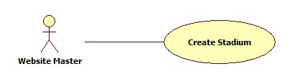

Figure 4: Create Stadium

|  |  |  |  |  |
| --- | --- | --- | --- | --- |
| **USE CASE-002 SPECIFICATION** | | | | |
| **Use-case No.** | UC_002 | **Use-case Version** | | 1.0 |
| **Use-case Name** | Create Stadium | | | |
| **Author** | KhánhNQ | | | |
| **Date** | 12/02/2014 | **Priority** | High | |
| **Actor:**  Website Master  **Summary:**  This use case describes how to create a stadium in website  **Goal:**  Create a stadium in website  **Triggers:**  Actor clicks on “Lưu” button after enter new stadium’s information  **Preconditions:**  Login as Website Master  **Post-conditions:**  N/A  **Main Success Scenario:**   |  |  |  | | --- | --- | --- | | Step | Actor Action | System Response | | 1 | Click “Thêm sân bóng” | The system will respond to “Thêm sân bóng” page | | 2 | Enter information of stadium. Click on “Lưu” button to finish | Display successful message |   **Alternative Scenario:**     |  |  | | --- | --- | | Actor Action | System Response | | Click on “Hủy bỏ” button to cancel | System will transfer to “Quản lý sân bóng” page |   **Exceptions:**  N/A  **Relationships:**  N/A  **Business Rules:**  N/A | | | | |

###### List Join System Requests

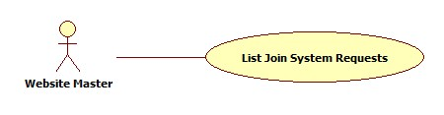

Figure 5: List Join System Requests

|  |  |  |  |  |
| --- | --- | --- | --- | --- |
| **USE CASE-003 SPECIFICATION** | | | | |
| **Use-case No.** | UC_003 | **Use-case Version** | | 1.0 |
| **Use-case Name** | List Join System Request | | | |
| **Author** | KhánhNQ | | | |
| **Date** | 12/02/2014 | **Priority** | High | |
| **Actor:**  Website Master  **Summary:**  This use case describes how to view the list of join system request.  **Goal:**  view the list of join system request  **Triggers:**  Actor enters “Yêu cầu tham gia” page  **Preconditions:**  Login as Website Master  **Post-conditions:**  N/A  **Main Success Scenario:**   |  |  |  | | --- | --- | --- | | Step | Actor Action | System Response | | 1 | Click on “Yêu cầu tham gia” to enter “Quản lý yêu cầu tham gia hệ thống” page | Display the list of join sysmte request |   **Alternative Scenario:**  N/A  **Exceptions:**  N/A  **Relationships:**  N/A  **Business Rules:**  N/A | | | | |

###### Handle Join System Request

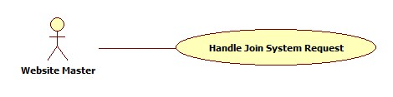

Figure 6: Handle Join System Request

|  |  |  |  |  |
| --- | --- | --- | --- | --- |
| **USE CASE-004 SPECIFICATION** | | | | |
| **Use-case No.** | UC_004 | **Use-case Version** | | 1.0 |
| **Use-case Name** | Handle Join System Request | | | |
| **Author** | KhánhNQ | | | |
| **Date** | 12/02/2014 | **Priority** | High | |
| **Actor:**  Website Master  **Summary:**  This use case describes how to handle join system request  **Goal:**  Handle request to join system  **Triggers:**  Actor clicks on “Cập nhật” button  **Preconditions:**  Login as Website Master  **Post-conditions:**  N/A  **Main Success Scenario:**   |  |  |  | | --- | --- | --- | | Step | Actor Action | System Response | | 1 | Click on “Chỉnh sửa” link of this request | View request’s detail | | 2 | Chose an option in “Trạng thái xử lý” combo box Click on “Cập nhật” button | Display successful message |   **Alternative Scenario:**   |  |  | | --- | --- | | Actor Action | System Response | | Click on “Hủy bỏ” button to cancel | Redirect to “Quản lý yêu cầu tham gia hệ thống” page |   **Exceptions:**  N/A  **Relationships:**  N/A  **Business Rules:**  N/A | | | | |

##### Configuration Management

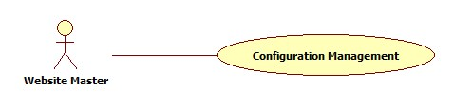

Figure 7: Configuration Management

|  |  |  |  |  |
| --- | --- | --- | --- | --- |
| **USE CASE-005 SPECIFICATION** | | | | |
| **Use-case No.** | UC_005 | **Use-case Version** | | 1.0 |
| **Use-case Name** | Configuration Management | | | |
| **Author** | KhanhNQ | | | |
| **Date** | 12/02/2014 | **Priority** | High | |
| **Actor:**  Website Master  **Summary:**  This use case describes how change the value of priorty norm for suggesting stadium or rival  **Goal:**  Edit value of configuration  **Triggers:**  Click “Lưu” button  **Preconditions:**  Login as Website Master  **Post-conditions:**    **Main Success Scenario:**   |  |  |  | | --- | --- | --- | | Step | Actor Action | System Response | | 1 | Enter quản “Quản lý gợi ý sân bóng” page | Display charts of priorty and value | | 2 | Drag the point to change value of priority Click on “Lưu” button | Display successful message |   **Alternative Scenario:**  N/A  **Exceptions:**  N/A  **Relationships:**  N/A  **Business Rules:**  N/A | | | | |

##### Advertising Management

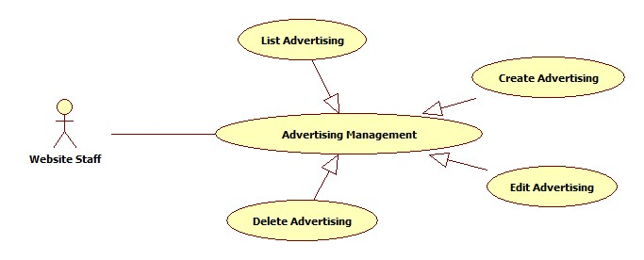

Figure 8: Advertising Management

###### List Advertisings

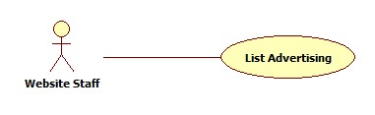

Figure 9: List Advertisings

|  |  |  |  |  |
| --- | --- | --- | --- | --- |
| **USE CASE-006 SPECIFICATION** | | | | |
| **Use-case No.** | UC_006 | **Use-case Version** | | 1.0 |
| **Use-case Name** | List Advertisings | | | |
| **Author** | KhanhNQ | | | |
| **Date** | 12/02/2014 | **Priority** | High | |
| **Actor:**  Website Master, Website Staff  **Summary:**  This use case describes how to see the list of advertisings in website  **Goal:**  See all advertisings  **Triggers:**  Actor goes to “Quảng cáo” page  **Preconditions:**  Login as Website Master or Website Staff  **Post-conditions:**    **Main Success Scenario:**   |  |  |  | | --- | --- | --- | | Step | Actor Action | System Response | | 1 |  | Display list of advertisings in system |   **Alternative Scenario:**  N/A  **Exceptions:**  N/A  **Relationships:**  N/A  **Business Rules:**  N/A | | | | |

###### Create Advertising

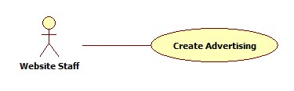

Figure 10: Create Advertising

|  |  |  |  |  |
| --- | --- | --- | --- | --- |
| **USE CASE-007 SPECIFICATION** | | | | |
| **Use-case No.** | UC_007 | **Use-case Version** | | 1.0 |
| **Use-case Name** | Create Advertising | | | |
| **Author** | KhanhNQ | | | |
| **Date** | 12/02/2014 | **Priority** | High | |
| **Actor:**  Website Staff, Website Master  **Summary:**  This use case describes how to create a new advertising in website  **Goal:**  Create advertising in Website  **Triggers:**  Actor clicks on “Thêm quảng cáo” button to create new advertising in website  **Preconditions:**  Login as Website Master or Website Staff  **Post-conditions:**    **Main Success Scenario:**   |  |  |  | | --- | --- | --- | | Step | Actor Action | System Response | | 1 | Click on “Thêm quảng cáo” | The system will respond to “Thêm quảng cáo” page | | 2 | Enter information of this advertising  Click “Lưu” button | Display successful message |   **Alternative Scenario:**   |  |  | | --- | --- | | Actor Action | System Response | | Click on “Hủy” button to cancel | System will transfer to “Quản lý quảng cáo” page |   **Exceptions:**  N/A  **Relationships:**  N/A  **Business Rules:**  N/A | | | | |

##### User Management

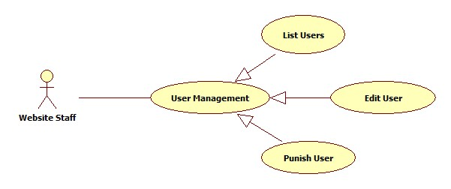

Figure 11: User Management

###### List Users

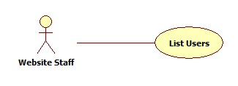

Figure 12: List Users

|  |  |  |  |  |
| --- | --- | --- | --- | --- |
| **USE CASE-008 SPECIFICATION** | | | | |
| **Use-case No.** | UC_008 | **Use-case Version** | | 1.0 |
| **Use-case Name** | List Users | | | |
| **Author** | KhanhNQ | | | |
| **Date** | 12/02/2014 | **Priority** | High | |
| **Actor:**  Website Staff, Website Master  **Summary:**  This use case describes how to see all users in website  **Goal:**  See all Users in website  **Triggers:**  Actor go to User Management page  **Preconditions:**  Login as Website Master or Website Staff  **Post-conditions:**  N/A  **Main Success Scenario:**   |  |  |  | | --- | --- | --- | | Step | Actor Action | System Response | | 1 |  | Display all users in system |   **Alternative Scenario:**  N/A  **Exceptions:**  N/A  **Relationships:**  N/A  **Business Rules:**  N/A | | | | |

###### Edit User

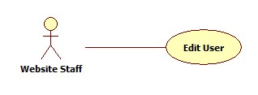

Figure 13: Edit User

|  |  |  |  |  |
| --- | --- | --- | --- | --- |
| **USE CASE-009 SPECIFICATION** | | | | |
| **Use-case No.** | UC_009 | **Use-case Version** | | 1.0 |
| **Use-case Name** | Edit User | | | |
| **Author** | KhanhNQ | | | |
| **Date** | 12/02/2014 | **Priority** | High | |
| **Actor:**  Website Staff, Website Master  **Summary:**  This use case describes how to edit user’s information  **Goal:**  View and change user’s information  **Triggers:**  Actor clicks on “Chỉnh sửa” link of the user which will be edited  **Preconditions:**  N/A  **Post-conditions:**  N/A  **Main Success Scenario:**   |  |  |  | | --- | --- | --- | | Step | Actor Action | System Response | | 1 | clicks on “Chỉnh sửa” link of the user which will be edited | The system will show the User’s Information Page | | 2 | Update information  Click on “Lưu” button to save information | Display successful message |   **Alternative Scenario:**   |  |  | | --- | --- | | Actor Action | System Response | | Click on “Hủy bỏ” button | System will transfer to “Thành viên” page |   **Exceptions:**  User login as Website Staff cannot edit information of other website staff or website master.  **Relationships:**  N/A  **Business Rules:**  N/A | | | | |

###### Punish User

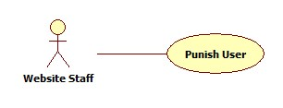

Figure 14: Punish User

|  |  |  |  |  |
| --- | --- | --- | --- | --- |
| **USE CASE-010 SPECIFICATION** | | | | |
| **Use-case No.** | UC_010 | **Use-case Version** | | 1.0 |
| **Use-case Name** | Punish User | | | |
| **Author** | KhanhNQ | | | |
| **Date** | 12/02/2014 | **Priority** | High | |
| **Actor:**  Website Staff, Website Master  **Summary:**  This use case describes how to punish an user  **Goal:**  Punish an user  **Triggers:**  Actor clicks “Cập nhật” button after choosing “Cấm hoạt động” option of the “Trạng thái hoạt động” drop down list.  **Preconditions:**  Login as Website Master or Website Staff  **Post-conditions:**  N/A  **Main Success Scenario:**   |  |  |  | | --- | --- | --- | | Step | Actor Action | System Response | | 1 | Chooses “Cấm hoạt động” option in the “Trạng thái hoạt động” drop down list |  | | 2 | Click “Lưu” button | Show successful message |   **Alternative Scenario:**     |  |  | | --- | --- | | Actor Action | System Response | | Click on “Hủy bỏ” button to cancel | Redirect to “Thành viên” page |   **Exceptions:**  User login as Website Staff cannot deactivate the other website staff or website master.  **Relationships:**  N/A  **Business Rules:**  N/A | | | | |

##### Rank Management

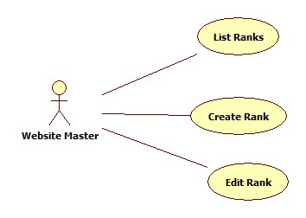

Figure 15: Rank Management

###### List Ranks

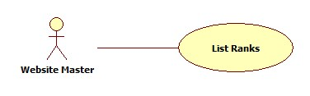

Figure 16: List Ranks

|  |  |  |  |  |
| --- | --- | --- | --- | --- |
| **USE CASE-011 SPECIFICATION** | | | | |
| **Use-case No.** | UC_011 | **Use-case Version** | | 1.0 |
| **Use-case Name** | List Ranks | | | |
| **Author** | ThinhND | | | |
| **Date** | 12/02/2014 | **Priority** | High | |
| **Actor:**  Website Master  **Summary:**  This use case describes how to view list of ranks  **Goal:**  List all ranks  **Triggers:**  Actor enter “Quản lý cấp độ thành viên” page  **Preconditions:**  Login as Website Master  **Post-conditions:**  N/A  **Main Success Scenario:**   |  |  |  | | --- | --- | --- | | Step | Actor Action | System Response | | 1 | Enter “Quản lý cấp độ thành viên” page | Display list of all ranks |   **Alternative Scenario:**  N/A  **Exceptions:**  N/A  **Relationships:**  N/A  **Business Rules:**  N/A | | | | |
|  | | | | |

###### Create Rank

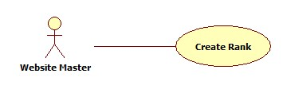

Figure 17: Create Rank

|  |  |  |  |  |
| --- | --- | --- | --- | --- |
| **USE CASE-012 SPECIFICATION** | | | | |
| **Use-case No.** | UC_012 | **Use-case Version** | | 1.0 |
| **Use-case Name** | Create Rank | | | |
| **Author** | ThinhND | | | |
| **Date** | 12/02/2014 | **Priority** | High | |
| **Actor:**  Website Master  **Summary:**  This use case describes how to edit stadium’s profiles  **Goal:**  Create new rank  **Triggers:**  Actor clicks on “Lưu” button  **Preconditions:**  Login as Website Master  **Post-conditions:**  N/A  **Main Success Scenario:**   |  |  |  | | --- | --- | --- | | Step | Actor Action | System Response | | 1 | Click on “Tạo cấp độ mới” link in “Quản lý cấp độ thành viên” | Display create rank form | | 2 | Enter new rank’s information  Click “Cập nhật” button | Display successful message |   **Alternative Scenario:**   |  |  | | --- | --- | | Actor Action | System Response | | Click on “Hủy bỏ” button | Discard all recent action and redirect to “Quản lý cấp độ thành viên” page |   **Exceptions:**  N/A  **Relationships:**  N/A  **Business Rules:**  N/A | | | | |

##### Edit Stadium’s Profile

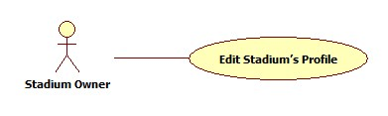

Figure 18: Edit Stadium's Profile

|  |  |  |  |  |
| --- | --- | --- | --- | --- |
| **USE CASE-013 SPECIFICATION** | | | | |
| **Use-case No.** | UC_013 | **Use-case Version** | | 1.0 |
| **Use-case Name** | Edit Stadium’s Profile | | | |
| **Author** | ThinhND | | | |
| **Date** | 12/02/2014 | **Priority** | High | |
| **Actor:**  Stadium Owner  **Summary:**  This use case describes how to edit stadium’s profiles  **Goal:**  Edit information of stadium  **Triggers:**  Actor clicks on “Cập nhật” button  **Preconditions:**  Login as Stadium Owner  **Post-conditions:**  N/A  **Main Success Scenario:**   |  |  |  | | --- | --- | --- | | Step | Actor Action | System Response | | 1 | Click on “Chỉnh sửa” link of the stadium which will be edited | Display Edit form with filled information | | 2 | Enter new information of stadium  Click “Cập nhật” button | Update new profiles for this stadium |   **Alternative Scenario:**   |  |  | | --- | --- | | Actor Action | System Response | | Click on “Hủy bỏ” button | Discard all recent action and redirect to “Quẩn lý sân bóng” page |   **Exceptions:**  N/A  **Relationships:**  N/A  **Business Rules:**  N/A | | | | |

##### Field Management

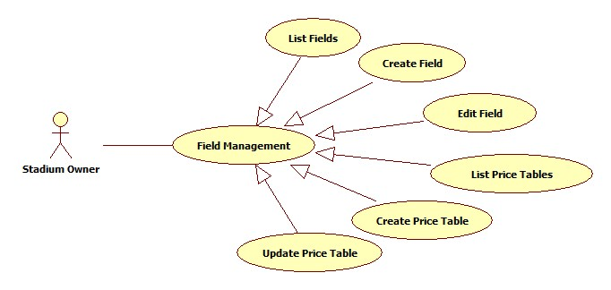

Figure 19: Field Management

###### List Fields

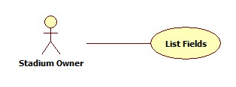

Figure 20: List Fields

|  |  |  |  |  |
| --- | --- | --- | --- | --- |
| **USE CASE-014 SPECIFICATION** | | | | |
| **Use-case No.** | UC_014 | **Use-case Version** | | 1.0 |
| **Use-case Name** | List Fields | | | |
| **Author** | ThinhND | | | |
| **Date** | 12/02/2014 | **Priority** | High | |
| **Actor:**  Stadium Owner  **Summary:**  This use case describes how to list all fields of a stadium.  **Goal:**  List all fields of stadium.  **Triggers:**  Actor clicks on “Sân con” link of the stadium  **Preconditions:**  Login as Stadium Owner  **Post-conditions:**  N/A  **Main Success Scenario:**   |  |  |  | | --- | --- | --- | | Step | Actor Action | System Response | | 1 | Actor clicks on “Sân con” link of the stadium | Show the field list of this stadium |   **Alternative Scenario:**  N/A  **Exceptions:**  Field has not been created by stadium owner.  **Relationships:**  N/A  **Business Rules:**  N/A | | | | |

###### Create Field

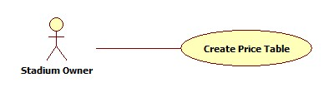

Figure 21: Create Field

|  |  |  |  |  |
| --- | --- | --- | --- | --- |
| **USE CASE-015 SPECIFICATION** | | | | |
| **Use-case No.** | UC_015 | **Use-case Version** | | 1.0 |
| **Use-case Name** | Create Field | | | |
| **Author** | ThinhND | | | |
| **Date** | 12/02/2014 | **Priority** | High | |
| **Actor:**  Stadium Owner  **Summary:**  This use case describes how to create a field of stadium.  **Goal:**  Create a field  **Triggers:**  Actor clicks on “Lưu” button  **Preconditions:**  Login as Stadium Owner role  **Post-conditions:**  N/A  **Main Success Scenario:**   |  |  |  | | --- | --- | --- | | Step | Actor Action | System Response | | 1 | Click on “Thêm sân con” button in the “Quản lý sân con” page | Display Create field form | | 2 | Enter information of this field  Click on “Lưu” button | Display successful message |   **Alternative Scenario:**   |  |  | | --- | --- | | Actor Action | System Response | | Click on “Hủy bỏ” button | Discard all recent activity and redirect to “Quản lý sân con” page |   **Exceptions:**  The List price has not been created.  **Relationships:**  N/A  **Business Rules:**  N/A | | | | |

###### List Price Tables

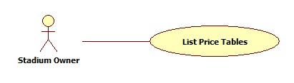

Figure 22: List Price Tables

|  |  |  |  |  |
| --- | --- | --- | --- | --- |
| **USE CASE-016 SPECIFICATION** | | | | |
| **Use-case No.** | UC_016 | **Use-case Version** | | 1.0 |
| **Use-case Name** | List Price Tables | | | |
| **Author** | ThinhND | | | |
| **Date** | 12/02/2014 | **Priority** | High | |
| **Actor:**  Stadium Owner  **Summary:**  This use case describes how view all price tables  **Goal:**  View list price tables  **Triggers:**  Actor clicks on “Bảng giá” button of the stadium  **Preconditions:**  Login as Stadium Owner role  **Post-conditions:**  N/A  **Main Success Scenario:**   |  |  |  | | --- | --- | --- | | Step | Actor Action | System Response | | 1 | Click on “Bảng giá” link in of the stadium which will be showed | Display price table list |   **Alternative Scenario:**  N/A  **Exceptions:**  N/A  **Relationships:**  N/A  **Business Rules:**  N/A | | | | |

###### Create Price Table

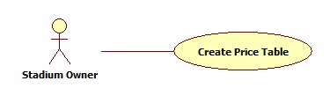

Figure 23: Create Price Table

|  |  |  |  |  |
| --- | --- | --- | --- | --- |
| **USE CASE-017 SPECIFICATION** | | | | |
| **Use-case No.** | UC_017 | **Use-case Version** | | 1.0 |
| **Use-case Name** | Create Field Price | | | |
| **Author** | ThinhND | | | |
| **Date** | 12/02/2014 | **Priority** | High | |
| **Actor:**  Stadium Owner  **Summary:**  This use case describes how to create price table  **Goal:**  Create a price table  **Triggers:**  Actor clicks on “Lưu” button  **Preconditions:**  Login as Stadium Owner role  **Post-conditions:**  N/A  **Main Success Scenario:**   |  |  |  | | --- | --- | --- | | Step | Actor Action | System Response | | 1 | Click on “Lưu” button in the “Quản lý bảng giá” page | Display create price table form | | 2 | Enter information of this price table  Click on “Thêm bảng giá” button | Display successful message |   **Alternative Scenario:**   |  |  | | --- | --- | | Actor Action | System Response | | Click on “Hủy bỏ” button | Discard all recent activity and redirect to “Quản lý bảng giá” page |   **Exceptions:**  N/A  **Relationships:**  N/A  **Business Rules:**  N/A | | | | |

##### Reservations Management

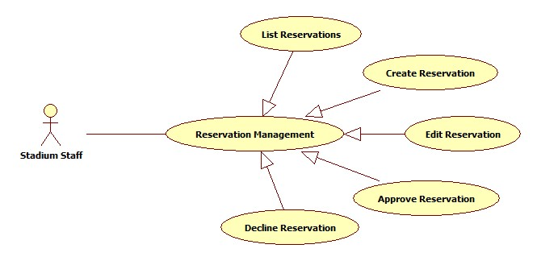

Figure 24: Reservation Management

###### List Reservations

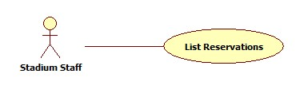

Figure 25: List Reservations

|  |  |  |  |  |
| --- | --- | --- | --- | --- |
| **USE CASE-018 SPECIFICATION** | | | | |
| **Use-case No.** | UC_018 | **Use-case Version** | | 1.0 |
| **Use-case Name** | List Reservations | | | |
| **Author** | ThinhND | | | |
| **Date** | 12/02/2014 | **Priority** | High | |
| **Actor:**  Stadium Staff, Stadium Owner  **Summary:**  This use case describes how to listt all reservations.  **Goal:**  List all reservations.  **Triggers:**  Actor goes to “Quản lý đặt sân” page  **Preconditions:**  Login as Stadium Staff or Stadium Owner role  **Post-conditions:**  N/A  **Main Success Scenario:**   |  |  |  | | --- | --- | --- | | Step | Actor Action | System Response | | 1 | Click on stadium link in “Quản lý đặt sân” page | The system shows the list of reservations of this stadium |   **Alternative Scenario:**  N/A  **Exceptions:**  N/A  **Relationships:**  N/A  **Business Rules:**  N/A | | | | |

###### Create Reservation

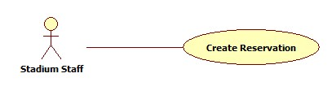

Figure 26: Create Reservation

|  |  |  |  |  |
| --- | --- | --- | --- | --- |
| **USE CASE-019 SPECIFICATION** | | | | |
| **Use-case No.** | UC_019 | **Use-case Version** | | 1.0 |
| **Use-case Name** | Create Reservation | | | |
| **Author** | ThinhND | | | |
| **Date** | 12/02/2014 | **Priority** | High | |
| **Actor:**  Stadium Staff, Stadium Owner  **Summary:**  This use case describes how to create a reservation  **Goal:**  Create a reservation.  **Triggers:**  Click on “Lưu” button in “Thêm đơn đặt sân” page  **Preconditions:**  Login as Stadium Staff or Stadium Owner role  **Post-conditions:**  N/A  **Main Success Scenario:**   |  |  |  | | --- | --- | --- | | Step | Actor Action | System Response | | 1 | Click on “Thêm đơn đặt sân” button | Display Book form | | 2 | Enter information of reservation  Click on “Lưu” button | Display successful message |   **Alternative Scenario:**   |  |  | | --- | --- | | Actor Action | System Response | | Click on “Hủy bỏ” button | Discard all recent action and redirect to “Quản lý đặt sân” page |   **Exceptions:**  This field is not available such as existing reservation, duplicate booking time, etc.  **Relationships:**  N/A  **Business Rules:**  N/A | | | | |

###### Approve Reservation

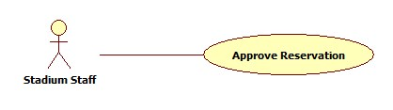

Figure 27: Approve Reservation

|  |  |  |  |  |
| --- | --- | --- | --- | --- |
| **USE CASE-020 SPECIFICATION** | | | | |
| **Use-case No.** | UC_020 | **Use-case Version** | | 1.0 |
| **Use-case Name** | Approve Reservation | | | |
| **Author** | ThinhND | | | |
| **Date** | 12/02/2014 | **Priority** | High | |
| **Actor:**  Stadium Staff, Stadium Owner  **Summary:**  This use case describes how to approve a reservation  **Goal:**  Approve a reservation  **Triggers:**  Click on “Lưu” button  **Preconditions:**  Login as Stadium Staff or Stadium Owner role  **Post-conditions:**  N/A  **Main Success Scenario:**   |  |  |  | | --- | --- | --- | | Step | Actor Action | System Response | | 1 | Click on “Chỉnh sửa” link of this reservation | Display this Reservation’s detail | | 2 | Click on “Lưu” button | Display successful message |   **Alternative Scenario:**   |  |  | | --- | --- | | Actor Action | System Response | | Click on “Quay lại” button | Discard all recent action and redirect to “Quản lý đặt sân” page |   **Exceptions:**  N/A  **Relationships:**  N/A  **Business Rules:**  N/A | | | | |

##### Stadium Promotion Management

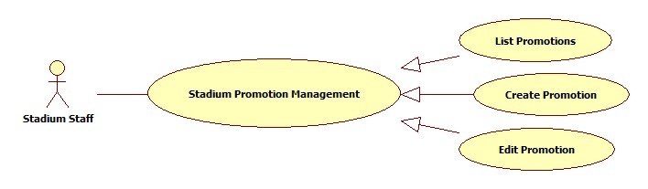

Figure 28: Stadium Promotion Management

###### List Promotions

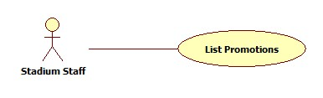

Figure 29: List Promotions

|  |  |  |  |  |
| --- | --- | --- | --- | --- |
| **USE CASE-021 SPECIFICATION** | | | | |
| **Use-case No.** | UC_021 | **Use-case Version** | | 1.0 |
| **Use-case Name** | List Promotions | | | |
| **Author** | ThinhND | | | |
| **Date** | 12/02/2014 | **Priority** | High | |
| **Actor:**  Stadium Staff, Stadium Owner  **Summary:**  This use case describe how to list all the promotion of stadium  **Goal:**  List all promotions of a stadium  **Triggers:**  Actor clicks on stadium of “Quản lý khuyến mãi” page  **Preconditions:**  Login as Stadium Staff or Stadium Owner role  **Post-conditions:**  N/A  **Main Success Scenario:**   |  |  |  | | --- | --- | --- | | Step | Actor Action | System Response | | 1 | Actor clicks on stadium of “Quản lý khuyến mãi” page | The system shows list of promotion. |   **Alternative Scenario:**  N/A  **Exceptions:**  N/A  **Relationships:**  N/A  **Business Rules:**  N/A | | | | |

###### Create Promotion

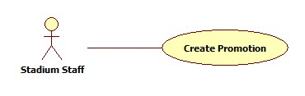

Figure 30: Create Promotion

|  |  |  |  |  |
| --- | --- | --- | --- | --- |
| **USE CASE-022 SPECIFICATION** | | | | |
| **Use-case No.** | UC_022 | **Use-case Version** | | 1.0 |
| **Use-case Name** | Create Promotion | | | |
| **Author** | ThinhND | | | |
| **Date** | 12/02/2014 | **Priority** | High | |
| **Actor:**  Stadium Staff, Stadium Owner  **Summary:**  This use case describes creating new promotion.  **Goal:**  Create a promotion for stadium.  **Triggers:**  Click on “Lưu” button  **Preconditions:**  Login as Stadium Staff or Stadium Owner role  **Post-conditions:**  N/A  **Main Success Scenario:**   |  |  |  | | --- | --- | --- | | Step | Actor Action | System Response | | 1 | Click on “Thêm khuyến mãi” of this stadium | Display create promotion form | | 2 | Enter information of this promotion Click “Lưu” button | Show successful message |   **Alternative Scenario:**   |  |  | | --- | --- | | Actor Action | System Response | | Click on “Hủy bỏ” button | Discard all recent action and redirect to “Quản lý khuyến mãi” page |   **Exceptions:**  N/A  **Relationships:**  N/A  **Business Rules:**  N/A | | | | |

##### Find Available Stadiums

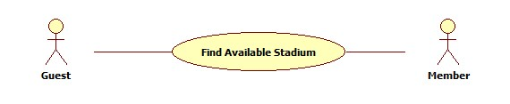

Figure 31: Find Available Stadium

|  |  |  |  |  |
| --- | --- | --- | --- | --- |
| **USE CASE-023 SPECIFICATION** | | | | |
| **Use-case No.** | UC_023 | **Use-case Version** | | 1.0 |
| **Use-case Name** | Find Available Stadium | | | |
| **Author** | ThinhND | | | |
| **Date** | 12/02/2014 | **Priority** | High | |
| **Actor:**  Guest, Member, Stadium Staff, Stadium Owner, Website Staff, Website Master  **Summary:**  This use case describes how to find an available stadium with some conditions  **Goal:**  Find available stadium  **Triggers:**  Actor clicks on “Tìm kiếm” button  **Preconditions:**  N/A  **Post-conditions:**  N/A  **Main Success Scenario:**   |  |  |  | | --- | --- | --- | | Step | Actor Action | System Response | | 1 | Choose condition information  Click on “Tìm kiếm” button | Show list of stadiums |   **Alternative Scenario:**  N/A  **Exceptions:**  There is no available stadium for those condition  **Relationships:**  N/A  **Business Rules:**  N/A | | | | |

##### Book Field

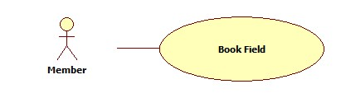

Figure 32: Book Field

|  |  |  |  |  |
| --- | --- | --- | --- | --- |
| **USE CASE-024 SPECIFICATION** | | | | |
| **Use-case No.** | UC_024 | **Use-case Version** | | 1.0 |
| **Use-case Name** | Book Field | | | |
| **Author** | ThinhND | | | |
| **Date** | 12/02/2014 | **Priority** | High | |
| **Actor:**  Member, Stadium Staff, Stadium Owner, Website Staff, Website Master  **Summary:**  This use case describes how to book a field  **Goal:**  Book a field of stadium  **Triggers:**  Actor clicks “Lưu” button  **Preconditions:**  Login as Member, Stadium Staff, Stadium Owner, Website Staff or Website Master  **Post-conditions:**  N/A  **Main Success Scenario:**   |  |  |  | | --- | --- | --- | | Step | Actor Action | System Response | | 1 | Click on “Đặt sân” button of stadium detail page or “Đặt” button after find stadium | Display reservation form | | 2 | Enter information of reservation  Click “Lưu” button | Display successful message |   **Alternative Scenario:**   |  |  | | --- | --- | | Actor Action | System Response | | There’s is no available field | Display message | | Click on “Hủy bỏ” button | Discard all recent action and redirect to Home page |   **Exceptions:**  This field is not available such as existing reservation, duplicate booking time, etc.  **Relationships:**  N/A  **Business Rules:**  N/A | | | | |

##### Find Rival

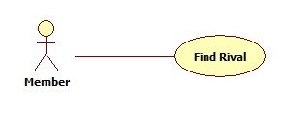

Figure 33: Find Rival

|  |  |  |  |  |
| --- | --- | --- | --- | --- |
| **USE CASE-025 SPECIFICATION** | | | | |
| **Use-case No.** | UC_025 | **Use-case Version** | | 1.0 |
| **Use-case Name** | Find Rival | | | |
| **Author** | ThinhND | | | |
| **Date** | 12/02/2014 | **Priority** | High | |
| **Actor:**  Guest, Member, Stadium Staff, Stadium Owner, Website Staff, Website Master  **Summary:**  This use case describes how to find a rival  **Goal:**  Find rival  **Triggers:**  Actor clicks on “Tìm kiếm” button  **Preconditions:**  N/A  **Post-conditions:**  N/A  **Main Success Scenario:**   |  |  |  | | --- | --- | --- | | Step | Actor Action | System Response | | 1 | Go to “Tìm kèo” page | Show list of all rivals | | 2 | Enter searching information Click on “Tìm kiếm” button | Show result |   **Alternative Scenario:**  N/A  **Exceptions:**  N/A  **Relationships:**  N/A  **Business Rules:**  N/A | | | | |

##### Join Rival

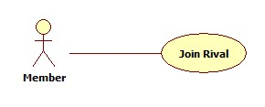

Figure 34: Join Rival

|  |  |  |  |  |
| --- | --- | --- | --- | --- |
| **USE CASE-026 SPECIFICATION** | | | | |
| **Use-case No.** | UC_026 | **Use-case Version** | | 1.0 |
| **Use-case Name** | Join Rival | | | |
| **Author** | ThinhND | | | |
| **Date** | 12/02/2014 | **Priority** | High | |
| **Actor:**  Member, Stadium Staff, Stadium Owner, Website Staff, Website Master  **Summary:**  This use case describes how to join a rival  **Goal:**  Join a rival  **Triggers:**  Actor clicks on “Cáp kèo” button  **Preconditions:**  Login as user  **Post-conditions:**  N/A  **Main Success Scenario:**   |  |  |  | | --- | --- | --- | | Step | Actor Action | System Response | | 1 | Click on “Chi tiết” link of this rival | Display rival’s detail | | 2 | Choose “Có” in “Bạn muốn cáp kèo này” combo box Enter additional information  Click “Cáp kèo” button | Display successful message |   **Alternative Scenario:**   |  |  | | --- | --- | | Actor Action | System Response | | Click on “Quay lại” button | Redirect to Home page |   **Exceptions:**  N/A  **Relationships:**  N/A  **Business Rules:**  N/A | | | | |

##### Reference Use Cases:

The following use cases are reference to:

* Edit Stadium
* Edit Advertising
* Edit Rank
* Edit Field
* Update Price Table
* Edit Reservation
* Decline Reservation
* Edit Promotion
* Login/Logout
* Find Stadiums
* Rivew Stadium
* Feedback Website
* Change Password
* View Rival’s Detail
* View Stadium Booking History
* Register
* Password Recovery
* View Stadium’s Detail:
* Rate Stadium
* Cancel Reservation
* Edit Account Profile
* Request Join System

#### Non-Functional Requirements

##### Reliability

* Mean Time Between Failures (MTBF): The acceptable failure is once a year
* Mean Time To Repair (MTTR): The acceptable mean time for a particular failure must be least than 12 hours
* Maximum Bugs or Defect Rate: 05 bugs / KLOC

##### Availability

* The system always responds to every user who got permission. The server shall be working 24/7.

##### Security

* Customer information must be secured
* The system always check authenticate and permission for every function

##### Maintainability

N/A

##### Portability

N/A

##### Performance

N/A

#### Entity Relationship Diagram

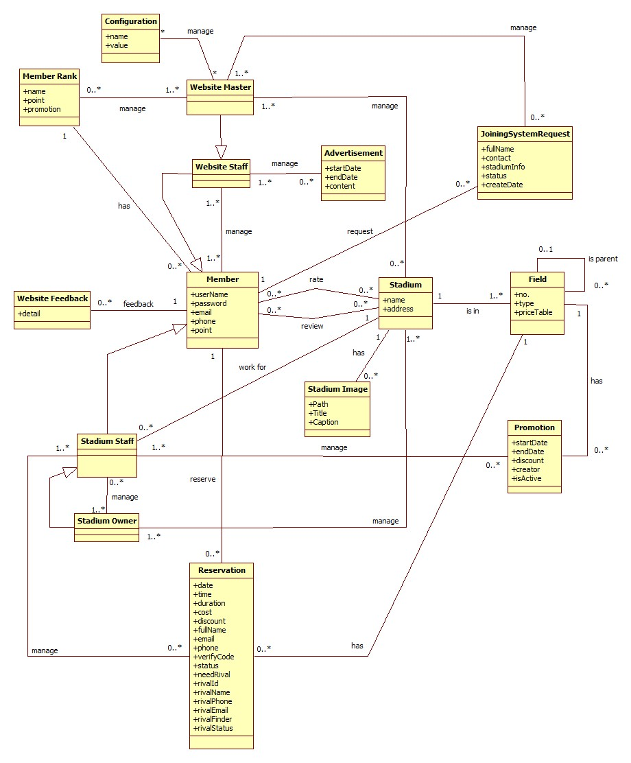

Figure 35: Entity Relationship Diagram

## System Design Description (SDD)

### Design Overview

* This document describes the technical and UI design of the FPB system. It includes the architectural design and the detailed design of common functions and business functions. It also includes the design of database model.
* The architectural design describes the overall architecture of the system, and the architecture of each main component and subsystem. It will describe the patterns being used, the role of each component and the role of the system in the working environment.
* The detailed design describes static and dynamic structure for each component and function. It includes class diagrams, class explanations, and sequence diagrams of the main use cases. The detailed design uses notations of .NET framework 4.0 and C#, as they are the framework and language for developing this system.
* The database design describes the relationship between entities, and details of each entity. It uses notations of SQL Server 2008 R2 as it is the database server for developing the system.
* The user interface design describes the layout of the system, and some design for the screens

### System Architectural Design

#### Choice of System Architecture

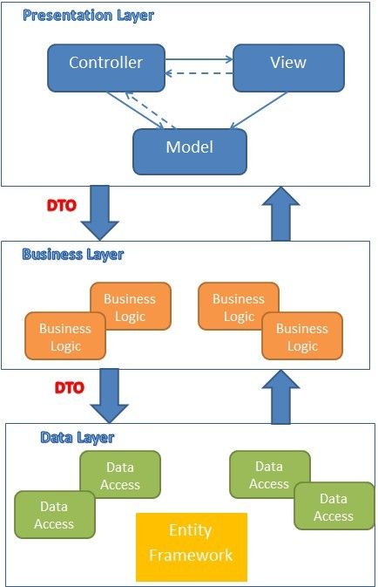

Figure 36: MVC implemented in a three-layer architecture

The above diagram is explained as the following:

**Model**: Used to prepare data for view

**View**: The view displays the data and also takes input form user. It renders the model data into a form, such as graphics, buttons, and tables, and so on to display to the user.

**Controller:** The controller handles all requests coming from the view or user interface. The data flows to whole application are controlled by controller.

**Business Logic:** This layer coordinates the application, processes commands, makes logical decisions and evaluations, and performs calculations. It also moves and processes data between the two surrounding layers.

**Data Access:** Here information is stored and retrieved from a database or file system. The information is then passed back to the logic tier for processing, and then eventually back to the user.

#### Discussion of Alternative Designs

N/A

#### Description of System Interface

N/A

### Component Diagram

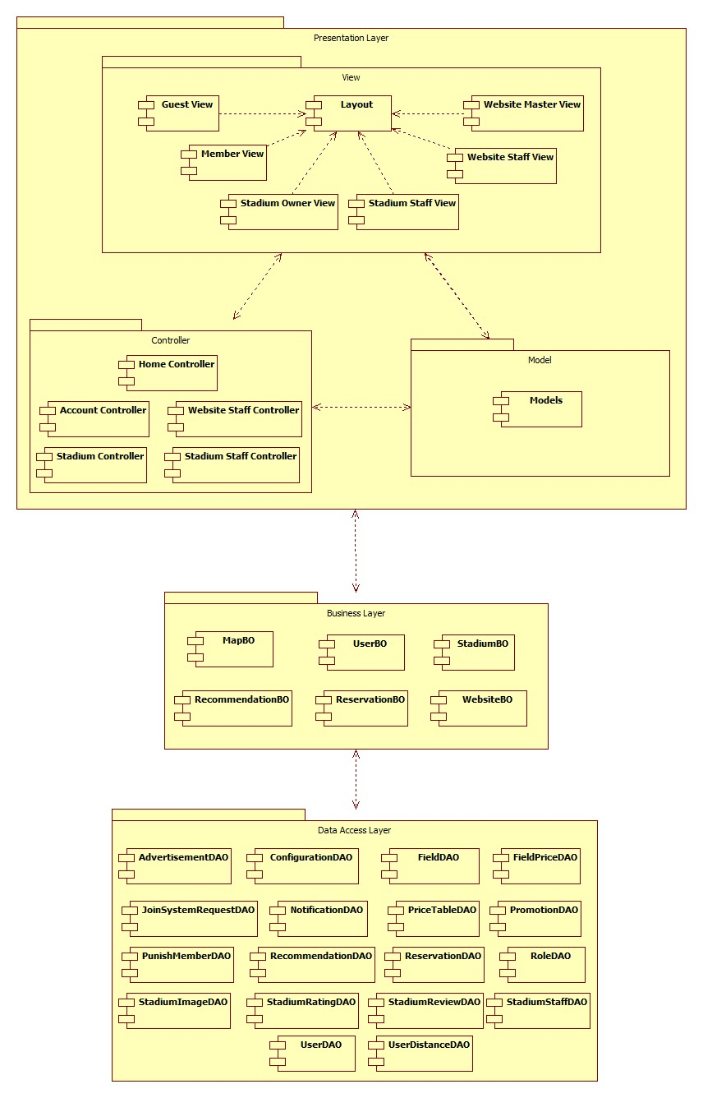

Figure 37: Component Diagram

### Detailed Description of Components

#### Class Diagram

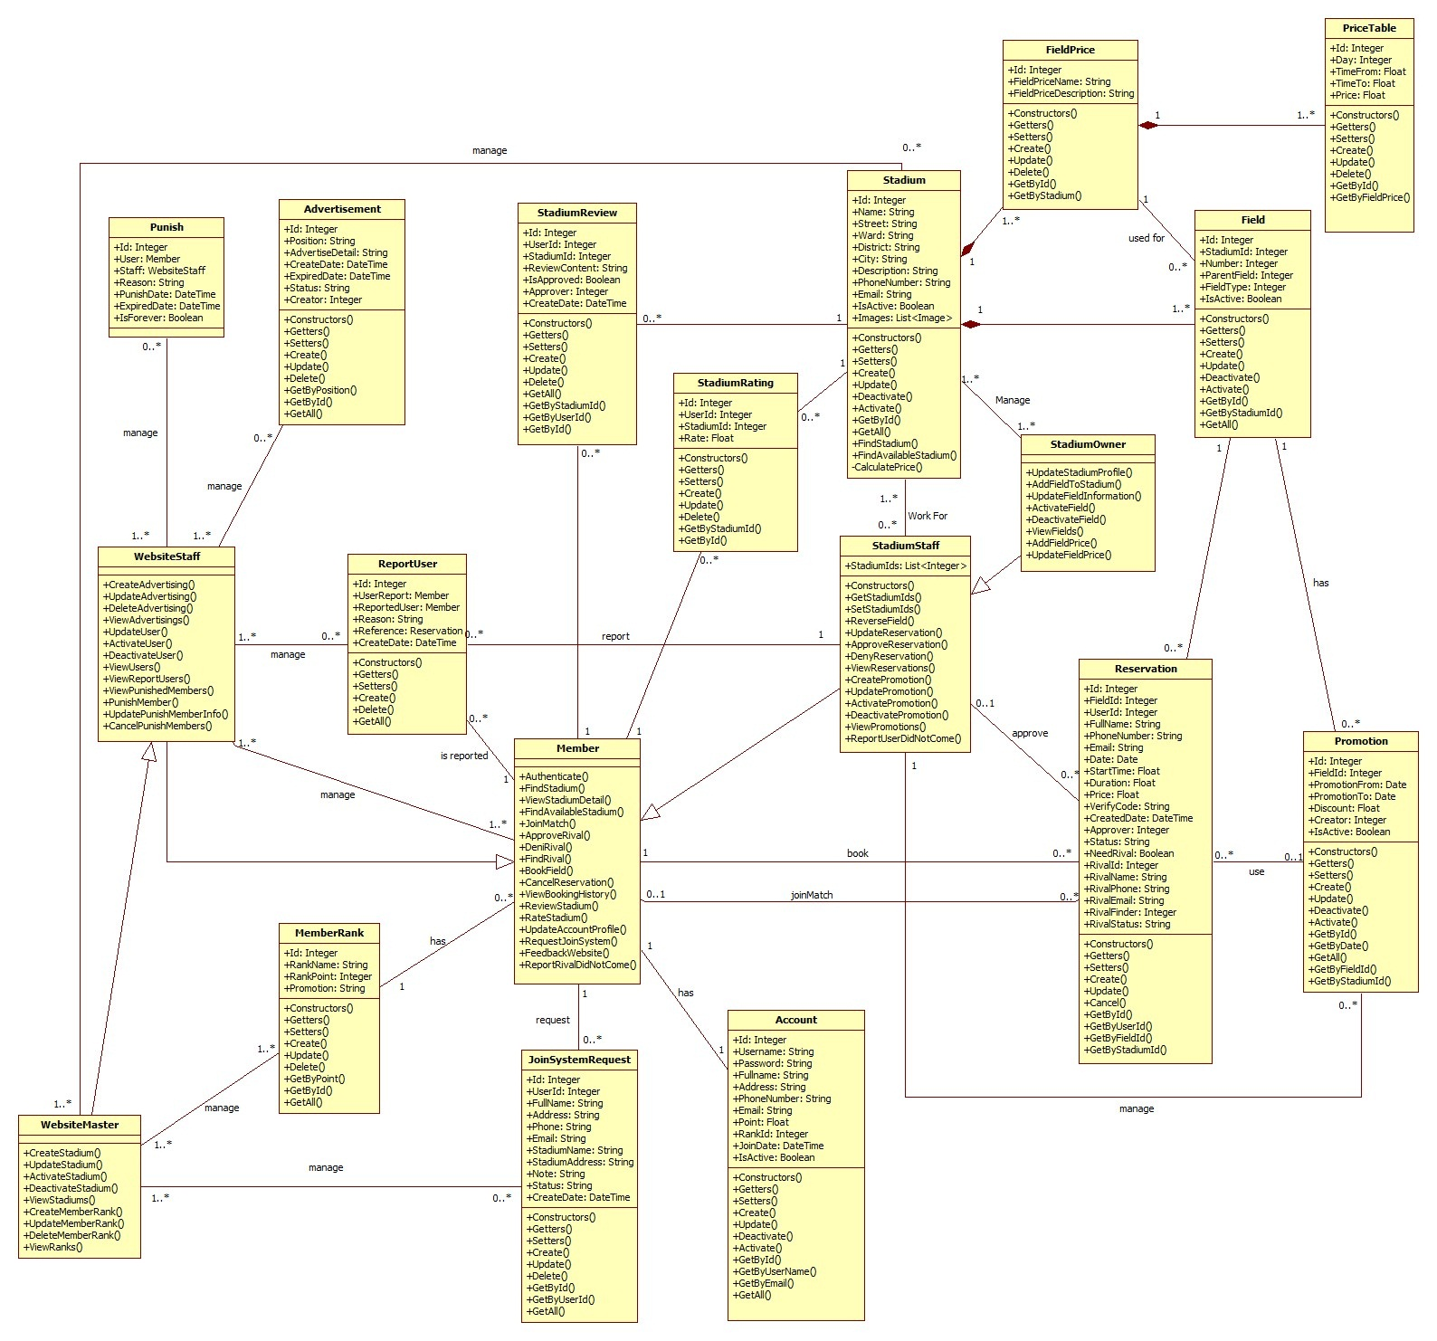

Figure 38: General Class Diagram

#### Class Diagram Explanation

##### Role

* **Attributes**

|  |  |  |
| --- | --- | --- |
| **Name** | **Type** | **Description** |
| Id | Integer | Id of Role |
| Role | String | Role |

* **Methods**

|  |  |  |  |
| --- | --- | --- | --- |
| **Name** | **Parameter** | **Return Type** | **Description** |
| Constructors | Optional | Account | Initialize a role with value (optional) |
| Getters | N/A | Type of attribute | Get value of an attribute corresponding with getter of attribute |
| Setters | Value of attribute | Void | Set value for an attribute corresponding with setter of attribute |
| Create | All of attribute of class Role | Integer | Create a role and save it to database |
| Update | * Role | Integer | Update information of an existing role in database |

##### Account

* **Attributes**

|  |  |  |
| --- | --- | --- |
| **Name** | **Type** | **Description** |
| Id | Integer | Id of an user in system |
| Username | String | Name of account, it is unique in system |
| Password | String | Password of account |
| FullName | String | Full name of user |
| Address | String | Address of user |
| PhoneNumber | String | Phone number of user |
| Email | String | Email of user |
| Point | Float | Point of user, it is used to calculate rank of account |
| RankId | Integer | Rank of account |
| IsReceivedReward | Boolean | Every time the rank grow up, account may receive a reward, this field is used to tracking whether account received reward or not |
| JoinDate | Date | The date when user join this system |
| IsActive | Boolean | Is this account active |
| Role | Integer | Id of role |

* **Methods**

|  |  |  |  |
| --- | --- | --- | --- |
| **Name** | **Parameter** | **Return Type** | **Description** |
| Constructors | Optional | Account | Initialize an account with value (optional) |
| Getters | N/A | Type of attribute | Get value of an attribute corresponding with getter of attribute |
| Setters | Value of attribute | Void | Set value for an attribute corresponding with setter of attribute |
| Create | All of attribute of class Account | Integer | Create an account and save it to database |
| Update | * Password * FullName * Address * PhoneNumber * Email * Point * RankId * IsReceivedReward * Role | Integer | Update information of an existing account in database |
| Deactivate | N/A | Integer | De-active an account |
| Activate | N/A | Integer | Activate an account |
| GetById | * Id | Account | Get an account instance by Id of account from database |
| GetByUserName | * UserName | Account | Get an account instance by UserName of account from database |
| GetByEmail | * Email | Account | Get an account instance by Email of account from database |
| GetAll | N/A | List<Account> | Get all account from database |

##### Stadium

* **Attributes**

|  |  |  |
| --- | --- | --- |
| **Name** | **Type** | **Description** |
| Id | Integer | Id of stadium |
| Name | String | Name of stadium |
| Street | String | Name of street that stadium located |
| Ward | String | Name of ward that stadium located |
| District | String | Name of district that stadium located |
| City | String | Name of city or province that stadium located |
| Description | String | Description of stadium |
| PhoneNumber | String | Phone number of stadium |
| Email | String | Email of stadium |
| IsActive | Boolean | Is the stadium active |

* **Methods**

|  |  |  |  |
| --- | --- | --- | --- |
| **Name** | **Parameter** | **Return Type** | **Description** |
| Constructors | Optional | Stadium | Initialize an Stadium with value (optional) |
| Getters | N/A | Type of attribute | Get value of an attribute corresponding with getter of attribute |
| Setters | Value of attribute | Void | Set value for an attribute corresponding with setter of attribute |
| Create | All of attribute of class Stadium | Integer | Create a stadium and save it to database |
| Update | * Name * Street * Ward * District * City * Description * PhoneNumber * Email | Integer | Update information of an existing stadium in database |
| Deactivate | N/A | Integer | De-active a stadium |
| Activate | N/A | Integer | Activate a stadium |
| GetById | * Id | Stadium | Get an stadium instance by Id of stadium from database |
| GetAll | N/A | List<Stadium> | Get all account from database |
| FindStadium | * Name * Address * FieldType | List<Stadium> | Get all stadiums correspond with filter |
| FindAvailableStadium | * Address * FieldType * Date * StartTime * Duration | List<Stadium> | Get all stadiums those are available with request date, time, location |

##### Field

* **Attributes**

|  |  |  |
| --- | --- | --- |
| **Name** | **Type** | **Description** |
| Id | Integer | Id of field |
| StadiumId | Integer | Id of stadium that contain this field |
| Number | Integer | Number of field in stadium |
| ParentField | Integer | Id of another field that contain this field |
| FieldType | Integer | Type of field |
| IsActive | Boolean | Is this field active |

* **Methods**

|  |  |  |  |
| --- | --- | --- | --- |
| **Name** | **Parameter** | **Return Type** | **Description** |
| Constructors | Optional | Field | Initialize an Field with value (optional) |
| Getters | N/A | Type of attribute | Get value of an attribute corresponding with getter of attribute |
| Setters | Value of attribute | Void | Set value for an attribute corresponding with setter of attribute |
| Create | All of attribute of class Field | Integer | Create a field and save it to database |
| Update | * Name * Street * Ward * District * City * Description * PhoneNumber * Email | Integer | Update information of an existing field in database |
| Deactivate | N/A | Integer | De-active a field |
| Activate | N/A | Integer | Activate a field |
| GetById | * Id | Field | Get a field instance by Id of field from database |
| GetByStadiumId | * StadiumId | List<Field> | Get all field of the stadium that has corresponding id |
| GetAll | N/A | List<Field> | Get all field from database |

##### FieldPrice

* **Attributes**

|  |  |  |
| --- | --- | --- |
| **Name** | **Type** | **Description** |
| Id | Integer | Id of field price |
| FieldId | Integer | Id of field that has this price |
| TimeFrom | Float | Start time in day that use this price |
| TimeTo | Float | End time in day that use this price |
| Price | Float | Price |
| Day | Integer | Day in week that use this price  Start with Sunday is 0, Monday is 1, … |

* **Methods**

|  |  |  |  |
| --- | --- | --- | --- |
| **Name** | **Parameter** | **Return Type** | **Description** |
| Constructors | Optional | FieldPrice | Initialize an FieldPrice with value (optional) |
| Getters | N/A | Type of attribute | Get value of an attribute corresponding with getter of attribute |
| Setters | Value of attribute | Void | Set value for an attribute corresponding with setter of attribute |
| Create | All of attribute of class FieldPrice | Integer | Create a price of field and save it to database |
| Update | * FieldId * TimeFrom * TimeTo * Price * Day | Integer | Update information of an existing field price in database |
| Delete | * Id | Integer | Delete a field price |
| GetById | * Id | FieldPrice | Get a field price instance by Id of field pricefrom database |
| GetByDayTime | * Day * StartTime | FieldPrice | Get Field Price for Day, StartTime |
| GetAll | N/A | List<FieldPrice> | Get all field price from database |
| GetByFieldId | * FieldId | List<FieldPrice> | Get All FieldPrice of a field |

##### Promotion

* **Attributes**

|  |  |  |
| --- | --- | --- |
| **Name** | **Type** | **Description** |
| Id | Integer | Id of promotion |
| FieldId | Integer | Id of field that use this promotion |
| PromotionFrom | Date | Start date that use this promotion |
| PromotionTo | Date | Expired date of this promotion |
| Discount | Float | Discount amount of this promotion |
| Creator | Integer | Id of staff that create this promotion |
| IsActive | Boolean | Is this promotion active |

* **Methods**

|  |  |  |  |
| --- | --- | --- | --- |
| **Name** | **Parameter** | **Return Type** | **Description** |
| Constructors | Optional | Promotion | Initialize an Promotion with value (optional) |
| Getters | N/A | Type of attribute | Get value of an attribute corresponding with getter of attribute |
| Setters | Value of attribute | Void | Set value for an attribute corresponding with setter of attribute |
| Create | All of attribute of class Promotion | Integer | Create a promotion and save it to database |
| Update | * FieldId * PromotionFrom * PromotionTo * Discount * Creator | Integer | Update information of an existing promotion in database |
| Delete | * Id | Integer | Delete a field price |
| GetById | * Id | Promotion | Get a Promotion instance by Id from database |
| GetByDate | * Date | List< Promotion > | Get all Promotion for date |
| GetAll | N/A | List< Promotion > | Get all Promotion from database |
| GetByFieldId | * FieldId | List< Promotion > | Get all Promotion of a field |
| GetByStadiumId | * StadiumId | List<Promotion> | Get all Promotion of a stadium |

##### StadiumReview

* **Attributes**

|  |  |  |
| --- | --- | --- |
| **Name** | **Type** | **Description** |
| Id | Integer | Id of review |
| UserId | Integer | Id of user create this review |
| StadiumId | Integer | Id of stadium being reviewed |
| ReviewContent | Float | Content of this review |
| IsApproved | Float | Is this review approved |
| Approver | Integer | Id of stadium staff approve this review |
| CreateDate | DateTime | The date that this review is created |

* **Methods**

|  |  |  |  |
| --- | --- | --- | --- |
| **Name** | **Parameter** | **Return Type** | **Description** |
| Constructors | Optional | StadiumReview | Initialize an StadiumReview with value (optional) |
| Getters | N/A | Type of attribute | Get value of an attribute corresponding with getter of attribute |
| Setters | Value of attribute | Void | Set value for an attribute corresponding with setter of attribute |
| Create | All of attribute of class StadiumReview | Integer | Create a review of stadium and save it to database |
| Update | * ReviewContent * IsApproved * TimeTo | Integer | Update information of an existing review in database |
| Delete | * Id | Integer | Delete a Review |
| GetById | * Id | StadiumReview | Get a review by Id of StadiumReview from database |
| GetByUserId | * UserId | List<StadiumReview> | Get all review of an user |
| GetAll | N/A | List<StadiumReview> | Get all review from database |
| GetByStadiumId | * StadiumId | List<StadiumReview> | Get all review of a stadium |

##### StadiumRating

* **Attributes**

|  |  |  |
| --- | --- | --- |
| **Name** | **Type** | **Description** |
| Id | Integer | Id of review |
| UserId | Integer | Id of user create this rate |
| StadiumId | Integer | Id of stadium being rated |
| Rate | Float | Rate |

* **Methods**

|  |  |  |  |
| --- | --- | --- | --- |
| **Name** | **Parameter** | **Return Type** | **Description** |
| Constructors | Optional | StadiumRating | Initialize an StadiumRating with value (optional) |
| Getters | N/A | Type of attribute | Get value of an attribute corresponding with getter of attribute |
| Setters | Value of attribute | Void | Set value for an attribute corresponding with setter of attribute |
| Create | All of attribute of class StadiumRating | Integer | Create a rate of stadium and save it to database |
| Update | * Rate | Integer | Update rate of an existing rate in database |
| Delete | * Id | Integer | Delete a Rate |
| GetById | * Id | StadiumRating | Get a review by Id of StadiumRating from database |
| GetByStadiumId | * StadiumId | List<StadiumRating> | Get all rate of a stadium |

##### Reservation

* **Attributes**

|  |  |  |
| --- | --- | --- |
| **Name** | **Type** | **Description** |
| Id | Integer | Id of Reservation |
| FieldId | Integer | Id of field that user book |
| UserId | Integer | Id of user create reservation |
| FullName | String | Name of person who book the field (booker) |
| PhoneNumber | String | Phone number of booker |
| Email | String | Email of booker |
| Date | Date | Date which booker want to reverse |
| StartTime | Float | Start time which booker want to start using |
| Duration | Float | How long booker want to using |
| Price | Float | Price of this reservation |
| VerifyCode | String | Verify code of this reservation, booker use this to trade with stadium manager for their approval |
| CreateDate | DateTime | The time this reservation is created |
| Approver | Integer | Id of stadium manager who approve this reservation |
| Status | String | Status of reservation |
| HasRival | Boolean | False if booker want to get a help for finding a rival  True if booker has a rival |
| RivalId | Integer | Id of an user who join as rival of booker (rival) |
| RivalName | String | Name of rival |
| RivalPhone | String | Phone number of rival |
| RivalEmail | String | Email of rival |
| RivalFinder | Integer | Id of user who found rival for this reservation  It can be Id of booker or stadium manager |

* **Methods**

|  |  |  |  |
| --- | --- | --- | --- |
| **Name** | **Parameter** | **Return Type** | **Description** |
| Constructors | Optional | Reservation | Initialize an Reservation with value (optional) |
| Getters | N/A | Type of attribute | Get value of an attribute corresponding with getter of attribute |
| Setters | Value of attribute | Void | Set value for an attribute corresponding with setter of attribute |
| Create | All of attribute of class Reservation | Integer | Create a reservation and save it to database |
| Update | * FieldId * FullName * PhoneNumber * Email * Date * StartTime * Duration * Price * CreateDate * Approver * Status * HasRival * RivalId * RivalName * RivalPhone * RivalEmail * RivalFinder | Integer | Update reservation information of an existing reservation in database |
| Cancel | * Id | Integer | Cancel a Reservation |
| GetById | * Id | Reservation | Get a reservation by Id from database |
| GetByUserId | * UserId | List<Reservation> | Get all reservation of an user |
| GetByFieldId | * FieldId | List<Reservation> | Get all reservation of a field |
| GetByStadiumId | * StadiumId | List<Reservation> | Get all reservation of a stadium |

##### JoinSystemRequest

* **Attributes**

|  |  |  |
| --- | --- | --- |
| **Name** | **Type** | **Description** |
| Id | Integer | Id of review |
| UserId | Integer | Id of user submit request (requester) |
| FullName | String | Full name of requester |
| Address | String | Address of requester |
| Phone | String | Phone of requester |
| Email | String | Email of requester |
| StadiumName | String | Name of stadium owned by requester |
| StadiumAddress | String | Address of stadium |
| Note | String | Note of requester |
| Status | String | Status of request |
| CreateDate | DateTime | Create date of request |

* **Methods**

|  |  |  |  |
| --- | --- | --- | --- |
| **Name** | **Parameter** | **Return Type** | **Description** |
| Constructors | Optional | RequestJoinSystem | Initialize an RequestJoinSystem with value (optional) |
| Getters | N/A | Type of attribute | Get value of an attribute corresponding with getter of attribute |
| Setters | Value of attribute | Void | Set value for an attribute corresponding with setter of attribute |
| Create | All of attribute of class RequestJoinSystem | Integer | Create a request and save it to database |
| Update | * FullName * Address * Phone * Email * StadiumName * StadiumAddress * Note * Status | Integer | Update request information of an existing request in database |
| Delete | * Id | Integer | Delete a RequestJoinSystem |
| GetById | * Id | RequestJoinSystem | Get a request by Id from database |
| GetByUserId | * UserId | List<RequestJoinSystem> | Get all request of an user |
| GetAll | N/A | List<RequestJoinSystem> | Get all request |

##### Member Rank

* **Atributes**

|  |  |  |
| --- | --- | --- |
| **Name** | **Type** | **Description** |
| Id | Integer | Id of rank |
| RankName | String | Name of rank |
| RankPoint | Integer | Minimum point to get rank |
| Promotion | String | Promotion of rank |

* **Methods**

|  |  |  |  |
| --- | --- | --- | --- |
| **Name** | **Parameter** | **Return Type** | **Description** |
| Constructors | Optional | MemberRank | Initialize an MemberRank with value (optional) |
| Getters | N/A | Type of attribute | Get value of an attribute corresponding with getter of attribute |
| Setters | Value of attribute | Void | Set value for an attribute corresponding with setter of attribute |
| Create | All of attribute of class MemberRank | Integer | Create a MemberRank and save it to database |
| Update | * RankName * RankPoint * Promotion | Integer | Update MemberRank information of an existing MemberRank in database |
| Delete | * Id | Integer | Delete a MemberRank |
| GetByPoint | * Id | MemberRank | Get a MemberRank by point |
| GetById | * UserId | MemberRank | Get a MemberRank by id |
| GetAll | N/A | List<MemberRank> | Get all MemberRank |

##### Advertisement

* **Atributes**

|  |  |  |
| --- | --- | --- |
| **Name** | **Type** | **Description** |
| Id | Integer | Id of advertisement |
| Position | String | Position of advertisement |
| AdvertiseDetail | String | Content of advertisement |
| CreateDate | DateTime | Create date of advertisement |
| ExpiredDate | DateTime | Expired date of advertisement |
| Status | String | Status of advertisement |
| Creator | Integer | Id of creator |

* **Methods**

|  |  |  |  |
| --- | --- | --- | --- |
| **Name** | **Parameter** | **Return Type** | **Description** |
| Constructors | Optional | Advertisement | Initialize an Advertisement with value (optional) |
| Getters | N/A | Type of attribute | Get value of an attribute corresponding with getter of attribute |
| Setters | Value of attribute | Void | Set value for an attribute corresponding with setter of attribute |
| Create | All of attribute of class Advertisement | Integer | Create an Advertisement and save it to database |
| Update | * Position * AdvertiseDetail * ExpiredDate * Status | Integer | Update Advertisement information of an existing Advertisement in database |
| Delete | * Id | Integer | Delete an Advertisement |
| GetByPosition | * Position | Advertisement | Get an Advertisement by position |
| GetById | * Id | Advertisement | Get an Advertisement by id |
| GetAll | N/A | List<Advertisement> | Get all Advertisement |

##### Member

Inherit all attributes and methods of class Account

* **Methods**

|  |  |  |  |
| --- | --- | --- | --- |
| **Name** | **Parameter** | **Return Type** | **Description** |
| Authenticate | * UserName * Password | Boolean | Authenticate a user with system |
| FindStadium | * StadiumName * Location * FieldType | List<Stadium> | Find stadium with some option, let a option null to ignore that option when search |
| ViewStadiumDetail | * StadiumId | Stadium | View detail of a stadium with member view |
| FindAvailableStadium | * Location * FieldType * Date * StartTime * Duration | List<Stadium> | Find available stadium with options |
| FindRival | * Location * FieldType * Date * StartTime * Duration | List<Reservation> | Find list reservation that do not have rival |
| JoinMatch | * ReservationId | Void | Join a match as rival of booker |
| BookField | * FieldId * FullName * Address * Phone * Email * Date * StartTime * Duration * HasRival | Boolean | Book a field |
| CancelReservation | * ReservationId | Void | Cancel a reservation |
| ViewBookingHistory | * UserId | List<Reservation> | View history of booking with Member view |
| ReviewStadium | * StadiumId * UserId * ReviewContent | Void | Review a stadium |
| RateStadium | * StadiumId * UserId * Rate | Void | Rate a stadium |
| UpdateAccountProfile | * UserId * Password * FullName * Address * PhoneNumber * Email | Void | Update account information |
| RequestJoinSystem | * UserId * FullName * Address * PhoneNumber * Email * StadiumName * StadiumAddress * Note | Void | Request for joining system of owned stadium |
| FeedbackWebsite | * Content * FullName * Email | Void | Send feedback content to email |

##### WebsiteStaff

Inherit all attributes and methods of class Member

* **Methods**

|  |  |  |  |
| --- | --- | --- | --- |
| **Name** | **Parameter** | **Return Type** | **Description** |
| CreateAdvertising | * Position * AdvertisementDetail * ExpiredDate * Status | Void | Create an advertisement |
| UpdateAdvertising | * AdvertisementId * Position * AdvertisementDetail * ExpiredDate * Status | Void | Update an advertisement |
| DeleteAdvertising | * AdvertisementId | Void | Delete an advertisement |
| ViewAdvertisings | N/A | List<Advertisement> | View all Advertisements with website staff view |
| UpdateUser | * UserId * Password * Email * Point * IsReceivedReward * IsActive * Role | Void | Update information of an user with website staff permission |
| ActivateUser | * UserId | Void | Activate an user |
| DeactivateUser | * UserId | Void | Deactivate an user |
| ViewUsers | N/A | List<User> | View all users with website staff view |

##### WebsiteMaster

Inherit all attributes and methods of class WebsiteStaff

* **Methods**

|  |  |  |  |
| --- | --- | --- | --- |
| **Name** | **Parameter** | **Return Type** | **Description** |
| CreateStadium | * Name * Street * Ward * District * City * Description * PhoneNumber * Email * IsActive | Void | Create a stadium |
| UpdateStadium | * StadiumId * Name * Street * Ward * District * City * Description * PhoneNumber * Email * IsActive | Void | Update a stadium |
| ActivateStadium | * StadiumId | Void | Delete an advertisement |
| DeactivateStadium | * StadiumId |  |  |
| ViewStadiums | N/A | List<Stadium> | View all Stadium with website master view |
| CreateMemberRank | * RankName * RankPoint * Promotion | Void | Create a member rank |
| UpdateMemberRank | * MemberRankId * RankName * RankPoint * Promotion | Void | Update a member rank |
| DeleteMemberRank | * MemberRankId | Void | Delete a member rank |
| ViewRanks | N/A | List<MemberRank> | View all member rank with website master view |

##### StadiumStaff

Inherit all attributes and methods of class Member

* **Attributes**

|  |  |  |
| --- | --- | --- |
| **Name** | **Type** | **Description** |
| StadiumIds | List<Integer> | List ids of stadium those staff work for |

* **Methods**

|  |  |  |  |
| --- | --- | --- | --- |
| **Name** | **Parameter** | **Return Type** | **Description** |
| Constructors | Optional | StadiumStaff | Initialize a StadiumStaff with value (optional) |
| GetStadiumIds | N/A | List<Integer> | Get list ids of stadium those staff work for |
| SetStadiumIds | * StadiumIds | Void | Set list ids of stadium those staff work for |
| ReverseReservation | * FieldId * FullName * PhoneNumber * Email * Date * StartTime * Duration * HasRival | Void | Create a reservation for a field that staff manage |
| UpdateReservation | * FieldId * FullName * PhoneNumber * Email * Date * StartTime * Duration * HasRival * RivalName * RivalPhone * RivalEmail | Void | Update a reservation that staff manage |
| ApproveReservation | * ReservationId | Void | Approve a reservation that staff manage |
| DenyReservation | * ReservationId | Void | Deny a reservation that staff manage |
| ViewReservations | N/A | List<Reservation> | View list reservation that staff manage |
| CreatePromotion | * FieldId * PromotionFrom * PromotionTo * Discount * IsActive | Void | Create a promotion for a field that staff manage |
| UpdatePromotion | * ReservationId * FieldId * PromotionFrom * PromotionTo * Discount * IsActive | Void | Update a promotion for a field that staff manage |
| ActivatePromotion | * ReservationId | Void | Activate a promotion that staff manage |
| DeactivatePromotion | * ReservationId | Void | Deactivate a promotion that staff manage |
| ViewPromotion | N/A | List<Promotion> | View list promotion that staff manage |

##### StadiumOwner

Inherit all attributes and methods of class StadiumStaff

* **Methods**

|  |  |  |  |
| --- | --- | --- | --- |
| **Name** | **Parameter** | **Return Type** | **Description** |
| UpdateStadiumProfile | * StadiumId * Name * Street * Ward * District * City * Description * PhoneNumber * Email | Void | Update a stadium of stadium owner |
| AddFieldToStadium | * StadiumId * Number * ParentField * FieldType * IsActive | Void | Add a field to an owned stadium |
| UpdateFieldInformation | * FieldId * Number * ParentField * FieldType * IsActive | Void | Update an owned field |
| ActivateField | * FieldId | Void | Activate an owned field |
| DeactivateField | * FieldId | Void | Deactivate an owned field |
| ViewFields | * StadiumId | List<Field> | View list owned fields |

### Sequence Diagram

#### Create Stadium

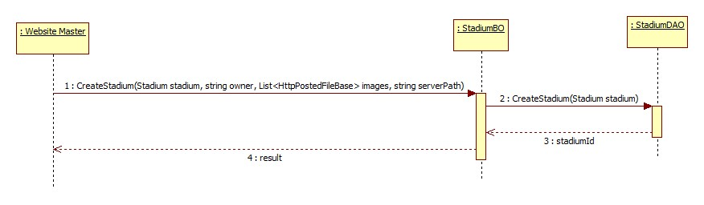

Figure 39: Create Stadium

#### Suggest Stadium

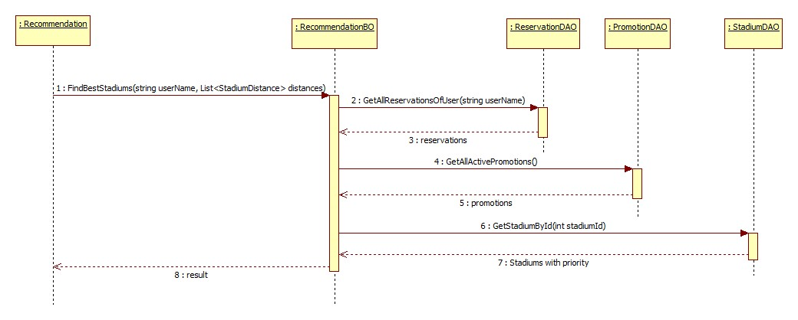

Figure 40: Suggest Stadium

#### Delete Member Rank

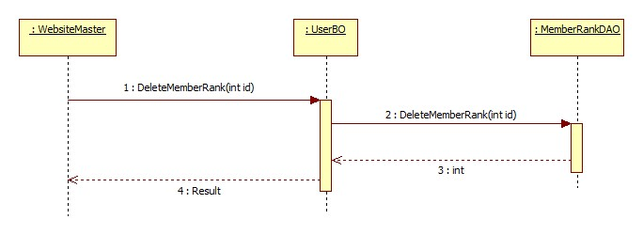

Figure 41: Delete Member Rank

#### Add Field To Stadium

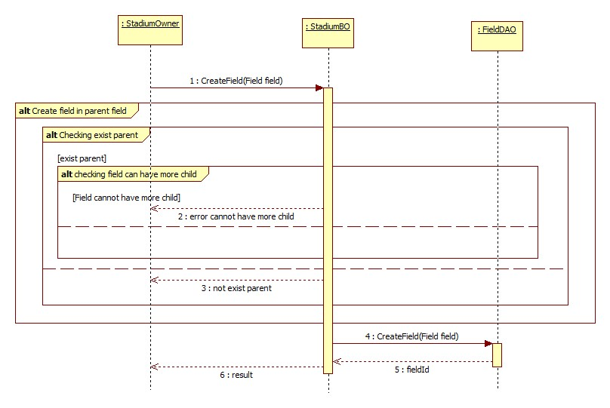

Figure 42: Create Field

#### Create Price Table

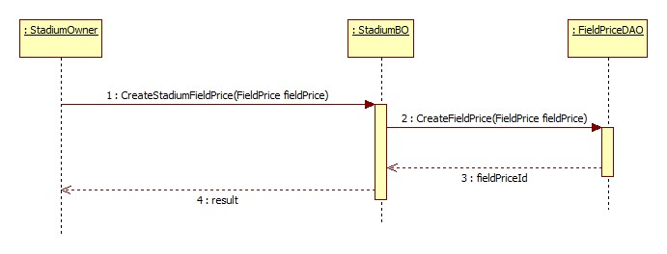

Figure 43: Create Price Table

#### Update Price Table

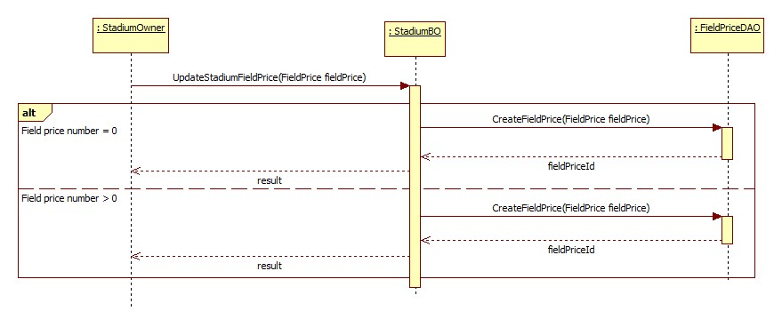

Figure 44: Update Price Table

#### Create Reservation

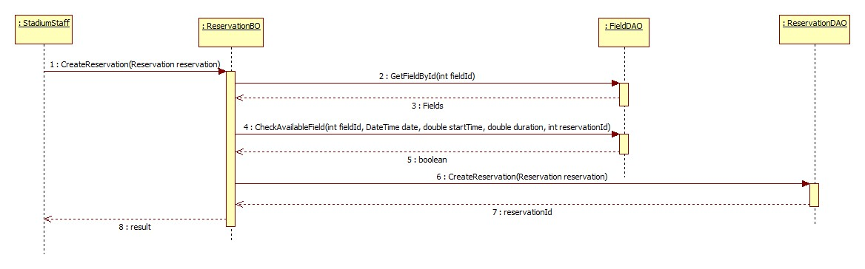

Figure 45: Create Reservation

#### Update Reservation

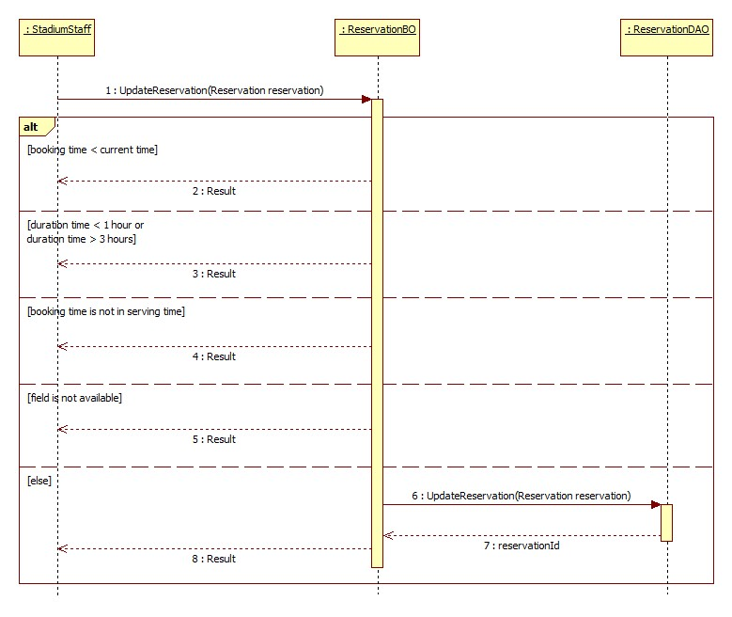

Figure 46: Update Reservation

#### Find Available Stadium

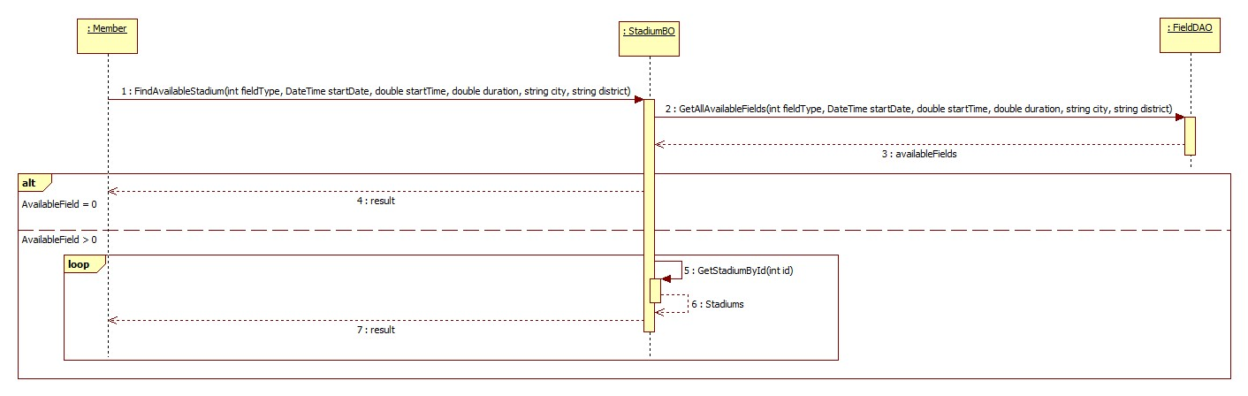

Figure 47: Find Available Stadium

#### Create Promotion

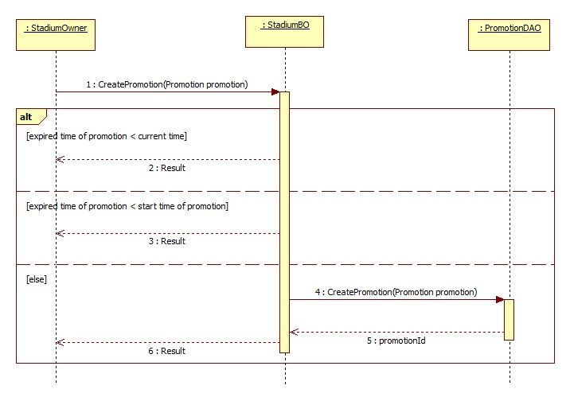

Figure 48: Create Promotion

#### Book Field

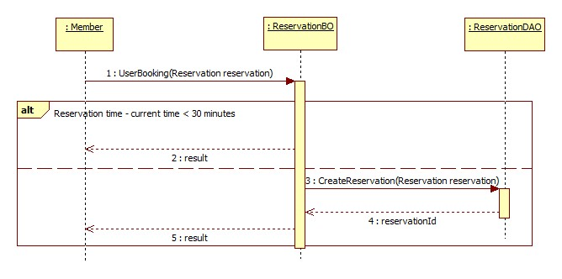

Figure 49: Book Field

#### Cancel Reservation

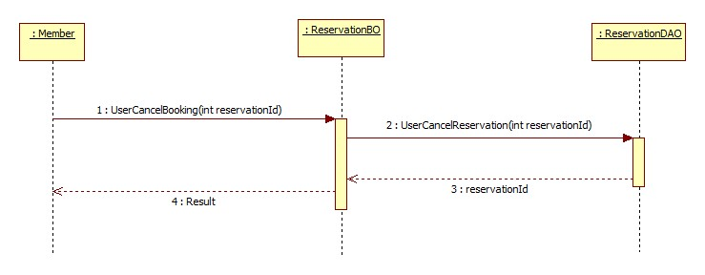

Figure 50: Cancel Reservaion

#### Find Rival

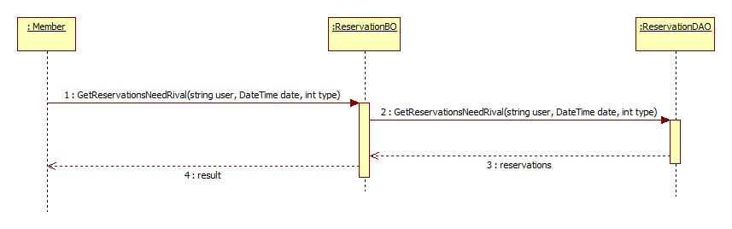

Figure 51: Find Rival

#### Join Match

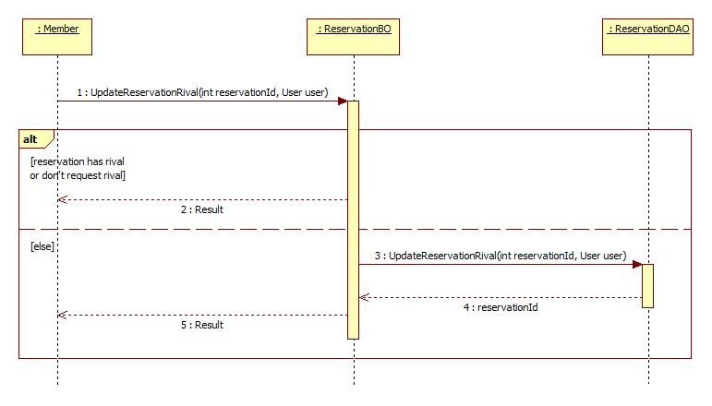

Figure 52: Join Match

#### Reference Sequence Diagrams

The following sequences diagram is referenced to: Link

* View Booking History
* Rate Stadium
* Review Stadium
* Update Account Profile
* Feedback Website
* Request Join System
* Update Stadium
* Update Configuration
* Suggest Rival
* View Stadiums
* Create Member Rank
* Update Member Rank
* View Member Ranks
* Create Advertising
* Update Advertising
* Delete Advertising
* View Advertisings
* Punish User
* Update User
* View Users
* Update Stadium Profile
* Update Field
* View Fields
* Approve Reservation
* Decline Reservation
* View Reservations
* Update Promotion
* View Promotions
* Find Stadium
* View Stadium Detail

### User Interface Design/ Hardware Interface Design (if any)

Update Later

### Database Design

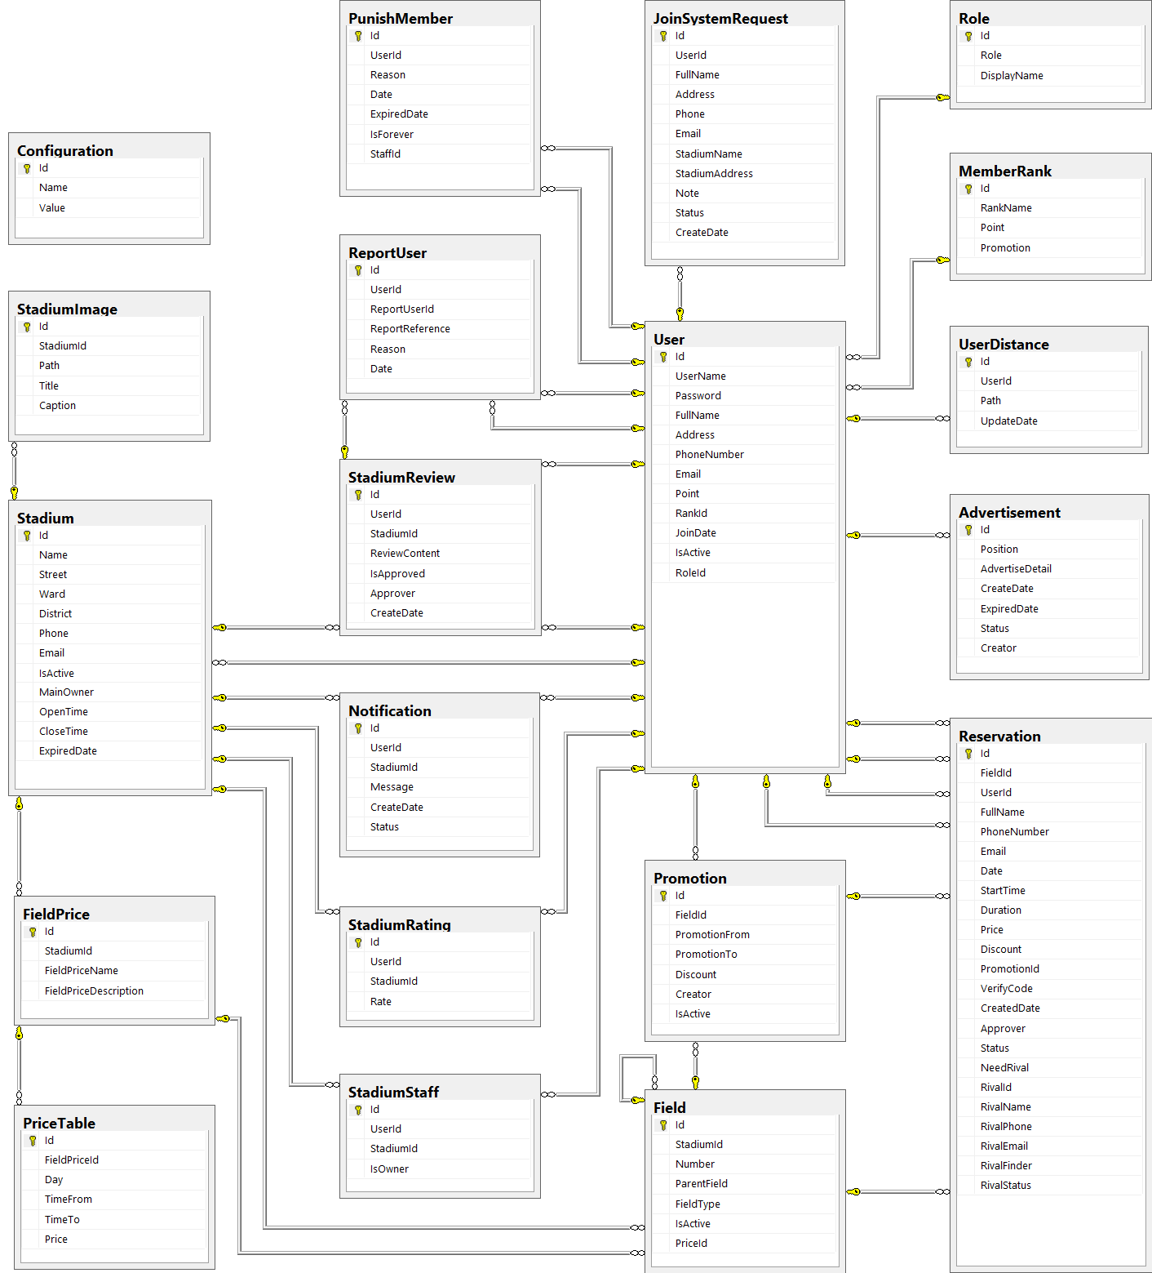

Figure 53: Database Diagram

#### Tables description

|  |  |  |
| --- | --- | --- |
| No. | Table name | Description |
| 1 | Advertisement | Store information about advertising of website |
| 2 | Field | Store information about fields in system |
| 3 | FieldPrice | Store information about price of fields in system |
| 4 | JoinSystemRequest | Store information about join system requests in system |
| 5 | MemberRank | Store information about rank of member in system |
| 6 | Promotion | Store information about promotions of stadiums in system |
| 7 | Reservation | Store information about reservations of stadiums in system |
| 8 | Role | Store information about roles of user in system |
| 9 | Stadium | Store information about stadiums in system |
| 10 | StadiumImage | Store information about images of stadiums in system |
| 11 | StadiumRating | Store information about rating of stadiums in system |
| 12 | StadiumReview | Store information about reviews of stadiums in system |
| 13 | StadiumStaff | Store information about staffs of stadiums in system |
| 14 | User | Store information about users in system |

#### Advertisement

|  |  |  |  |  |  |  |
| --- | --- | --- | --- | --- | --- | --- |
| Field name | Type | Null | Unique | P/F key | Default | Description |
| Id | int |  |  | PK |  | The index of this advertising |
| Position | nvarchar(10) |  |  |  |  | The position to display of the advertising |
| AdvertiseDetail | ntext |  |  |  |  | The content of this advertising |
| CreateDate | date |  |  |  |  | The date when this advertising is created |
| ExpiredDate | date |  |  |  |  | The date when this advertising is expired |
| Status | nvarchar(50) |  |  |  |  | The status of this advertising |
| Creator | int | true |  | FK |  | The creator who is created this advertising |

#### Field

|  |  |  |  |  |  |  |
| --- | --- | --- | --- | --- | --- | --- |
| Field name | Type | Null | Unique | P/F key | Default | Description |
| Id | int |  |  | PK |  | The index of this field |
| StadiumId | int |  |  | FK |  | The index of stadium which contain this field |
| Number | nvarchar(5) |  |  |  |  | The number of this field |
| ParentField | int | true |  | FK |  | The index of field which is parent of this field |
| FieldType | int |  |  |  |  | The type of this field |
| IsActive | bit | true |  |  |  | The status of this field |

#### FieldPrice

|  |  |  |  |  |  |  |
| --- | --- | --- | --- | --- | --- | --- |
| Field name | Type | Null | Unique | P/F key | Default | Description |
| Id | int |  |  | PK |  | The index of price of field |
| FieldId | int |  |  | FK |  | The index of field |
| TimeFrom | float |  |  |  |  | The price of field begin from this time |
| TimeTo | float |  |  |  |  | The price of field end from this time |
| Price | float |  |  |  |  | The price of field |
| Day | int |  |  |  |  | The price of fiend in this day |

#### JoinSystemRequest

|  |  |  |  |  |  |  |
| --- | --- | --- | --- | --- | --- | --- |
| Field name | Type | Null | Unique | P/F key | Default | Description |
| Id | int |  |  | PK |  | The index of this join system request |
| UserId | int |  |  | FK |  | The user who send this join system request |
| FullName | nvarchar(50) |  |  |  |  | The full name of user who send this join system request |
| Address | nvarchar(100) |  |  |  |  | The address of user who send this join system request |
| Phone | nvarchar(20) |  |  |  |  | The phone number of user who send this join system request |
| Email | nvarchar(50) |  |  |  |  | The email of user who send this join system request |
| StadiumName | nvarchar(100) |  |  |  |  | The name of stadium which is user want to join system |
| StadiumAddress | nvarchar(100) |  |  |  |  | The address of stadium which is user want to join system |
| Note | nvarchar(1000) | true |  |  |  | The note of this request |
| Status | nvarchar(50) |  |  |  |  | The status of this request |
| CreateDate | datetime |  |  |  |  | The date when this request is created |

#### MemberRank

|  |  |  |  |  |  |  |
| --- | --- | --- | --- | --- | --- | --- |
| Field name | Type | Null | Unique | P/F key | Default | Description |
| Id | int |  |  | PK |  | The index of this rank |
| RankName | nvarchar(50) | true |  |  |  | The name of this rank |
| Point | int | true |  |  |  | This point is condition to have this user rank |
| Promotion | nvarchar(500) | true |  |  |  | The promotion for user who have this rank |

#### Promotion

|  |  |  |  |  |  |  |
| --- | --- | --- | --- | --- | --- | --- |
| Field name | Type | Null | Unique | P/F key | Default | Description |
| Id | int |  |  | PK |  | The index of this promotion |
| FieldId | int |  |  | FK |  | The index of field which this promotion apply |
| PromotionFrom | date |  |  |  |  | The time when this promotion is started |
| PromotionTo | date |  |  |  |  | The time when this promotion is finished |
| Discount | float |  |  |  |  | The discount per cent of this promotion |
| Creator | int | true |  |  |  | The creator who is created this promotion |
| IsActive | bit | true |  |  |  | The status of this promotion |

#### Reservation

|  |  |  |  |  |  |  |
| --- | --- | --- | --- | --- | --- | --- |
| Field name | Type | Null | Unique | P/F key | Default | Description |
| Id | int |  |  | PK |  | The index of this reservation |
| FieldId | int |  |  | FK |  | The index of field is booked |
| UserId | int | true |  | FK |  | The index of user who book the field |
| FullName | nvarchar(50) |  |  |  |  | The full name of user who book the field |
| PhoneNumber | nvarchar(20) |  |  |  |  | The phone number of user who book the field |
| Email | nvarchar(50) | true |  |  |  | The email of user who book the field |
| Date | date |  |  |  |  | The date that is booked the field |
| StartTime | float |  |  |  |  | The start time when user need the field |
| Duration | float |  |  |  |  | The duration time that user need the field |
| Price | float |  |  |  |  | The price of field |
| Discount | float | true |  |  |  | The discount per cent of the promotion is applied to this reservation |
| PromotionId | int | true |  |  |  | The index of the promotion is applied to this reservation |
| VerifyCode | nvarchar(50) |  |  |  |  | The code which use for verifying this reservation |
| CreatedDate | datetime |  |  |  |  | The date when this reservation is created |
| Approver | int | true |  | FK |  | The index of stadium staff who approve this reservation |
| Status | nvarchar(20) |  |  |  |  | The status about approving of this reservation |
| HasRival | bit |  |  |  |  | The status about having rival of this reservation |
| RivalId | int | true |  | FK |  | The index of rival who join this request rival of this reservation |
| RivalName | nvarchar(50) | true |  |  |  | The name of rival who join this request rival of this reservation |
| RivalPhone | nvarchar(20) | true |  |  |  | The phone number of rival who join this request rival of this reservation |
| RivalEmail | nvarchar(50) | true |  |  |  | The email of rival who join this request rival of this reservation |
| RivalFinder | int | true |  |  |  | The index of user who find rival for this request rival of this reservation |

#### Role

|  |  |  |  |  |  |  |  |  |  |  |  |  |
| --- | --- | --- | --- | --- | --- | --- | --- | --- | --- | --- | --- | --- |
| Field name | Type | | Null | | Unique | | P/F key | | Default | | Description | |
| Id | | int | |  | |  | | PK, FK | |  | | The index of this role |
| Role | | nvarchar(50) | |  | |  | |  | |  | | The name of this role |

#### Stadium

|  |  |  |  |  |  |  |
| --- | --- | --- | --- | --- | --- | --- |
| Field name | Type | Null | Unique | P/F key | Default | Description |
| Id | int |  |  | PK |  | The index of this stadium |
| Name | nvarchar(100) |  |  |  |  | The name of this stadium |
| Street | nvarchar(50) |  |  |  |  | The street address of this stadium |
| Ward | nvarchar(50) |  |  |  |  | The ward address of this stadium |
| District | nvarchar(50) |  |  |  |  | The district address of this stadium |
| City | nvarchar(50) |  |  |  |  | The city address of this stadium |
| Description | nvarchar(500) |  |  |  |  | The description about this stadium |
| Phone | nvarchar(20) |  |  |  |  | The phone number to contact with this stadium staff |
| Email | nvarchar(50) |  |  |  |  | The email to contact with this stadium staff |
| IsActive | bit | true |  |  |  | The status of this stadium |

#### StadiumImage

|  |  |  |  |  |  |  |
| --- | --- | --- | --- | --- | --- | --- |
| Field name | Type | Null | Unique | P/F key | Default | Description |
| Id | int |  |  | PK |  | The index of this image |
| StadiumId | int |  |  | FK |  | The index of stadium which the image about |
| Path | nvarchar(100) |  |  |  |  | The path of this image store in server |
| Title | nvarchar(100) | true |  |  |  | The title of this image |
| Caption | nvarchar(200) | true |  |  |  | The caption of this image |

#### StadiumRating

|  |  |  |  |  |  |  |
| --- | --- | --- | --- | --- | --- | --- |
| Field name | Type | Null | Unique | P/F key | Default | Description |
| Id | int |  |  | PK |  | The index of this rating |
| UserId | int |  |  | FK |  | The index of user who rate the stadium |
| StadiumId | int |  |  | FK |  | The index of stadium which is rated |
| Rate | float |  |  |  |  | The point of this rating |

#### StadiumReview

|  |  |  |  |  |  |  |  |  |  |  |  |  |
| --- | --- | --- | --- | --- | --- | --- | --- | --- | --- | --- | --- | --- |
| Field name | Type | | | Null | | Unique | | P/F key | | Default | | Description |
| Id | | int |  | |  | | PK | |  | | The index of this review | |
| UserId | | int |  | |  | | FK | |  | | The index of user who review the stadium | |
| StadiumId | | int |  | |  | | FK | |  | | The index of stadium which is reviewed | |
| ReviewContent | | nvarchar(500) |  | |  | |  | |  | | The content of this review | |
| IsApproved | | bit |  | |  | |  | |  | | The status about approving of this review | |
| Approver | | int | true | |  | | FK | |  | | The index of stadium staff who approve this review | |
| CreateDate | | datetime |  | |  | |  | |  | | The date when this review is created | |

#### StadiumStaff

|  |  |  |  |  |  |  |  |  |  |  |  |  |
| --- | --- | --- | --- | --- | --- | --- | --- | --- | --- | --- | --- | --- |
| Field name | Type | | Null | | Unique | | P/F key | | Default | | Description | |
| Id | | int | |  | |  | | PK | |  | | The index of this stadium staff |
| UserId | | int | |  | |  | | FK | |  | | The index of user who is staff of stadium |
| StadiumId | | int | |  | |  | | FK | |  | | The index of stadium |
| IsOwner | | bit | |  | |  | |  | |  | | The role of this staff |

#### User

|  |  |  |  |  |  |  |
| --- | --- | --- | --- | --- | --- | --- |
| Field name | Type | Null | Unique | P/F key | Default | Description |
| Id | int |  |  | PK |  | The index of this user |
| UserName | nvarchar(50) |  |  |  |  | The user name of this user |
| Password | nvarchar(50) |  |  |  |  | The password of this user |
| FullName | nvarchar(50) | true |  |  |  | The full name of this user |
| Address | nvarchar(100) | true |  |  |  | The address of this user |
| PhoneNumber | nvarchar(20) | true |  |  |  | The phone number of this user |
| Email | nvarchar(50) |  |  |  |  | The email of this user |
| Point | int |  |  |  |  | The point of this user |
| RankId | int |  |  | FK |  | The index of rank of this user |
| IsReceivedReward | bit |  |  |  |  | The status about receiving reward of this user |
| JoinDate | date |  |  |  |  | The date when user register at website |
| IsActive | bit |  |  |  |  | The status of this user |
| RoleId | int |  |  |  |  | The index of role of this user |

### Algorithm Of Business Intelligence

#### Overview:

This automatic function helps system to suggest stadium or rival when users login. It makes the website becomes more friendly and convenience for user. We apply Google API to calculate the distance from user’s address to stadium’s address, storage the reservation history of user to understand their habits, and get the promoted information of stadium to give user best advices.

Therefore we use three norms to recommend the stadium for user:

* Most booked stadium
* The nearest stadium
* Stadium which is discounted

#### Implement:

* User logins system
* System gets the reservation history of this user, all the available promoted stadiums and the distance from user to each stadium.
* Each recommended stadium is calculated by three norms: the stadium which is most booked, the stadium which is nearest to user’s address and the most discount stadium.
* System calculates the priority of each norms and combines it into final priority to decide the order of stadium which is displayed on Homepage.
* Homepage has 4 categories of stadium: The best stadium (balance rate of priority), most booked stadium(highest priority rate for the most booked stadium), most nearest stadium (highest priority rate for the nearest stadium), and most discount stadium (highest priority rate for the most discounted stadium).
* The best stadium, most booked stadium, most nearest stadium, and most discount stadium have the same method to be suggested but they have the difference value of priority rate.
* For example, Most Booked Stadium is suggested by: the highest priority rate for most booked stadium (60 percent), the lower priority rate for near stadium (20 percent) and discounted stadium (20 percent).
* In addition, the value of priority rate is able to be changed. It depend on taste of customer. If they interest more about near stadium, website master can raise the rate of nearest stadium priority, and decrease the others dow.

Beside that we apply the same way to suggest rival for player who wants to find competitors or have not enough players for a match.

Suggest Stadium

The Best Stadium

The Nearest Stadium

The Most

Booked Stadium

The Most

Discounted Stadium

Nearest priority

Most booked

priority

Most discounted

priority

Nearest priority

Most booked

priority

Most discounted

priority

Nearest priority

Most booked

priority

Most discounted

priority

Nearest priority

Most booked

priority

Most discounted

priority

Figure 54: Stadium Suggestion

#### Algorithm

**Most Booked Stadium Point (MBSP):**

* Get all reservation, we assume number of stadiums were booked
* Reduced Point = 10 / number of stadiums were booked
* Stadium with max reservation: set 10 mark
* Next Stadium mark =

10 – [(Max reservation number – Next reservation number) x Reduced Point]

* Calculate to the end of booked stadiums list
* We have mark of each booked stadium

**Most Discounted Stadium Point(MDSP):**

* Get all available promoted stadium, assume number of stadium are being discounted
* Reduced Point = 10 / number of stadium are being discounted.
* Stadium with the highest discount: set 10 mark
* Next Stadium mark =

10 – [(highest discount amount – next discount amount) x Reduced Point]

* Calculate to the end of the discounted stadiums list.
* We have mark of each promoted satdium

**Nearest Priority Stadium Point(NPSP):**

* Distance from user’s address to stadium < 2km: set 10 mark
* Distance from user’s address to stadium < 4km: set 9 mark
* Distance from user’s address to stadium < 8km: set 8 mark
* ….
* Distance from user’s address to stadium out of 20 km: 0 mark

We have mark of each stadium near user’s address

**Summarise:**

* Most booked priority: **MostBooked**
* Most discount priority: **MostPromoted**
* Distance priority: **Nearest**

Final priority of each stadium =

(**MostBooked** x **MBSP) + (MostPromoted** x **MDSP)** + (**Nearest** x **NPSP)**

Note: Value of MostBooked, MostPromoted and Nearest is store in Tbl.Configuration. It’s able to change.

Result: The stadium with the highest priority is display firstly in each category on Home page.

## System Implementation & Test (SIT)

### Introduction

#### System Overview

This document describes the approach and methodologies used by the testing group to plan, organize and manage the testing of this system. It describes implementation details of test cases or technical details of how the product features should work.

The system will be tested is also the system our team are currently developing. This system developed based on MVC4 framework.

#### Test Approach

* Test goals: the testing aims to identify the remaining bugs in the system before releasing and confirm the consistency in design and implementation.
* Test type: black box testing.
* Test level: system and integration test.

### Test Plan

The purpose of this section is to verify and ensure that BUSG meets its design specification and other requirements from user. The following part will describe which features will be tested and which will not.

#### Functions

##### Role ‘Website Master’

Test all functions of role ‘Website Master’ including:

* Stadium Management
* User Management
* Advertise Management
* Request Join System Management

##### Role ‘Stadium Owner’

* Field Management
* Stadium Management
* Promotion Management
* Reservation Management

##### Role ‘Member’

* Account Management
* Feedback Management
* Find
* Booking Field Management

#### Features not to be tested

##### Performance test

There was not enough time so we cannot optimize source code and improve performance. We can only ensure the system work well but not at its best performance.

##### Testing Tools and Environment

* Windows 7 operating system
* Google Chrome 19 or higher
* Microsoft Visual Studio 2012
* Microsoft SQL Server 2008 R2

### Test Cases

#### Role ‘Website Master’

##### Stadium Managements

|  |  |  |  |  |  |
| --- | --- | --- | --- | --- | --- |
| **Test case No** | **Test case** | **Input** | **Expected Result** | **Status** | **Note** |
| **View Stadium Management** | | | | | |
| TC_1 | Test View Stadium List | 1. Login the system as WebsiteMaster. 2. Click “Quản trị website” link 3. Click " Sân bóng" link | “ Quản lý sân bóng “ page is displayed with the following informations:  - Image of Stadium - Tên sân bóng - Địa chỉ - Số điện thoại - Đánh giá  - “ Đặt sân “ buttons | Tested |  |
| **Create Stadium** | | | | | |
| TC_2 | Test View Create Stadium Form | 1. Login the system as WebsiteMaster. 2. Click “Quản trị website" link 3. Click " Sân bóng" link  4. Click “ Thêm sân mới “ button | “ Thêm sân bóng “ page is displayed with the following field: - Tên sân bóng - Chủ sân  - Ngày hết hạn - Số điện thoại  - Email - Đường, phường , quận  - Hình ảnh sân  - Giờ hoạt động  - Thêm hình ảnh sân  - Trạng thái hoạt động  - “ Lưu “ button & “ Hủy bỏ “ button | Tested |  |
| TC_3 | Test Create Stadium Successfully | 1. Insert stadium's information 2. Click "Lưu" button | Display success message Redirect to “ Quản lý sân bóng “ page | Tested |  |
| TC_4 | Test Create Stadium With Blank Field | 1. Insert stadium's information 2. Leave empty some fields 3. Click “ Lưu" button | Error message will be displayed : “ Xin hãy điền đầy đủ những thông tin bắt buộc “ | Tested |  |
| TC_5 | Test Cancel Create Stadium | 1. Insert stadium's information 2. Click "Hủy bỏ" button | Confirm discard all recent activity is displayed Redirect to “ Quản lý sân bóng “ page | Tested |  |
| **Edit Stadium** | | | | | |
| TC_6 | Test View Edit Stadium Form | 1. Login the system as WebsiteMaster. 2. Click “Quản trị website" link 3. Click " Sân bóng" link  4. Click “ Chỉnh sửa “ button | “ Chỉnh sửa thông tin sân bóng “ page is displayed with the following field: - Tên sân bóng - Chủ sân  - Ngày hết hạn - Số điện thoại  - Email - - Đường, phường , quận  - Hình ảnh sân  - Giờ hoạt động  - Thêm hình ảnh sân  - Trạng thái hoạt động  - “ Lưu “ button & “ Hủy bỏ “ button | Tested |  |
| TC_7 | Test Edit Stadium Successfully | 1. Insert stadium's information 2. Click “ Lưu " button | Display success message Redirect to “ Quản lý sân bóng “ page | Tested |  |
| TC_8 | Test Edit Stadium With Blank Field | 1. Insert stadium's information  2. Leave empty some fields  3. Click "Lưu" button | Error message will be displayed : “ Xin hãy điền đầy đủ những thông tin bắt buộc “ | Tested |  |
| TC_9 | Test Cancel Edit Stadium | 1. Insert stadium's information  2. Click "Hủy" button | Confirm discard all recent activity is displayed Redirect to “ Quản lý sân bóng “ page | Tested |  |
| **Update Stadium Status** | | | | | |
| TC_10 | Test Active Stadium | 1. Login the system as WebsiteMaster. 2. Click “Quản trị website" link 3. Click " Sân bóng" link  4. Click “ Chỉnh sửa “ button  5. Choose “ Đang hoạt động “ in “ Trạng thái hoạt động “ drop down list of the stadium which will be active  6. Click “ Lưu “ button | New message will be displayed : “ Cập nhật thành công “  The Stadium status changes from deactive to active | Tested |  |
| TC_11 | Test Deactive Stadium | 1. Login the system as WebsiteMaster. 2. Click “Quản trị website " link 3. Click " Sân bóng" link  4. Click “ Chỉnh sửa “ button  5. Choose “ Không hoạt động “ in “ Trạng thái hoạt động “ drop down list of the stadium which will be active  6. Click “ Lưu “ button | New message will be displayed : “ Cập nhật thành công “  The Stadium status changes from deactive to active | Tested |  |

##### User Managements

|  |  |  |  |  |  |
| --- | --- | --- | --- | --- | --- |
| **Test case No** | **Test case** | **Input** | **Expected Result** | **Status** | **Note** |
| **View User Management** | | | | | |
| TC_12 | Test View User List | 1. Login the system as WebsiteMaster. 2. Click “Quản trị website" link 3. Click "Thành Viên" link | “ Quản lý thành viên “ page is displayed with the following informations: - Thành viên - Tên đầy đủ - Địa chỉ  - Email  - Quyền hạn  - “ Tìm kiếm “ textbox  - “ Tìm kiếm “ button & “ Xem tất cả “ button | Tested |  |
| **Update User's Profile** | | | | | |
| TC_13 | Test View Update User's Profile Form | 1. Login the system as WebsiteMaster. 2. Click “Quản trị website" link 3. Click "Thành Viên" link  4. Click user which will be edited | “ Chỉnh sửa thông tin thành viên “ page is displayed with the following informations: - Tên đăng nhập - Tên thành viên  - Địa chỉ  - Số điện thoại - “ Email “ textbox  - “ Mật khẩu “ textbox & “ Xác nhận mật khẩu “ textbox  - Point  - “ Trạng thái hoạt động “ drop down list  - “ Quyền hạn “ drop down list  - “ Lưu “ button & “ Hủy bỏ “ button | Tested |  |
| TC_14 | Test Update User's Profile Successfully | 1. Insert new User's information 2. Click "Lưu" button | Update Successfully Redirect to “ Quản lý thành viên “ page | Tested |  |
| TC_15 | Test Update User's Profile With Blank Field | 1. Insert new User's information  2. Leave empty some fields 3. Click "Lưu" button | Error message will be displayed : “ Xin hãy điền đầy đủ những thông tin bắt buộc “ | Tested |  |
| TC_16 | Test Cancel Update User's Profile | 1. Insert new User's information 2. Click "Hủy" button | Confirm discard all recent activity is displayed Redirect to “ Quản lý thành viên “ page | Tested |  |

#### Role ‘Stadium Owner’

##### Field Managements

|  |  |  |  |  |  |
| --- | --- | --- | --- | --- | --- |
| **Test case No** | **Test case** | **Input** | **Expected Result** | **Status** | **Note** |
| **View List Fields** | | | | | |
| TC_17 | Test viewing "Quản lý sân con" list | 1. Login the system as StadiumOwner  2. Click "Quản lý sân bóng" link  3. Click “ Sân bóng “ link  4. Click " Sân con" button | "Quản lý sân con" page is displayed as list with the following informations:  - “ Tên sân“ - “ Kiểu sân“  - “ Tên sân cha“  - “ Trạng thái “  - “ Chỉnh sửa “ button & “ Thêm ssân con “ button & “ Bảng giá “ button | Tested |  |
| **Create Field** | | | | | |
| TC_18 | Test creating a field with blank fields | 1. Login the system as StadiumOwner  2. Click "Quản lý sân bóng" link  3. Click “ Sân bóng “ link  4. Click " Sân con" button  5. Click “ Thêm sân con “  6. Leave empty some fields  7. Click “ Lưu “ button | Error message will be displayed:  - " Bạn cần sử dụng mẫu nhập bên dưới để thêm đầy đủ thông tin vào sân bóng". | Tested |  |
| TC_19 | Test creating a field but don’t have price list | 1. Login the system as StadiumOwner  2. Click "Quản lý sân bóng" link  3. Click “ Sân bóng “ link  4. Click " Sân con" button  5. Click “ Thêm sân con “  6. Click “ Đây “ button | Error message will be displayed:  - " Bạn cần them bảng giá vào hệ thống trước khi thêm sân con vào hệ thống. Click vào ” “ Đây “ buton “ để đến trang them bảng giá".  - Redirect to “ Thêm bảng giá “ page | Tested |  |
| TC_20 | Test creating a field | 1. Login the system as StadiumOwner  2. Click "Quản lý sân bóng" link  3. Click “ Sân bóng “ link  4. Click " Sân con" button  5. Click “ Thêm sân con “  6. Input require information  7. Click "Lưu" button | Create successfully  Redirect to "Quản lý sân con" page with new "Sân con" is created | Tested |  |
| TC_21 | Test cancel creating action | 1. Login the system as StadiumOwner  2. Click "Quản lý sân bóng" link  3. Click “ Sân bóng “ link  4. Click " Sân con" button  5. Click “ Thêm sân con “  6. Click "Huỷ" button | Confirm discard all recent activity is displayed Redirect to “ Quản lý sân con “ page | Tested |  |
| **Update Field** | | | | | |
| TC_22 | Test updating a field with blank fields | 1. Login the system as StadiumOwner  2. Click "Quản lý sân bóng" link  3. Click “ Sân bóng “ link  4. Click " Sân con" button  5. Click “ Chính sửa “ button  6. Leave empty some fields  7. Click "Lưu" button | Error message will be displayed:  - " Bạn cần sử dụng mẫu nhập bên dưới để thêm đầy đủ thông tin vào sân bóng". | Tested |  |
| TC_23 | Test updating a field | 1. Login the system as StadiumOwner  2. Click "Quản lý sân bóng" link  3. Click “ Sân bóng “ link  4. Click " Sân con" button  5. Insert field's information  6. Click "Lưu" button | Update Successfully Redirect to “ Quản lý sân con “ page | Tested |  |
| TC_24 | Test cancel updating action | 1. Login the system as StadiumOwner  2. Click "Quản lý sân bóng" link  3. Click “ Sân bóng “ link  4. Click " Sân con" button  5. Click “ Chính sửa “ button  6. Click "Huỷ" button | Confirm discard all recent activity is displayed Redirect to “ Quản lý sân con “ page | Tested |  |
| TC_25 | Test active a field | 1. Login the system as StadiumOwner  2. Click "Quản lý sân bóng" link  3. Click “ Sân bóng “ link  4. Click " Sân con" button  5. Click “ Chính sửa “ button  6. Choose “ Đang hoạt động “ in “ Trạng thái hoạt động “ drop down list of the advertising which will be active  7. Click "Lưu" on button | New message will be displayed : “ Cập nhật thành công “  The Field status changes from deactive to active | Tested |  |
| TC_26 | Test deactive a field | 1. Login the system as StadiumOwner  2. Click "Quản lý sân bóng" link  3. Click “ Sân bóng “ link  4. Click " Sân con" button  5. Click “ Chính sửa “ button  6. Choose “Không hoạt động “ in “ Trạng thái hoạt động “ drop down list of the advertising which will be deactive  7. Click "Lưu" button | New message will be displayed : “ Cập nhật thành công “  The Fields atus changes from active to deactive | Tested |  |

##### Promotion Managements

|  |  |  |  |  |  |
| --- | --- | --- | --- | --- | --- |
| **Test case No** | **Test case** | **Input** | **Expected Result** | **Status** | **Note** |
| **View List Promotions** | | | | | |
| TC_27 | Test viewing Promotion Management pagepage | 1. Login the system as StadiumOwner  2. Click "Quản lý sân bóng" link  3. Click “ Khuyến mãi" link  4. Click stadium you want to view promotion | "Quản lý khuyến mãi" page is displayed as list with the following informations:  - Số sân  - Thời gian khuyến mãi  - Giảm giá  - Trạng thái hoạt động  - “ Thêm khuyến mãi “ button & “ Chỉnh sửa “ button | Tested |  |
| **Create Promotion** | | | | | |
| TC_28 | Test creating a promotion with blank fields | 1. Login the system as StadiumOwner  2. Click "Quản lý sân bóng" link  3. Click “ Khuyến mãi" link  4. Click stadium you want to view promotion  5. Click "Thêm khuyến mãi" button  6. Leave empty some fields  7. Click "Lưu" button | Error message will be displayed:  - "Xin vui lòng chọn thời gian khuyến mãi  - “ Xin nhập và số ưu đãi giảm giá". | Tested |  |
| TC_29 | Test creating a promotion with "Thời gian kết thúc" is over | 1. Login the system as StadiumOwner  2. Click "Quản lý sân bóng" link  3. Click “ Khuyến mãi" link  4. Click stadium you want to view promotion  5. Click"Thêm khuyến mãi" button  6. Input require information  - Select "1" in "Số sân" field  - Input "05/03/2014" into "Thời gian bắt đầu"  - Input "06/03/2014" into "Thời gian kết thúc" field  - Input "10" into "Giảm giá (%)" field  7. Click "Lưu" button | Error message will be displayed:  - "Thời gian khuyến mãi đã kết thúc, xin vui lòng chọn thời gian kết thúc khác". | Tested |  |
| TC_30 | Test creating a promotion with "Thời gian kết thúc" before "Thời gian bắt đầu" | 1. Login the system as StadiumOwner  2. Click "Quản lý sân bóng" link  3. Click “ Khuyến mãi" link  4. Click stadium you want to view promotion  5. Click "Thêm khuyến mãi" button  6. Input require information  - Select "1" in "Số sân" field  - Input "25/03/2014" into "Thời gian bắt đầu" field  - Input "20/03/2014" into "Thời gian kết thúc" field  - Input "10" into "Giảm giá (%)" field  7. Click"Lưu" button | Error message will be displayed:  - "Thời gian khuyến mãi không đúng, vui lòng chọn thời gian khác". | Tested |  |
| TC_31 | Test creating a promotion with "Giảm giá (%)" is not a number | 1. Login the system as StadiumOwner  2. Click "Quản lý sân bóng" link  3. Click “ Khuyến mãi" link  4. Click stadium you want to view promotion  5. Click "Thêm khuyến mãi" button  6. Input require information  - Select "1" in "Số sân" field  - Input "11/11/2014" into "Thời gian bắt đầu" field  - Input "12/12/2014" into "Thời gian kết thúc" field  - Input "12a" into "Giảm giá (%)" field  7.Click"Lưu" button | Error message will be displayed:  - "Giá trị giảm giá không chính xác, vui lòng nhập lại". | Tested |  |
| TC_32 | Test creating a promotion with "Giảm giá (%)" is not in a space | 1. Login the system as StadiumOwner  2. Go to "Quản lý sân bóng" page  3. Click “ Khuyến mãi" link  4. Click stadium you want to view promotion  5. Click "Thêm khuyến mãi" button  6. Input require information  - Select "1" in "Số sân" field  - Input "11/11/2014" into "Thời gian bắt đầu" field  - Input "12/12/2014" into "Thời gian kết thúc" field  - Input "500" into "Giảm giá (%)" field  7.Click "Lưu" button | Error message will be displayed:  - "Yêu cầu giảm giá nằm trong khoảng 0 đến 100". | Tested |  |
| TC_33 | Test creating a promotion | 1. Login the system as StadiumOwner  2. Click "Quản lý sân bóng" link  3. Click “ Khuyến mãi" link  4. Click stadium you want to view promotion  5. Click "Thêm khuyến mãi" button  6. Input require information  - Select "1" in "Số sân" field  - Input "11/11/2014" into "Thời gian bắt đầu" field  - Input "12/12/2014" into "Thời gian kết thúc" field  - Input "10" into "Giảm giá (%)" field  7. Click "Lưu" button | Create successfully  Redirect to "Quản lý khuyến mãi" page with new "Khuyến mãi" is created | Tested |  |
| TC_34 | Test cancel creating action | 1. Login the system as StadiumOwner  2. Click "Quản lý sân bóng" link  3. Click “ Khuyến mãi" link  4. Click stadium you want to view promotion  5. Click "Thêm khuyến mãi" button  6. Click "Huỷ bỏ" button | Confirm discard all recent activity is displayed Redirect to “ Quản lý khuyến mãi “ page | Tested |  |
| Update Promotion | | | | | |
| TC_35 | Test updating a promotion with blank fields | 1. Login the system as StadiumOwner  2. Click "Quản lý sân bóng" link  3. Click “ Khuyến mãi" link  4. Click stadium you want to view promotion  5. Click "Chỉnh sửa" link on a row  6. Leave empty some fields  7. Click "Lưu" button | Error message will be displayed:  - "Xin vui lòng chọn thời gian khuyến mãi  - “ Xin nhập và số ưu đãi giảm giá". | Tested |  |
| TC_36 | Test updating a promotion with "Thời gian kết thúc" is over | 1. Login the system as StadiumOwner  2. Click "Quản lý sân bóng" link  3. Click “ Khuyến mãi" link  4. Click stadium you want to view promotion  5. Click "Chỉnh sửa" button  6. Input require information  - Select "1" in "Số sân" field  - Input "05/03/2014" into "Thời gian bắt đầu"  - Input "06/03/2014" into "Thời gian kết thúc" field  - Input "10" into "Giảm giá (%)" field  7. Click "Lưu" button | Error message will be displayed:  - "Thời gian khuyến mãi đã kết thúc, xin vui lòng chọn thời gian kết thúc khác". | Tested |  |
| TC_37 | Test updating a promotion with "Thời gian kết thúc" before "Thời gian bắt đầu" | 1. Login the system as StadiumOwner  2. Click "Quản lý sân bóng" link  3. Click “ Khuyến mãi" link  4. Click stadium you want to view promotion  5. Click "Chỉnh sửa" button  6. Input require information  - Select "1" in "Số sân" field  - Input "25/03/2014" into "Thời gian bắt đầu" field  - Input "20/03/2014" into "Thời gian kết thúc" field  - Input "10" into "Giảm giá (%)" field  7. Click"Lưu" button | Error message will be displayed:  - "Thời gian khuyến mãi không đúng, vui lòng chọn thời gian khác". | Tested |  |
| TC_38 | Test updating a promotion with "Giảm giá (%)" is not a number | 1. Login the system as StadiumOwner  2. Click "Quản lý sân bóng" link  3. Click “ Khuyến mãi" link  4. Click stadium you want to view promotion  5. Click "Chỉnh sửa" button  6. Input require information  - Input "12a" into "Giảm giá (%)" field  7.Click"Lưu" button | Error message will be displayed:  - "Giá trị giảm giá không chính xác, vui lòng nhập lại". | Tested |  |
| TC_39 | Test creating a promotion with "Giảm giá (%)" is not in a space | 1. Login the system as StadiumOwner  2. Click "Quản lý sân bóng" link  3. Click “ Khuyến mãi" link  4. Click stadium you want to view promotion  5. Click "Chỉnh sửa “ button  6. Input require information  - Input "500" into "Giảm giá (%)" field  7.Click "Lưu" button | Error message will be displayed:  - "Yêu cầu giảm giá nằm trong khoảng 0 đến 100". | Tested |  |
| TC_40 | Test updating a promotion | 1. Login the system as StadiumOwner  2. Click "Quản lý sân bóng" link  3. Click “ Khuyến mãi" link  4. Click stadium you want to view promotion  5. Click "Chỉnh sửa" button  6. Input require information  - Change value to "2" in "Số sân" field  - Change value to "11/11/2014" in "Thời gian bắt đầu" field  - Change value to "12/12/2014" in "Thời gian kết thúc" field  - Change value to "20" in "Giảm giá (%)" field  7. Click "Lưu" button | Update successfully  Redirect to "Quản lý khuyến mãi" page with new "Khuyến mãi" is created | Untested |  |
| TC_41 | Test cancel updating action | 1. Login the system as StadiumOwner  2. Click "Quản lý sân bóng" link  3. Click “ Khuyến mãi" link  4. Click stadium you want to view promotion  5. Click "Chỉnh sửa" button  6. Click “ Hủy bỏ “ button | Confirm discard all recent activity is displayed Redirect to “ Quản lý khuyến mãi “ page | Tested |  |
| TC_42 | Test activating a promotion | 1. Login the system as StadiumOwner  2. Click "Quản lý sân bóng" link  3. Click “ Khuyến mãi" link  4. Click promotion you want to view promotion  5. Click "Chỉnh sửa" button  6. Choose “ Đang hoạt động “ in “ Trạng thái hoạt động “ drop down list of the promotion which will be active  7. Click"Lưu" button | New message will be displayed : “ Cập nhật thành công “  The Promotion status changes from deactive to active | Tested |  |
| TC_43 | Test deactivating a promotion | 1. Login the system as StadiumOwner  2. Click "Quản lý sân bóng" link  3. Click “ Khuyến mãi" link  4. Click stadium you want to view promotion  5. Click "Chỉnh sửa" button  6. Choose “ Đang hoạt động “ in “ Trạng thái hoạt động “ drop down list of the promotion which will be deactive  7. Click "Lưu" button | New message will be displayed : “ Cập nhật thành công “  The Promotion status changes from deactive to deactive | Tested |  |

##### Reservation Managements

|  |  |  |  |  |  |
| --- | --- | --- | --- | --- | --- |
| **Test case No** | **Test case** | **Input** | **Expected Result** | **Status** | **Note** |
| **View List Reservations** | | | | | |
| TC_44 | Test view Reservation Managements page | 1. Login the system as StadiumOwner  2. Click "Quản lý sân bóng" link  3. Click “ Đặt sân" link  4. Click stadium you want to view promotion | "Quản lý đơn đặt sân “ page is displayed as list with the following informations:  - "Tên khánh hàng"  - "Số điện thoại"  - "Số sân"  - "Thời gian đặt sân "  - "Thời lượng"  - "Trạng thái "  - “ Chi tiết “ button & “ Thêm đơn đặt sân “ button | Tested |  |
| **Create Reservation** | | | | | |
| TC_45 | Test creating a reservation with blank fields | 1. Login the system as StadiumOwner  2. Click "Quản lý sân bóng" link  3. Click “ Đặt sân" link  4. Click "Thêm đơn đặt sân" button  5. Leave empty some fields 6. Click "Lưu" button | Error message will be displayed:  - "Xin vui lòng chọn ngày đặt sân".  - "Xin vui lòng chọn giờ đặt sân".  - “ Yêu cầu từ 1 đến 30 kí tự “  - “ Yêu cầu phải nhập đúng số điện thoại “  - “ Email không đúng “ | Tested |  |
| TC_46 | Test creating a reservation with customer username is not existed | 1. Login the system as StadiumOwner  2. Click "Quản lý sân bóng" link  3. Click “ Đặt sân" link  4. Click "Thêm đơn đặt sân" button  5. Input require information  - Select "1" in "Số sân" field  - Input customer information  + Input "abc123" into "Khách hàng" field  + Input "ABCDEF" into "Tên đầy đủ" field  + Input "1234567890" into "Số điện thoại" field  + Input "abcdef@ghi.jk" into "Email" field  + Input "15/03/2014" into "Ngày đặt" field  + Input "16:30" in "Giờ đặt" field  + Input "1:30" "Thời lượng" field  + Choose “ Không” in "Đối thủ" drop down list  6. Click"Lưu" button | Error message will be displayed:  - "Tên khách hàng không tồn tại". | Tested |  |
| TC_47 | Test creating a reservation with blank customer username | 1. Login the system as StadiumOwner  2. Click "Quản lý sân bóng" link  3. Click “ Đặt sân" link  4. Click "Thêm đơn đặt sân" button  5. Input require information  - Select "1" in "Số sân" field  - Input customer information  + Input "ABCDEF" into "Tên đầy đủ" field  + Input "1234567890" into "Số điện thoại" field  + Input "abcdef@ghi.jk" into "Email" field  + Input "15/03/2014" into "Ngày đặt" field  + Input "16:30" in "Giờ đặt" field  + Input "1:30" "Thời lượng" field  + Choose “ Không” in "Đối thủ" drop down list  6. Click "Lưu" button | Redirect to "Quản lý đơn đặt sân “ page with new "Đơn đặt sân" created | Tested |  |
| TC_48 | Test creating a reservation with booking time is over | 1. Login the system as StadiumOwner  2. Click "Quản lý sân bóng" link  3. Click “ Đặt sân" link  4. Click "Thêm đơn đặt sân" button  5. Input require information  - Select "1" in "Số sân" field  - Input customer information  + Input "ABCDEF" into "Tên đầy đủ" field  + Input "1234567890" into "Số điện thoại" field  + Input "abcdef" into "Email" field  + Input "15/03/2014" into "Ngày đặt" field  + Input "16:30" in "Giờ đặt" field  + Input "1:30" "Thời lượng" field  + Choose “ Không” in "Đối thủ" drop down list  6. Click "Lưu" button | Error message will be displayed:  - "Thời gian đặt sân đã kết thúc, vui lòng chọn thời gian khác". | Tested |  |
| TC_49 | Test creating a reservation with check "Đối thủ" with blank rival information | 1. Login the system as StadiumStaff  2. Click "Quản lý sân bóng" link  3. Click “ Đặt sân" link  4. Click "Thêm đơn đặt sân" button  5. Input require information  - Select "1" in "Số sân" field  - Input customer information  + Input "ABCDEF" into "Tên đầy đủ" field  + Input "1234567890" into "Số điện thoại" field  + Input "abcdef" into "Email" field  + Input "15/03/2014" into "Ngày đặt" field  + Input "16:30" in "Giờ đặt" field  + Input "1:30" "Thời lượng" field  + Choose “ Có” in "Đối thủ" drop down list  6. Click "Lưu" button | Error message will be displayed:  - "Xin vui lòng nhập thông tin của đối thủ". | Tested |  |
| TC_50 | Test creating a reservation with rival username is not existed | 1. Login the system as StadiumOwner  2. Click "Quản lý sân bóng" link  3. Click “ Đặt sân" link  4. Click "Thêm đơn đặt sân" button  5. Input require information  - Input customer information  + Input "ABCDEF" into "Tên đầy đủ" field  + Input "1234567890" into "Số điện thoại" field  + Input "abcdef@ghi.jk" into "Email" field  + Input "15/03/2014" into "Ngày đặt" field  + Input "16:30" in "Giờ đặt" field  + Input "1:30" "Thời lượng" field  + Choose “ Có” in "Đối thủ" drop down list  - Input rival information  + Input "aaaaaa" into "Đối thủ" field  + Input "ABC123" into "Tên đầy đủ" field  + Input "123456789" into "Số điện thoại" field  + Input "abc123@def.ghi" into "Email" field  6. Click"Lưu" button | Error message will be displayed:  - "Tên đối thủ không tồn tại". | Tested |  |
| TC_51 | Test creating a reservation with blank rival username | 1. Login the system as StadiumOwner  2. Click "Quản lý sân bóng" link  3. Click “ Đặt sân" link  4. Click "Thêm đơn đặt sân" button  5. Input require information  - Select "1" in "Số sân" field  - Input customer information  + Input "ABCDEF" into "Tên đầy đủ" field  + Input "1234567890" into "Số điện thoại" field  + Input "abcdef@ghi.jk" into "Email" field  + Input "15/03/2014" into "Ngày đặt" field  + Input "16:30" in "Giờ đặt" field  + Input "1:30" "Thời lượng" field  + Choose “ Có ” in "Đối thủ" drop down list  - Input rival information  + Input "ABC123" into "Tên đầy đủ" field  + Input "123456789" into "Số điện thoại" field  + Input "abc123@def.ghi" into "Email" field  6. Click "Lưu" button | Redirect to "Quản lý đơn đặt sân" page with new "Đơn đặt sân" is created | Tested |  |
| TC_52 | Test creating a reservation | 1. Login the system as StadiumOwner  2. Click "Quản lý sân bóng" link  3. Click “ Đặt sân" link  4. Click "Thêm đơn đặt sân" button  5. Input require information  - Select "1" in "Số sân" field  - Input customer information  + Input "ABCDEF" into "Tên đầy đủ" field  + Input "1234567890" into "Số điện thoại" field  + Input "abcdef@ghi.jk" into "Email" field  + Input "15/03/2014" into "Ngày đặt" field  + Input "16:30" in "Giờ đặt" field  + Input "1:30" "Thời lượng" field  + Choose “ Có ” in "Đối thủ" drop down list  - Input rival information  + Input "thinhnd" into "Đối thủ" field  + Input "ABC123" into "Tên đầy đủ" field  + Input "123456789" into "Số điện thoại" field  + Input "abc123@def.ghi" into "Email" field  6. Click "Lưu" button | Create successfully  Redirect to "Quản lý đơn đặt sân" page with new "Đơn đặt sân" is created | Tested |  |
| TC_53 | Test cancel creating action | 1. Login the system as StadiumOwner  2. Click "Quản lý sân bóng" link  3. Click “ Đặt sân" link  4. Click "Thêm đơn đặt sân"  5. Click "Huỷ" button | Confirm discard all recent activity is displayed Redirect to “ Quản lý đơn đặt sân “ page | Tested |  |
| **Edit Reservation** | | | | | |
| TC_54 | Test updating a reservation with blank fields | 1. Login the system as StadiumOwner  2. Click "Quản lý sân bóng" link  3. Click “ Đặt sân" link  4. Click "Chi tiết" button  5. Click "Chỉnh sửa " button  6. Leave empty some fields  7. Click “ Lưu “ button | Error message will be displayed:  - "Xin vui lòng chọn ngày đặt sân".  - “ Yêu cầu từ 1 đến 30 kí tự “  - “ Yêu cầu phải nhập đúng số điện thoại “  - “ Email không đúng” | Tested |  |
| TC_55 | Test updating a reservation with customer username is not existed | 1. Login the system as StadiumOwner  2. Click "Quản lý sân bóng" link  3. Click “ Đặt sân" link  4. Click "Chi tiết" button  5. Click "Chỉnh sửa " button  6. Input require information  - Input "abc123" into "Tên đầy đủ " field  7. Click "Lưu" button | Error message will be displayed:  - "Tên khách hàng không tồn tại". | Tested |  |
| TC_56 | Test updating a reservation with blank customer username | 1. Login the system as StadiumOwner  2. Click "Quản lý sân bóng" link  3. Click “ Đặt sân" link  4. Click "Chi tiết" button  5. Click "Chỉnh sửa " button  6. Input require information  - Blank "Tên khách hàng" field  7. Click "Lưu" button | Redirect to "Quản lý đơn đặt sân" page with new "Đơn đặt sân" is created | Tested |  |
| TC_57 | Test updating a reservation with wrong email format | 1. Login the system as StadiumOwner  2. Go to "Quản lý sân bóng" page  3. Click “ Đặt sân" link  4. Click "Chi tiết" button  5. Click "Chỉnh sửa " button  6. Input require information  - Change value to "abcdef" in "Email" field a  7. Click "Lưu" button | Error message will be displayed:  - "Email không chính xác, vui lòng chọn email khác". | Tested |  |
| TC_58 | Test updating a reservation with booking time is not available | 1. Login the system as StadiumOwner  2. Click "Quản lý sân bóng" link  3. Click “ Đặt sân" link  4. Click "Chi tiết" button  5. Click "Chỉnh sửa " button  6. Input require information  - Change value to "15/03/2014" into "Ngày đặt" field  - Change value to "19:30" in "Giờ đặt " field  5. Click "Lưu" button | Error message will be displayed:  - "Sân đã có được đặt vào thời gian này, vui lòng chọn thời gian khác". | Tested |  |
| TC_59 | Test updating a reservation with booking time is over | 1. Login the system as StadiumOwner  2. Click "Quản lý sân bóng" link  3. Click “ Đặt sân" link  4. Click “ Chi tiết “ button  5. Click "Chỉnh sửa" button  6. Input require information  - Change value to "06/03/2014" in "Ngày đặt " field  7. Click "Lưu" button | Error message will be displayed:  - "Thời gian đặt sân đã kết thúc, vui lòng chọn thời gian khác". | Tested |  |
| TC_60 | Test updating a reservation with booking time is too near real time | 1. Login the system as StadiumOwner  2. Click "Quản lý sân bóng" link  3. Click “ Đặt sân" link  4. Click “ Chi tiết “ button  5. Click "Chỉnh sửa" button  6. Input require information  - Change value to "15:00" in "Giờ đặt " field when real time is “14:00”  7. Click "Lưu" button | Error message will be displayed:  - "Thời gian đặt sân phải muộn hơn thời gian hiện tại ít nhất 1h". | Tested |  |
| TC_61 | Test updating a reservation with booking time isn’t support by stadium | 1. Login the system as StadiumOwner  2. Click "Quản lý sân bóng" link  3. Click “ Đặt sân" link  4. Click “ Chi tiết “ button  5. Click "Chỉnh sửa" button  6. Input require information  - Change value to "12:00" in "Giờ đặt " field  7. Click "Lưu" button | Error message will be displayed:  - "Sân không hỗ trợ thời gian đặt này". | Tested |  |
| TC_62 | Test updating a reservation with check "Đối thủ" with blank rival information | 1. Login the system as StadiumOwner  2. Click "Quản lý sân bóng" link  3. Click “ Đặt sân" link  4. Click “ Chi tiết “ button  5. Click "Chỉnh sửa" button  6. Input require information  - Choose “ Có ” in "Đối thủ" drop down list  - Blank all fields in "Thông tin đối thủ"  7. Click"Lưu" button | Error message will be displayed:  - "Xin vui lòng nhập thông tin của đối thủ". | Tested |  |
| TC_63 | Test updating a reservation with rival username is not existed | 1. Login the system as StadiumOwner  2. Click "Quản lý sân bóng" link  3. Click “ Đặt sân" link  4. Click “ Chi tiết “ button  5. Click "Chỉnh sửa" button  6. Input require information  - Choose “ Có ” in "Đối thủ" drop down list  - Input "aaaaaa" into "Đối thủ" field of "Thông tin đối thủ" area  7. Click "Lưu" button | Error message will be displayed:  - "Tên đối thủ không tồn tại". | Tested |  |
| TC_64 | Test updating a reservation with blank rival username | 1. Login the system as StadiumOwner  2. Click "Quản lý sân bóng" link  3. Click “ Đặt sân" link  4. Click “ Chi tiết “ button  5. Click "Chỉnh sửa" button  6. Input require information  - Choose “ Có ” in "Đối thủ" drop down list  - Blank "Đối thủ" field  7. Click "Lưu" button | Redirect to "Quản lý đơn đặt sân" page with new "Đơn đặt sân" is created | Tested |  |
| TC_65 | Test updating a reservation with status change | 1. Login the system as StadiumOwner  2. Click "Quản lý sân bóng" link  3. Click “ Đặt sân" link  4. Click “ Chi tiết “ button  5. Click "Chỉnh sửa" button  6. Input require information  - Select "bị từ chối" in "Trạng thái" field  7. Click "Lưu" button | Redirect to "Quản lý đơn đặt sân" page | Tested |  |
| TC_66 | Test cancel updating action | 1. Login the system as StadiumOwner  2. Click "Quản lý sân bóng" link  3. Click “ Đặt sân" link  4. Click “ Chi tiết “ button  5. Click "Chỉnh sửa" button  6. Click "Huỷ" button | Redirect to "Quản lý đơn đặt sân" page | Tested |  |
| **Deny Reservation** | | | | | |
| TC_67 | Test deny a reservation | 1. Login the system as StadiumOwner  2. Click "Quản lý sân bóng" link  3. Click “ Đặt sân" link  4. Click "Chi tiết" button in “ Đơn đặt sân “ which you want to approve  5. Click “ Từ chối “ button | Reload "Quản lý đơn đặt sân" page with " Trạng thái" of this stadium is "Bị từ chối" | Tested |  |

##### Price Table Management

|  |  |  |  |  |  |
| --- | --- | --- | --- | --- | --- |
| **Test case No** | **Test case** | **Input** | **Expected Result** | **Status** | **Note** |
| **View Price List** | | | | | |
| TC_68 | Test view Price List Management page | 1. Login the system as StadiumOwner  2. Click "Quản lý sân bóng" link  3. Click " Sân bóng " link  4. Click “ Bảng giá “ button of the stadium which you want to view price lisst | "Quản lý bảng giá " page is displayed as list with the following informations:  - “ Tên bảng giá“ - “ Mô tả “  - “ Chi tiết “ button & “Xóa“ button | Tested |  |
| **Create Price List** | | | | | |
| TC_69 | Test creating a pricelist with blank fields | 1. Login the system as StadiumOwner  2. Click "Quản lý sân bóng" link  3. Click " Sân bóng " link  4. Click “ Bảng giá “ button  4. Click “ Thêm bảng giá “  5. Leave empty some fields  6. Click “ Lưu “ button | Error message will be displayed:  - "Xin hãy điền đầy đủ vào những trường thông tin bắt buộc".  - “ Bảng giá mặc định không hợp lệ “ | Tested |  |
| TC_70 | Test creating a price list | 1. Login the system as StadiumOwner  2. Click "Quản lý sân bóng" link  3. Click " Sân bóng " link  4. Click “ Bảng giá “ button  5. Click “ Thêm bảng giá “  5. Input require information  6. Click "Lưu" button | Create successfully  Redirect to "Quản lý bảng giá" page with new "Bảng giá" is created | Tested |  |
| TC_71 | Test cancel creating action | 1. Login the system as StadiumStaff  2. Click "Quản lý sân bóng" link  3. Click " Sân bóng " link  4. Click “ Bảng giá “ button  5. Click “ Thêm bảng giá “  “  6. Click "Huỷ" button | Confirm discard all recent activity is displayed Redirect to “ Quản lý bảng giá “ page | Tested |  |
| **Update Price List** | | | | | |
| TC_72 | Test updating a price list with blank fields | 1. Login the system as StadiumOwner  2. Click "Quản lý sân bóng" link  3. Click " Sân bóng " link  4. Click “ Bảng giá “ button  5. Click “ Chi tiết “ button  6. Leave empty some fields  7. Click "Lưu" button | Error message will be displayed:  - "Xin hãy điền đầy đủ vào những trường thông tin bắt buộc".  - “ Bảng giá mặc định không hợp lệ | Tested |  |
| TC_73 | Test updating a price list | 1. Login the system as StadiumOwner  2. Click "Quản lý sân bóng" link  3. Click " Sân bóng " link  4. Click “ Bảng giá “ button  5. Click “ Chi tiết “ button  6. Insert field's information  7. Click "Lưu" button | Update Successfully  New message will be displayed : “ Cập nhật thành công “ | Tested |  |
| TC_74 | Test cancel updating action | 1. Login the system as StadiumStaff  2. Click "Quản lý sân bóng" link  3. Click " Sân bóng " link  4. Click “ Bảng giá “ button  5. Click “ Chi tiết “ button  6. Click "Huỷ" button | Confirm discard all recent activity is displayed Redirect to “ Quản lý bảng giá “ page | Tested |  |
| **Delete Price List** | | | | | |
| TC_75 | Test delete price list | 1. Login the system as StadiumOwner  2. Click "Quản lý sân bóng" link  3. Click " Sân bóng " link  4. Click “ Bảng giá “ button  5. Click “ Xóa “ button | Price list will be deleted. Reload“ Quản lý bảng giá “ page | Tested |  |

#### Role ‘Member’

##### Rival

|  |  |  |  |  |  |
| --- | --- | --- | --- | --- | --- |
| **Test case No** | **Test case** | **Input** | **Expected Result** | **Status** | **Note** |
| **Create Rival** | | | | | |
| TC_76 | Create Rival | 1. Click “ Sân bóng “ link on “ Trang chủ “ page  2. Click " Đặt Sân " button in one stadium in list stadium or lick on one stadium and click “ Đặt sân “ button  3. Input all information  4. Check on “ Yêu cầu tìm đội giao hữu “drop down list  5. Click “ Đặt sân “ button | Rival create successfully | Tested |  |
| **Find Rival** | | | | | |
| TC_77 | Find Rival Page | 1.Click " Tìm Kèo " button in “ Trang chủ “ page | “ Tìm kèo “ page will be shown with all team need rival | Tested |  |
| TC_78 | Test Search in Find Rival Page | 1. Go to “ Tìm kèo “ page  2. Click " Tìm Kiếm " button in to find one team in list of available teams | “ Tìm kèo “ page will be shown with input information of search | Tested |  |
| TC_79 | Test Search with only input in " Thời gian đá " field | 1. Input information in " Thời gian đá " field  2. Click " Tìm kiếm" button | All result will be display with input in in " Thời gian đá " field | Tested |  |
| TC_80 | Test Search with only input in " Loại sân " field | 1. Input information in " Loại sân " field  2. Click " Tìm kiếm" button | All result will be display with input in in " Loại sân " field | Tested |  |
| TC_81 | Test Search with only input in " Thông tin chủ sân " field | 1. Input information in " Thông tin chủ sân " field  2. Click " Tìm kiếm" button | All result will be display with input in in " Thông tin chủ sân " field | Tested |  |
| TC_82 | Reload all Rivals | 1. Click “ Xem tất cả “ button | - Reload list of all Rivals | Tested |  |
| TC_83 | Join Rival Page | 1.Click " Tìm Kèo " button in “ Trang chủ “ page  2. Click team want to book  3. Click " Chi tiết " button | “ Thông tin chi tiết kèo đá bóng “ page will be shown | Tested |  |
| TC_84 | Test Find Rival Successful successfully | 1.Click " Tìm Kèo " button in “ Trang chủ “ page  2. Click team want to book  3. Click " Chi tiết " button  4. Choose “ Có “ in “ Bạn muốn cáp kèo này “ drop down list  5. Input all information  6. Click “ Cáp kèo “ button | - Find rival successfully  - Redirect to “Tìm kèo ” page | Tested |  |

##### Book Field

|  |  |  |  |  |  |
| --- | --- | --- | --- | --- | --- |
| **Test case No** | **Test case** | **Input** | **Expected Result** | **Status** | **Note** |
| **Book Field** | | | | | |
| TC_85 | Book Field Page | 1. Click “ Sân bóng “ link on “ Trang chủ “ page  2. Click " Đặt Sân " button in one stadium in list stadium or lick on one stadium and click “ Đặt sân “ button | “ Đặt sân “ page will be shown | Tested |  |
| TC_86 | Test Book Field Available validation Blank Field | 1. Click " Đặt Sân " button in one stadium in list stadium  2. Click “ Đặt sân “ button | Error message will be displayed: " Bạn phải dùng mẫu bên dưới để đặt sân " | Tested |  |
| TC_87 | Test Book Field Available validation Blank Field | 1. Do not input information for any field  2. Click “ Đặt sân “ button | Error message will be displayed: " Yêu cầu nhập nội dung " | Tested |  |
| TC_88 | Test Book Field Successful successfully | 1. Input information in all field  2. Click “ Đặt sân “ button | Book Field successfully.  - New message will be displayed : "Bạn đã đặt sân thành công. Mã số xác nhận của bạn là : abcxyz " | Tested |  |
| TC_89 | Test cancel BookField | 1. Click “ Hủy bỏ“ button | - Discard recent action  - Redirect to “Trang chủ” page | Tested |  |
| **Cancel Reservation** | | | | | |
| TC_90 | Booking History Page | On Account bar  1. Click your account 2. Click “ Lịch sử đặt sân “ link | “ Lịch sử đặt sân “ page will be shown | Tested |  |
| TC_91 | Test Edit Reservation | 1. Click your account 2. Click “ Lịch sử đặt sân “ link  3. Click “ Chỉnh sửa “ link in the reservation you want to edit | “ Chỉnh sửa thông tin đặt sân page “ page will be shown with input information of search | Tested |  |
| TC_92 | Test Edit Reservation Successfully | 1. Click your account 2. Click “ Lịch sử đặt sân “ link  3. Click “ Chỉnh sửa “ link in the reservation you want to edit  4. Change information in “ Tên người đặt “ or “ Số điện thoại “ or “ E-mail “ textbox which you want to change  5. Click “ Lưu “ button | - Update successfully  - New message will be displayed : "Cập nhật thành công " | Tested |  |
| TC_93 | Test Cancel Reservation | 1. Click your account 2. Click “ Lịch sử đặt sân “ link  3. Click “ Chỉnh sửa “ link in the reservation you want to cancel  4. Click “ Hủy đặt sân “ button | - Delete that reservation  New message will be displayed: " Phiên đặt sân đã được hủy " | Tested |  |
|  | Cancel the edit reservation | 1. Click your account 2. Click “ Lịch sử đặt sân “ link  3. Click “ Chỉnh sửa “ link in the reservation you want to cancel  4. Click “ Hủy bỏ “ button | - Discard recent action  - Redirect to “Lịch sử đặt sân ” page | Tested |  |
| **View Reservation History** | | | | | |
| TC_94 | Booking History Page | On Account bar  1. Click your account 2. Click “ Lịch sử đặt sân “ link or Click “ Lịch sử đặt sân “ button after book field in “ Đặt sân “ page | “ Lịch sử đặt sân “ page will be shown | Tested |  |

#### Role “StadiumStaff”

##### Reservation Management

|  |  |  |  |  |  |
| --- | --- | --- | --- | --- | --- |
| **Test case No** | **Test case** | **Input** | **Expected Result** | **Status** | **Note** |
| **View List Reservations** | | | | | |
| TC_95 | Test viewing "Quản lý đơn hàng" form | 1. Login the system as StadiumStaff  2. Click "Quản lý sân bóng" link  3. Click “ Đặt sân" link  4. Click stadium you want to view promotion | "Quản lý đơn đặt sân “ page is displayed as list with the following informations:  - "Tên khánh hàng"  - "Số điện thoại"  - "Số sân"  - "Thời gian đặt sân "  - "Thời lượng"  - "Trạng thái "  - “ Chi tiết “ button & “ Thêm đơn đặt sân “ button | Tested |  |
| **Create Reservation** | | | | | |
| TC_96 | Test creating a reservation with blank fields | 1. Login the system as StadiumStaff  2. Click "Quản lý sân bóng" link  3. Click “ Đặt sân" link  4. Click "Thêm đơn đặt sân" button  5. Leave empty some fields 6. Click "Lưu" button | Error message will be displayed:  - "Xin vui lòng chọn ngày đặt sân".  - "Xin vui lòng chọn giờ đặt sân".  - “ Yêu cầu từ 1 đến 30 kí tự“  - “ Yêu cầu phải nhập đúng số điện thoại “  - “ Email không đúng“ | Tested |  |
| TC_97 | Test creating a reservation with customer username is not existed | 1. Login the system as StadiumStaff  2. Click "Quản lý sân bóng" link  3. Click “ Đặt sân" link  4. Click "Thêm đơn đặt sân" button  5. Input require information  - Select "1" in "Số sân" field  - Input customer information  + Input "abc123" into "Khách hàng" field  + Input "ABCDEF" into "Tên đầy đủ" field  + Input "1234567890" into "Số điện thoại" field  + Input "abcdef@ghi.jk" into "Email" field  + Input "15/03/2014" into "Ngày đặt" field  + Input "16:30" in "Giờ đặt" field  + Input "1:30" "Thời lượng" field  + Choose “ Không” in "Đối thủ" drop down list  6. Click"Lưu" button | Error message will be displayed:  - "Tên khách hàng không tồn tại". | Tested |  |
| TC_98 | Test creating a reservation with blank customer username | 1. Login the system as StadiumStaff  2. Click "Quản lý sân bóng" link  3. Click “ Đặt sân" link  4. Click "Thêm đơn đặt sân" button  5. Input require information  - Select "1" in "Số sân" field  - Input customer information  + Input "ABCDEF" into "Tên đầy đủ" field  + Input "1234567890" into "Số điện thoại" field  + Input "abcdef@ghi.jk" into "Email" field  + Input "15/03/2014" into "Ngày đặt" field  + Input "16:30" in "Giờ đặt" field  + Input "1:30" "Thời lượng" field  + Choose “ Không” in "Đối thủ" drop down list  6. Click "Lưu" button | Redirect to "Quản lý đơn đặt sân “ page with new "Đơn đặt sân" created | Tested |  |
| TC_99 | Test creating a reservation with booking time is over | 1. Login the system as StadiumStaff  2. Click "Quản lý sân bóng" link  3. Click “ Đặt sân" link  4. Click "Thêm đơn đặt sân" button  5. Input require information  - Select "1" in "Số sân" field  - Input customer information  + Input "ABCDEF" into "Tên đầy đủ" field  + Input "1234567890" into "Số điện thoại" field  + Input "abcdef" into "Email" field  + Input "15/03/2014" into "Ngày đặt" field  + Input "16:30" in "Giờ đặt" field  + Input "1:30" "Thời lượng" field  + Choose “ Không” in "Đối thủ" drop down list  6. Click "Lưu" button | Error message will be displayed:  - "Thời gian đặt sân đã kết thúc, vui lòng chọn thời gian khác". | Tested |  |
| TC_100 | Test creating a reservation with check "Đối thủ" with blank rival information | 1. Login the system as StadiumStaff  2. Click "Quản lý sân bóng" link  3. Click “ Đặt sân" link  4. Click "Thêm đơn đặt sân" button  5. Input require information  - Select "1" in "Số sân" field  - Input customer information  + Input "ABCDEF" into "Tên đầy đủ" field  + Input "1234567890" into "Số điện thoại" field  + Input "abcdef" into "Email" field  + Input "15/03/2014" into "Ngày đặt" field  + Input "16:30" in "Giờ đặt" field  + Input "1:30" "Thời lượng" field  + Choose “ Có” in "Đối thủ" drop down list  6. Click "Lưu" button | Error message will be displayed:  - "Xin vui lòng nhập thông tin của đối thủ". | Tested |  |
| TC_101 | Test creating a reservation with rival username is not existed | 1. Login the system as StadiumStaff  2. Click "Quản lý sân bóng" link  3. Click “ Đặt sân" link  4. Click "Thêm đơn đặt sân" button  5. Input require information  - Input customer information  + Input "ABCDEF" into "Tên đầy đủ" field  + Input "1234567890" into "Số điện thoại" field  + Input "abcdef@ghi.jk" into "Email" field  + Input "15/03/2014" into "Ngày đặt" field  + Input "16:30" in "Giờ đặt" field  + Input "1:30" "Thời lượng" field  + Choose “ Có” in "Đối thủ" drop down list  - Input rival information  + Input "aaaaaa" into "Đối thủ" field  + Input "ABC123" into "Tên đầy đủ" field  + Input "123456789" into "Số điện thoại" field  + Input "abc123@def.ghi" into "Email" field  6. Click"Lưu" button | Error message will be displayed:  - "Tên đối thủ không tồn tại". | Tested |  |
| TC_102 | Test creating a reservation with blank rival username | 1. Login the system as StadiumStaff  2. Click "Quản lý sân bóng" link  3. Click “ Đặt sân" link  4. Click "Thêm đơn đặt sân" button  5. Input require information  - Select "1" in "Số sân" field  - Input customer information  + Input "ABCDEF" into "Tên đầy đủ" field  + Input "1234567890" into "Số điện thoại" field  + Input "abcdef@ghi.jk" into "Email" field  + Input "15/03/2014" into "Ngày đặt" field  + Input "16:30" in "Giờ đặt" field  + Input "1:30" "Thời lượng" field  + Choose “ Có ” in "Đối thủ" drop down list  - Input rival information  + Input "ABC123" into "Tên đầy đủ" field  + Input "123456789" into "Số điện thoại" field  + Input "abc123@def.ghi" into "Email" field  6. Click "Lưu" button | Redirect to "Quản lý đơn đặt sân" page with new "Đơn đặt sân" is created | Tested |  |
| TC_103 | Test creating a reservation | 1. Login the system as StadiumStaff  2. Click "Quản lý sân bóng" link  3. Click “ Đặt sân" link  4. Click "Thêm đơn đặt sân" button  5. Input require information  - Select "1" in "Số sân" field  - Input customer information  + Input "ABCDEF" into "Tên đầy đủ" field  + Input "1234567890" into "Số điện thoại" field  + Input "abcdef@ghi.jk" into "Email" field  + Input "15/03/2014" into "Ngày đặt" field  + Input "16:30" in "Giờ đặt" field  + Input "1:30" "Thời lượng" field  + Choose “ Có ” in "Đối thủ" drop down list  - Input rival information  + Input "thinhnd" into "Đối thủ" field  + Input "ABC123" into "Tên đầy đủ" field  + Input "123456789" into "Số điện thoại" field  + Input "abc123@def.ghi" into "Email" field  6. Click "Lưu" button | Create successfully  Redirect to "Quản lý đơn đặt sân" page with new "Đơn đặt sân" is created | Tested |  |
| TC_104 | Test cancel creating action | 1. Login the system as StadiumStaff  2. Click "Quản lý sân bóng" link  3. Click “ Đặt sân" link  4. Click "Thêm đơn đặt sân"  5. Click "Huỷ" button | Confirm discard all recent activity is displayed Redirect to “ Quản lý đơn đặt sân “ page | Tested |  |
| **Edit Reservation** | | | | | |
| TC_105 | Test updating a reservation with blank fields | 1. Login the system as StadiumStaff  2. Click "Quản lý sân bóng" link  3. Click “ Đặt sân" link  4. Click "Chi tiết" button  5. Click "Chỉnh sửa " button  6. Leave empty some fields  7. Click “ Lưu “ button | Error message will be displayed:  - "Xin vui lòng chọn ngày đặt sân".  - “ Yêu cầu từ 1 đến 30 kí tự “  - “ Yêu cầu phải nhập đúng số điện thoại “  - “ Email không đúng” | Tested |  |
| TC_106 | Test updating a reservation with customer username is not existed | 1. Login the system as StadiumStaff  2. Click "Quản lý sân bóng" link  3. Click “ Đặt sân" link  4. Click "Chi tiết" button  5. Click "Chỉnh sửa " button  6. Input require information  - Input "abc123" into "Tên đầy đủ " field  7. Click "Lưu" button | Error message will be displayed:  - "Tên khách hàng không tồn tại". | Tested |  |
| TC_107 | Test updating a reservation with blank customer username | 1. Login the system as StadiumStaff  2. Click "Quản lý sân bóng" link  3. Click “ Đặt sân" link  4. Click "Chi tiết" button  5. Click "Chỉnh sửa " button  6. Input require information  - Blank "Tên khách hàng" field  7. Click "Lưu" button | Redirect to "Quản lý đơn đặt sân" page with new "Đơn đặt sân" is created | Tested |  |
| TC_108 | Test updating a reservation with wrong email format | 1. Login the system as StadiumStaff  2. Click "Quản lý sân bóng" link  3. Click “ Đặt sân" link  4. Click "Chi tiết" button  5. Click "Chỉnh sửa " button  6. Input require information  - Change value to "abcdef" in "Email" field a  7. Click "Lưu" button | Error message will be displayed:  - "Email không chính xác, vui lòng chọn email khác". | Tested |  |
| TC_109 | Test updating a reservation with booking time is not available | 1. Login the system as StadiumStaff  2. Click "Quản lý sân bóng" link  3. Click “ Đặt sân" link  4. Click "Chi tiết" button  5. Click "Chỉnh sửa " button  6. Input require information  - Change value to "15/03/2014" into "Ngày đặt" field  - Change value to "19:30" in "Giờ đặt " field  5. Click "Lưu" button | Error message will be displayed:  - "Sân đã có được đặt vào thời gian này, vui lòng chọn thời gian khác". | Tested |  |
| TC_110 | Test updating a reservation with booking time is over | 1. Login the system as StadiumStaff  2. Click "Quản lý sân bóng" link  3. Click “ Đặt sân" link  4. Click “ Chi tiết “ button  5. Click "Chỉnh sửa" button  6. Input require information  - Change value to "06/03/2014" in "Ngày đặt " field  7. Click "Lưu" button | Error message will be displayed:  - "Thời gian đặt sân đã kết thúc, vui lòng chọn thời gian khác". | Tested |  |
| TC_111 | Test updating a reservation with booking time is too near real time | 1. Login the system as StadiumStaff  2. Click "Quản lý sân bóng" link  3. Click “ Đặt sân" link  4. Click “ Chi tiết “ button  5. Click "Chỉnh sửa" button  6. Input require information  - Change value to "15:00" in "Giờ đặt " field when real time is “14:00”  7. Click "Lưu" button | Error message will be displayed:  - "Thời gian đặt sân phải muộn hơn thời gian hiện tại ít nhất 1h". | Tested |  |
| TC_112 | Test updating a reservation with booking time isn’t support by stadium | 1. Login the system as StadiumStaff  2. Click "Quản lý sân bóng" link  3. Click “ Đặt sân" link  4. Click “ Chi tiết “ button  5. Click "Chỉnh sửa" button  6. Input require information  - Change value to "12:00" in "Giờ đặt " field  7. Click "Lưu" button | Error message will be displayed:  - "Sân không hỗ trợ thời gian đặt này". | Tested |  |
| TC_113 | Test updating a reservation with check "Đối thủ" with blank rival information | 1. Login the system as StadiumStaff  2. Click "Quản lý sân bóng" link  3. Click “ Đặt sân" link  4. Click “ Chi tiết “ button  5. Click "Chỉnh sửa" button  6. Input require information  - Choose “ Có ” in "Đối thủ" drop down list  - Blank all fields in "Thông tin đối thủ"  7. Click"Lưu" button | Error message will be displayed:  - "Xin vui lòng nhập thông tin của đối thủ". | Tested |  |
| TC_114 | Test updating a reservation with rival username is not existed | 1. Login the system as StadiumStaff  2. Click "Quản lý sân bóng" link  3. Click “ Đặt sân" link  4. Click “ Chi tiết “ button  5. Click "Chỉnh sửa" button  6. Input require information  - Choose “ Có ” in "Đối thủ" drop down list  - Input "aaaaaa" into "Đối thủ" field of "Thông tin đối thủ" area  7. Click "Lưu" button | Error message will be displayed:  - "Tên đối thủ không tồn tại". | Tested |  |
| TC_115 | Test updating a reservation with blank rival username | 1. Login the system as StadiumStaff  2. Click "Quản lý sân bóng" link  3. Click “ Đặt sân" link  4. Click “ Chi tiết “ button  5. Click "Chỉnh sửa" button  6. Input require information  - Choose “ Có ” in "Đối thủ" drop down list  - Blank "Đối thủ" field  7. Click "Lưu" button | Redirect to "Quản lý đơn đặt sân" page with new "Đơn đặt sân" is created | Tested |  |
| TC_116 | Test updating a reservation with status change | 1. Login the system as StadiumStaff  2. Click "Quản lý sân bóng" link  3. Click “ Đặt sân" link  4. Click “ Chi tiết “ button  5. Click "Chỉnh sửa" button  6. Input require information  - Select "bị từ chối" in "Trạng thái" field  7. Click "Lưu" button | Redirect to "Quản lý đơn đặt sân" page | Tested |  |
| TC_117 | Test cancel updating action | 1. Login the system as StadiumStaff  2. Click "Quản lý sân bóng" link  3. Click “ Đặt sân" link  4. Click “ Chi tiết “ button  5. Click "Chỉnh sửa" button  6. Click "Huỷ" button | Redirect to "Quản lý đơn đặt sân" page | Tested |  |
| **Decline Reservation** | | | | | |
| TC_118 | Test deny a reservation | 1. Login the system as StadiumStaff  2. Click "Quản lý sân bóng" link  3. Click “ Đặt sân" link  4. Click "Chi tiết" button in “ Đơn đặt sân “ which you want to approve  5. Click “ Từ chối “ button | Reload "Quản lý đơn đặt sân" page with " Trạng thái" of this stadium is "Bị từ chối" | Tested |  |

### Reference Test Cases:

The following test cases are referenced to:

**Website Master:**

* Advertising Management
* Rank Managements

**Website Staff:**

* User Managements
* Advertise Management

**Stadium Staff:**

* Promotion Management

**Member:**

* Resend Active Account By Email
* Register
* Login/Logout
* Account Managements
* Send Feedback
* Review Stadium
* Rate Stadium
* Find Stadium

### Checklist

#### Checklist validation

N/A

#### Submission Checklist

N/A

### Other material (if any)

N/A

## Report No.6 : System User’s Manual

### Installation Guide

#### System requirements

* Operation system: Windows 7 (32 or 64 bit) or laster
* Memory: 2G RAM or more
* Browser: Firefox v25 or laster
* IIS feature is turned on

#### Installation

##### Deploy Database

* Run script file “~/FootballPitchesBooking/Database/FootballPitchesBooking.sql” in SQL Server Management Studio.

##### Deploy Application

* Open “Internet information Services (IIS) Manager”.
* Right Click “Sites” folder in left content, select “Add Web Site”.

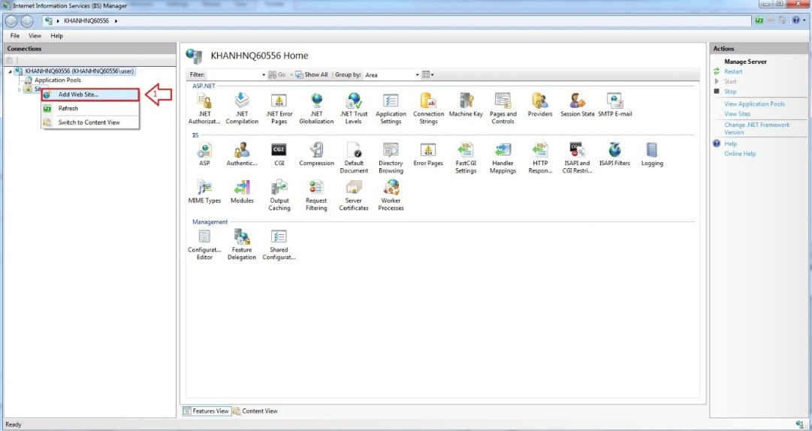

Figure 55: Add Website

* Enter “Site Name”.
* Click “Select” button to select Application pool.

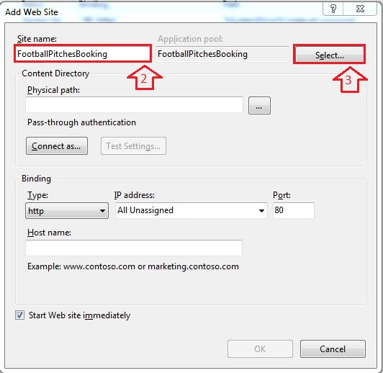

Figure 56: Add Site Name

* Select “ASP.NET v4.0”.

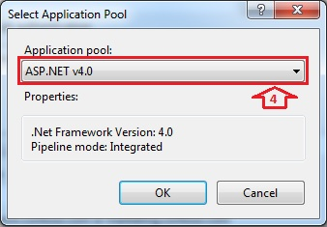

Figure 57: Select ASP.NET

* Browse physical path: “~/ FootballPitchesBooking”.

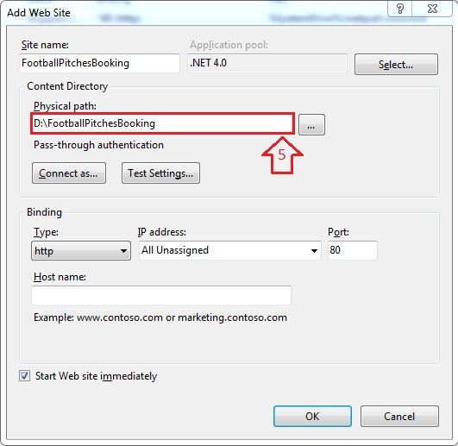

Figure 58: Add Path Link

* Open “~/ FootballPitchesBookingProject/Web.config” file by Notepad.

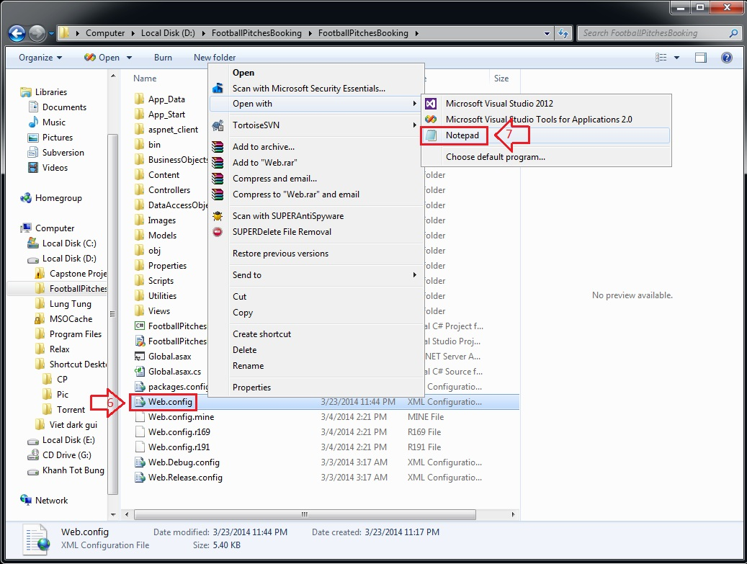

Figure 59: Edit Web.config

* Find “connectionStrings” tag, change “Server Name”, “User ID” and “Password” in its connection string depend on your computer.

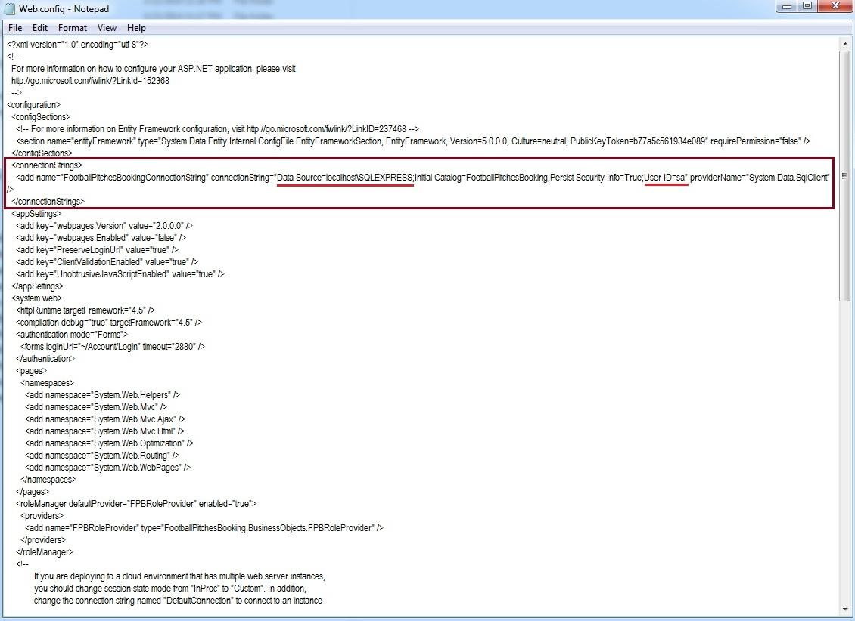

Figure 60: Edit Web.config

* Right Click new site name (FootballPitchesBooking) in left content -> Manage Web Site -> Browse to view the website.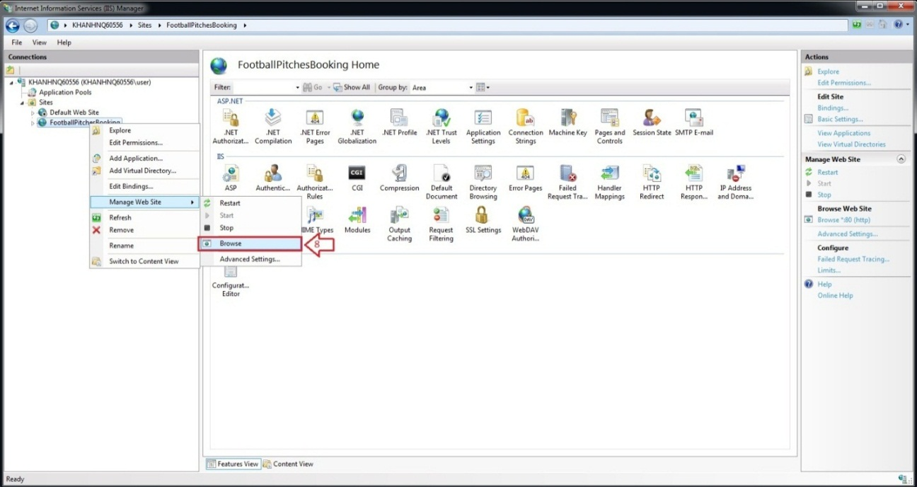

Figure 61: How to open Website

* The website is deployed.

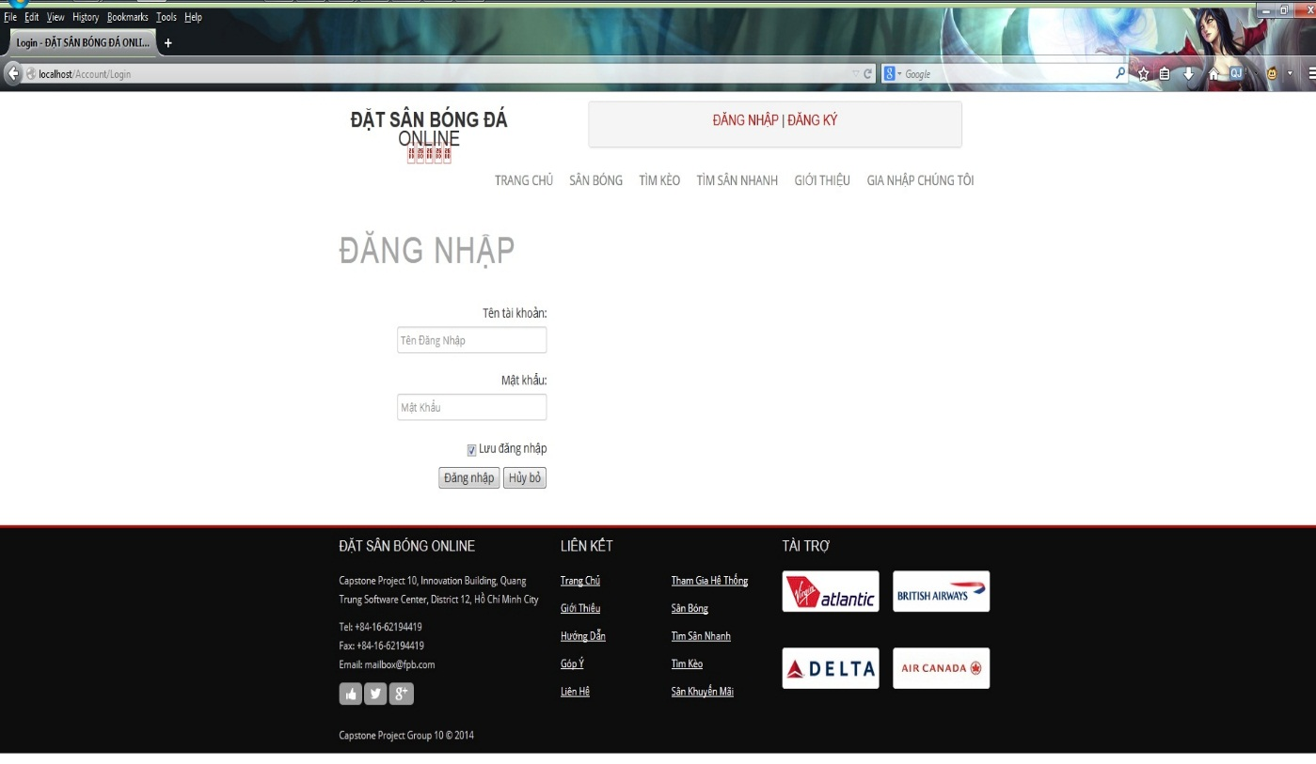

Figure 62: Website is deployed

### User’s Guide

#### Website Master

- Step 1 : Login with WebsiteMaster role

- Step 2 : Click “Quản Trị Website” link in Admin page

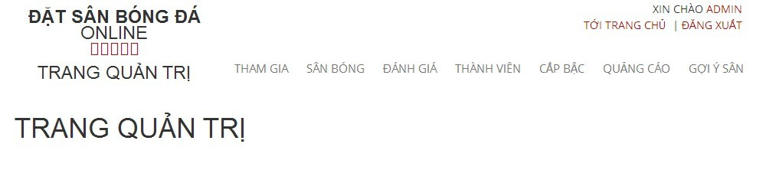

Figure 63: Website Staff

##### Join Request Management

##### View All Join Request

- Step 1 : Click “ Tham Gia “ link to view all join request from member

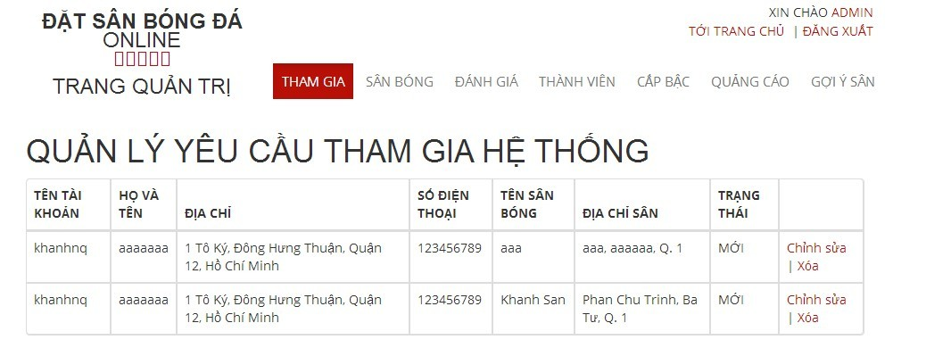

Figure 64: View Join System Requests

##### Stadium Management

###### View All Stadiums

- Step 1 : Click “ Sân Bóng “ link to view all stadiums

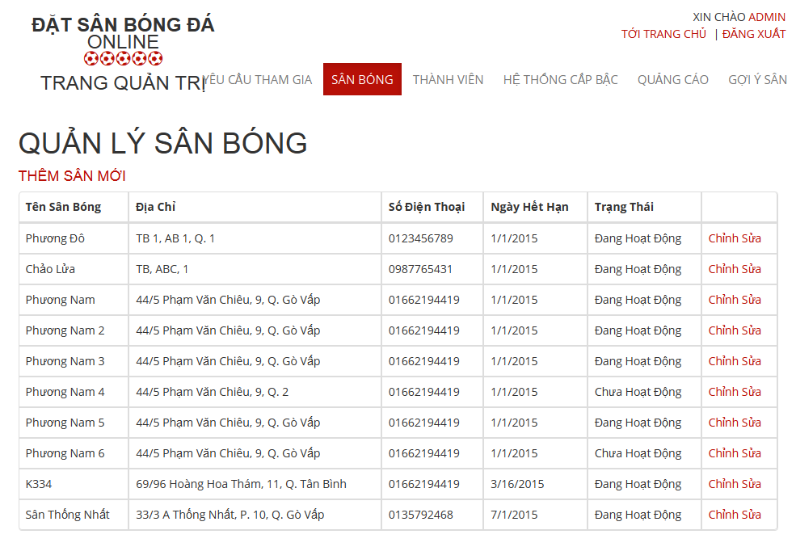

Figure 65: View All Stadiums

###### Add New Stadium

- Step 1 : Click “ Thêm Sân Mới “ link

- Step 2 : Input all required fields

- Step 3 : Click“ Thêm Sân Mới” button to add new stadium or click “ Hủy Bỏ “ button to cancel

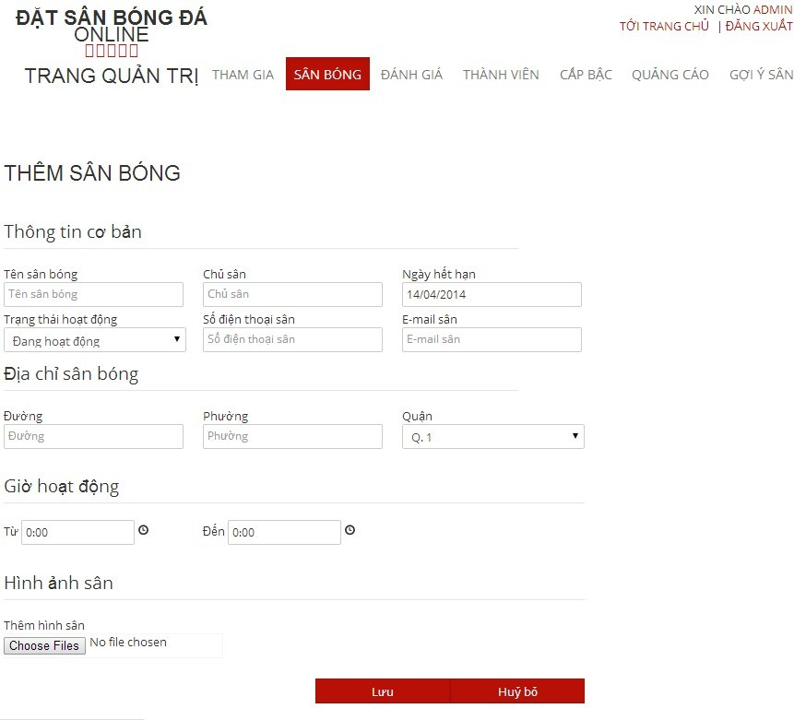

Figure 66: Add New Stadium

###### Edit Stadium

- Step 1 : Click “ Chỉnh Sửa “ link

- Step 2 : Change information of field which you want to change

- Step 3 : : Click“ Lưu” button to save the information of member or click “ Hủy Bỏ “ button to cancel



Figure 67: Edit Stadium

##### User Management

###### View List Members

- Step 1: Choose “ Thành Viên “ link to view all members of the website

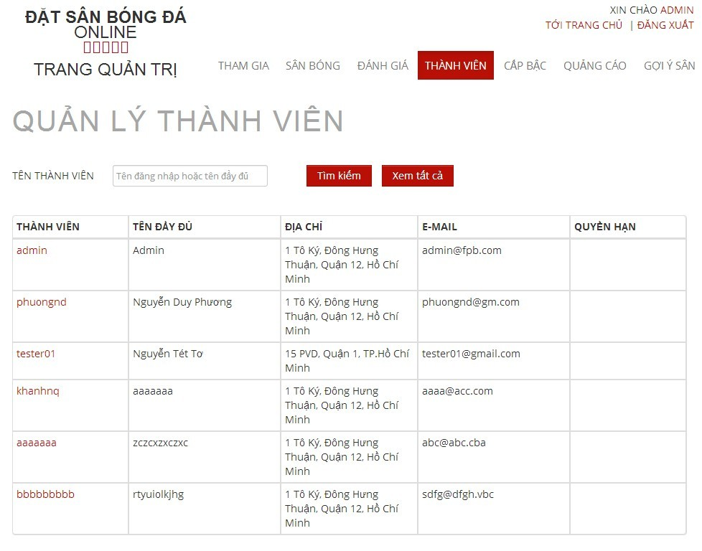

Figure 68: View Add Users

###### Search Members

- Step 1 : Click the textbox beside Search Button in “ Quản Lý Người Sử Dụng “ page

- Step 2 : Input name of member you want to find

- Step 3 : Click“ Tìm Kiếm “ button to find

- Step 4 : Click“ Làm Mới “ to refresh member list.

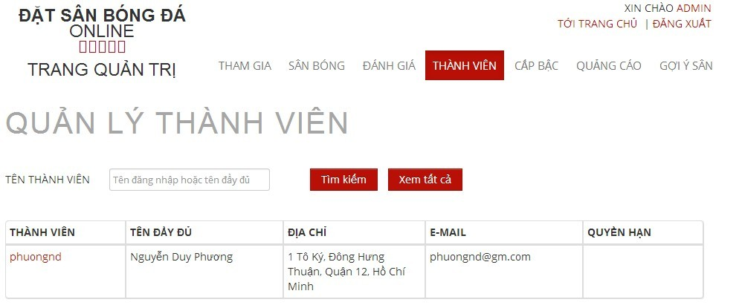

Figure 69: Search User

###### Edit Members

- Step 1 : Click name of the member you want to change information

- Step 2 : Change information of field which you want to change

- Step 3 : Click “ Cập Nhật” button to save the information of member or click “ Hủy Bỏ “ button to cancel

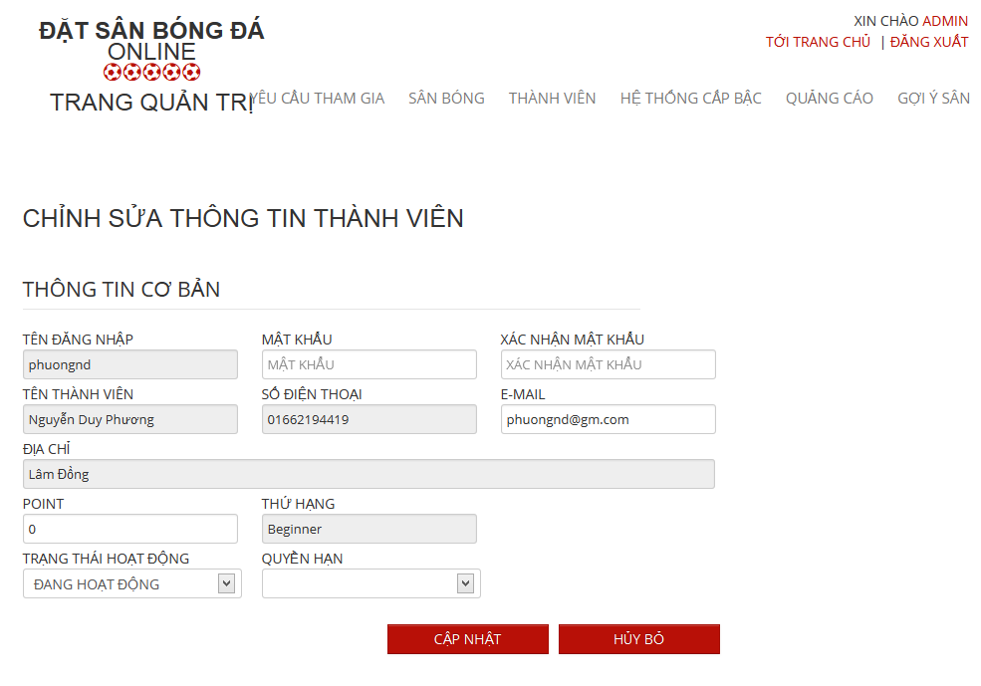

Figure 70: Edit User

##### Recommendation Management

###### View Recommendation Management Page

- Step 1 : Click “ Gợi Ý Sân “ link

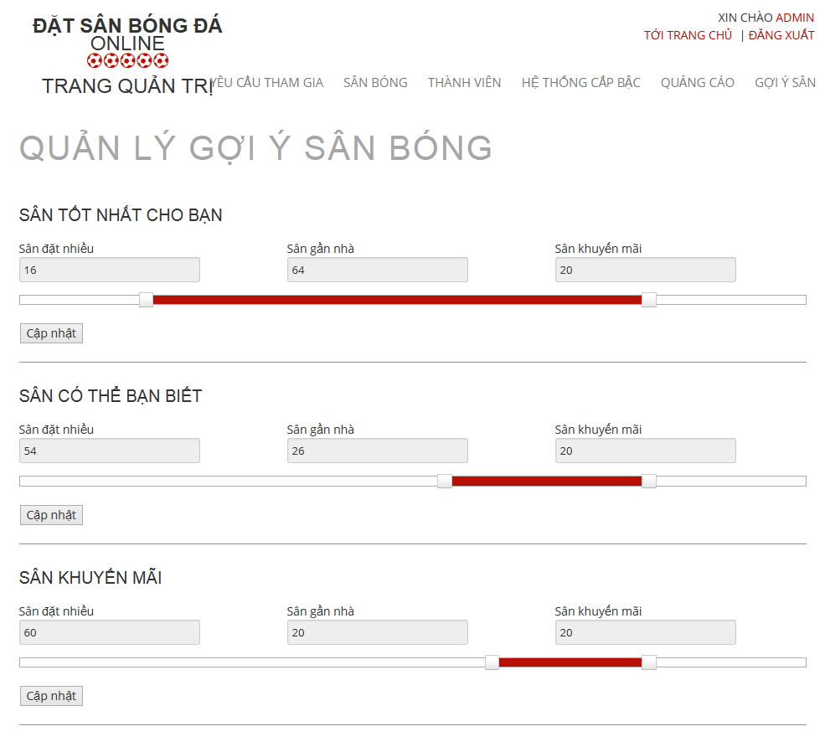

Figure 71: View Recommendation Management

###### Edit in Recommendation Management Page

- Step 1 : Drag on the point to change the value of each priority

- Step 2 : Click “ Cập Nhật “ button to save

#### Website Staff

- Step 1 : Login with WebsiteStaff role

- Step 2 : Click “Quản Trị Website” link

##### User Management

###### View Users List

- Step 1: CLick “ Thành Viên “ link to view all members of the website



Figure 72: View Users List

###### Search User

- Step 1 : Click the textbox beside Search Button in “ Quản Lý Người Sử Dụng “ page

- Step 2 : Input name of member you want to find

- Step 3 : Click“ Tìm Kiếm “ button to find

- Step 4 : Click“ Làm Mới “ to refresh member list.



Figure 73: Search User

###### Edit User

- Step 1 : Click name of the member who you want to change information

- Step 2 : Change information of field which you want to change

- Step 3 : Click “ Cập Nhật” button to save the information of member or click “ Hủy Bỏ “ button to cancel



Figure 74: Edit User

#### Stadium Staff

- Step 1 : Login with Stadium Staff role

- Step 2 : Click “Quản Lý Sân Bóng ” link

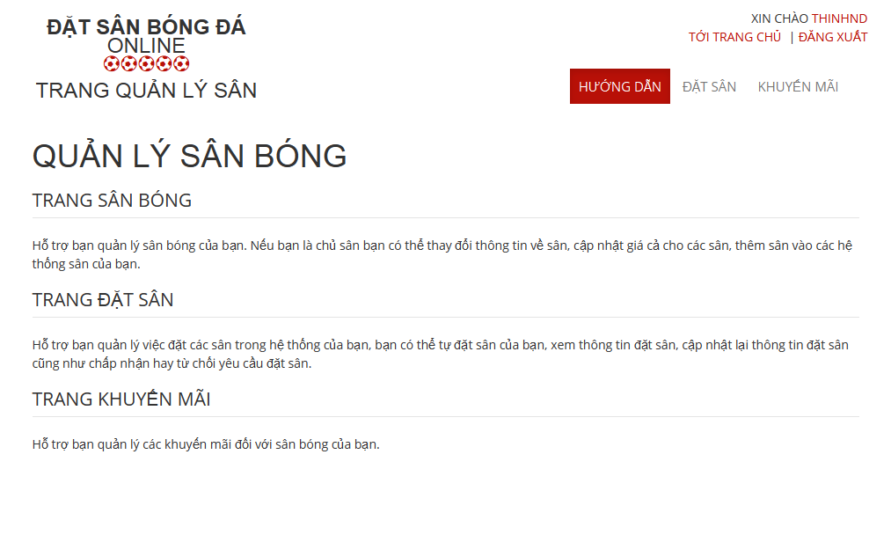

Figure 75: Stadium Management

##### Reservation Management

###### View All Reservations

- Step 1 : Click “ Đặt Sân “ link to view all reservations

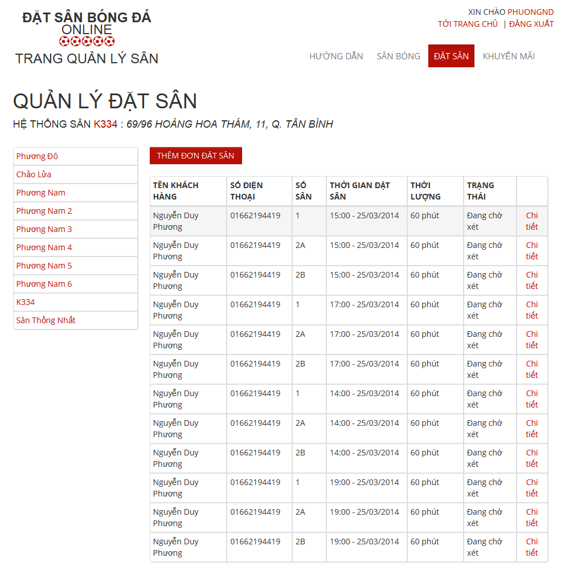

Figure 76: View Reservations

###### Create Reservation

- Step 1 : Click “ Thêm Đơn Đặt Sân “ button in “ Quản Lý Đặt Sân “ page

- Step 2: Input in all required fields

- Step 3: Click “ Lưu” button to add new price list or click “ Hủy Bỏ “ button to cancel

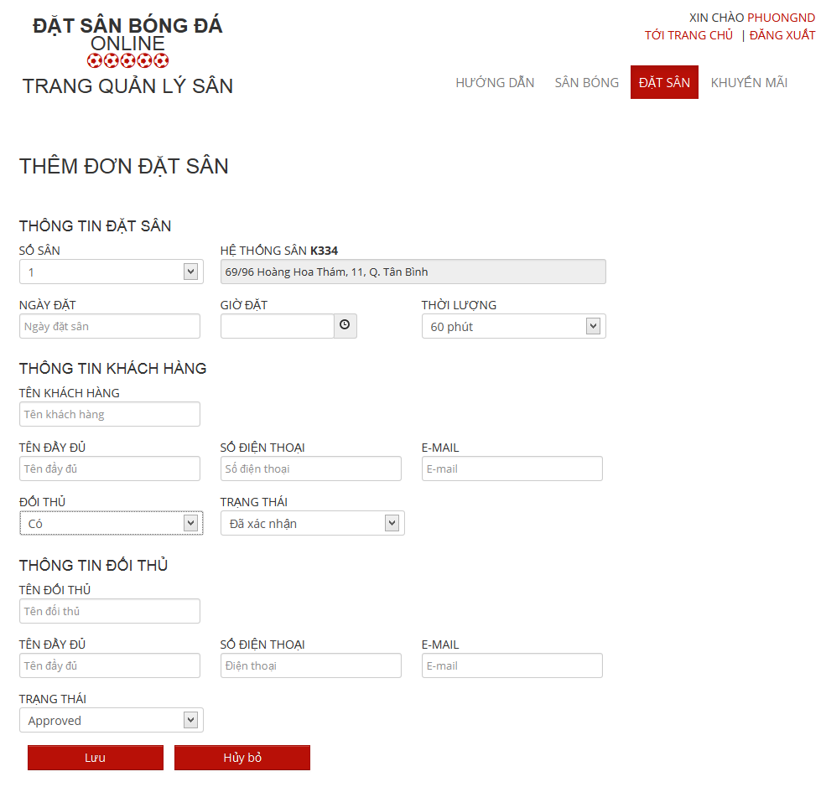

Figure 77: Create Reservation

###### Confirm Reservation

- Step 1 : Click “ Chi tiết “ link of the reservation which you want to examine

- Step 2 : Click “Xác Nhận” button to confirm or Click “Từ Chối” to deny or Click “ Chỉnh Sửa “ to edit reservation or Click “ Quay Lại “ to cancel

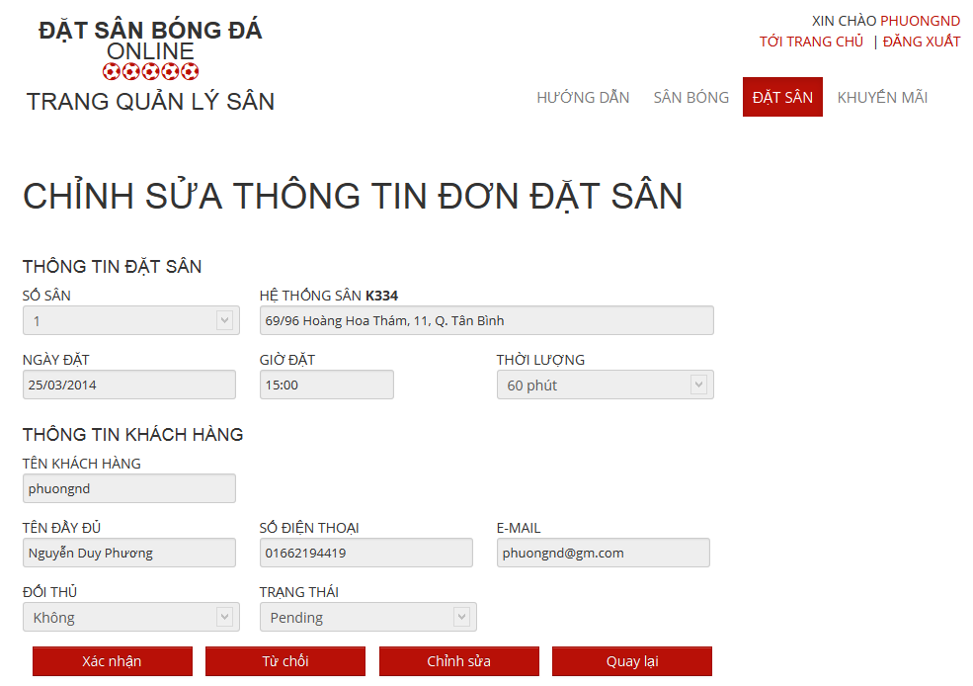

Figure 78: Confirm Reservation

###### Edit Reservation

- Step 1 : Click “ Chỉnh Sửa “ button to edit reservation which you want to change

- Step 2: Change information about that reservation

- Step 3: Click “Lưu” button to save or click “Hủy bỏ” to cancel

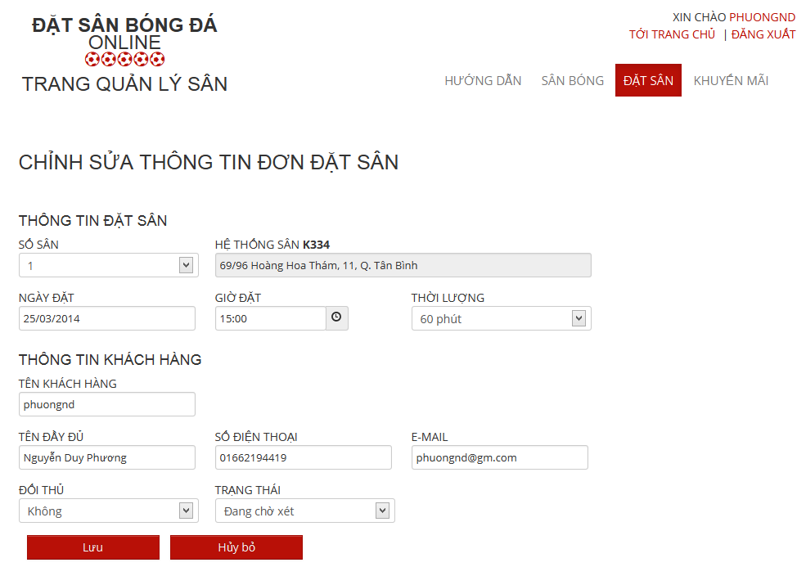

Figure 79: Edit Reservation

#### Stadium Owner

- Step 1 : Login with StadiumOwner role

- Step 2 : Click “Quản Trị Sân Bóng” link

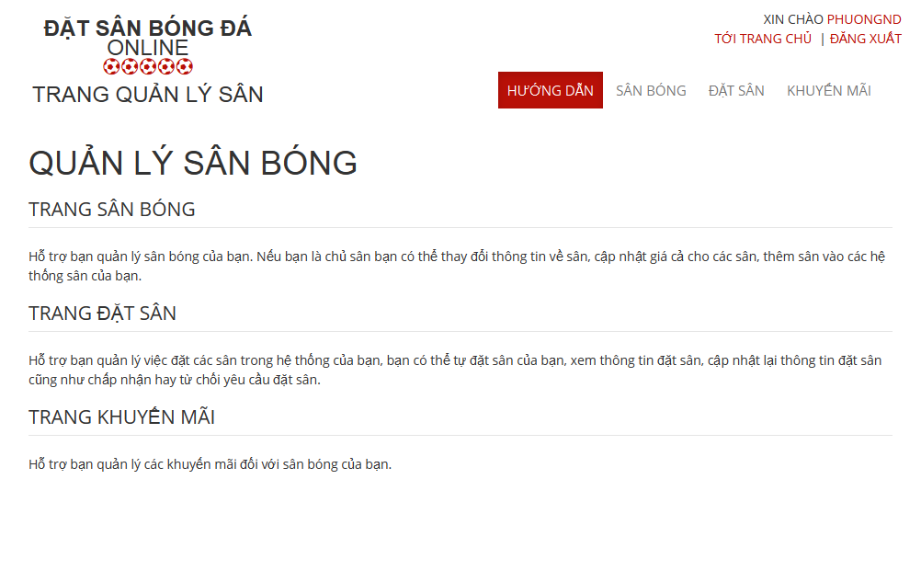

Figure 80: Stadium Management

##### Stadium Management

###### View All Stadiums

-Step 1 : Click “ Sân Bóng “ link

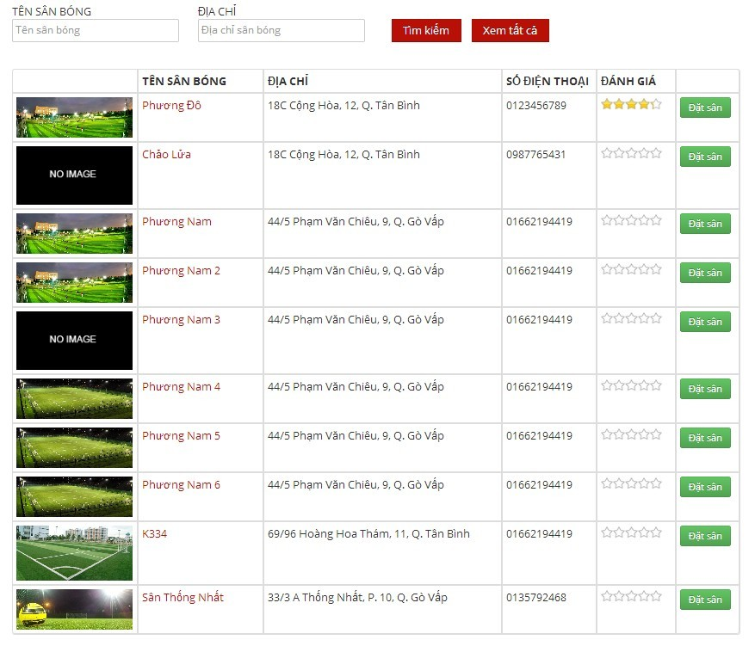

Figure 81: View Stadiums

###### Edit Stadium

- Step 1 : Click “ Chỉnh sửa “ link of the stadium which you want to change

- Step 2 : Change information of field which you want to change

- Step 3 : Click “ Chọn Hình Ảnh “ button to choose new image about this stadium

- Step 4 : Click “Lưu ” button to save or click “Hủy bỏ” to cancel

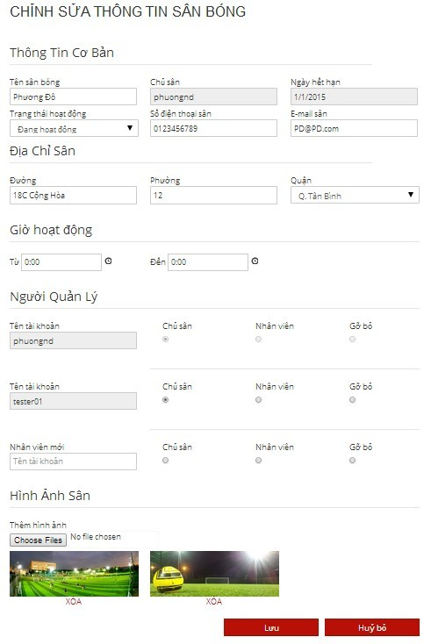

Figure 82: Edit Stadium

###### View Child Fields

- Step 1 : Click “ Sân Con “ link to see all child fields of this stadium

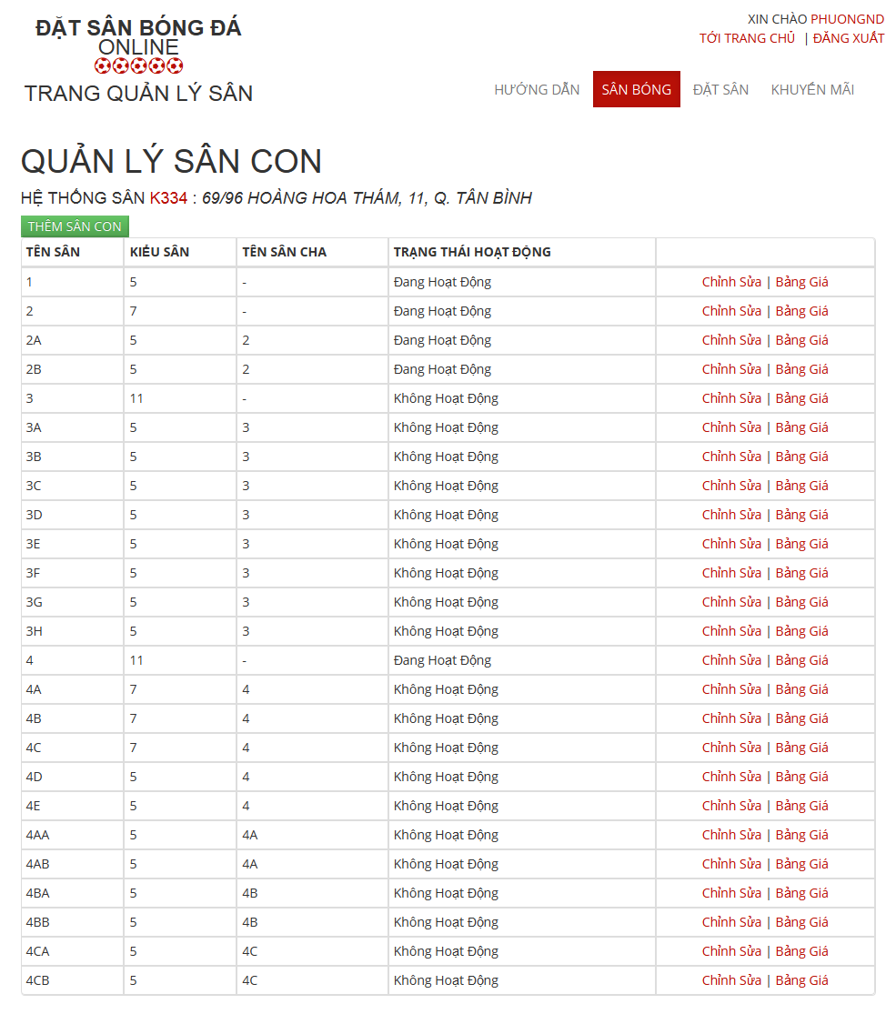

Figure 83: View Child Fields

###### Add New Child Field

- Step 1 : Click “ Thêm Sân Con “ button in “ Quản Lý Sân Con “ Page

- Step 2: Input in all required fields

- Step 3: Click “ Lưu” button to add new child field or click “ Hủy Bỏ “ button to cancel

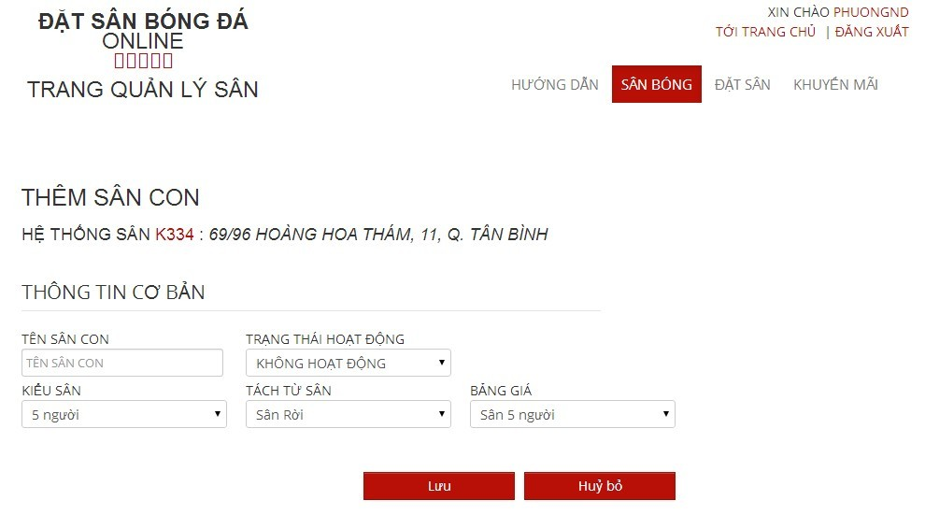

Figure 84: Add Child Field

###### Edit Child Field

- Step 1 : Click “ Chỉnh sửa “ link of the child field which you want to change

- Step 2 : Change information of field which you want to change

- Step 3 : Click “Lưu” button to save or click “Hủy bỏ” to cancel

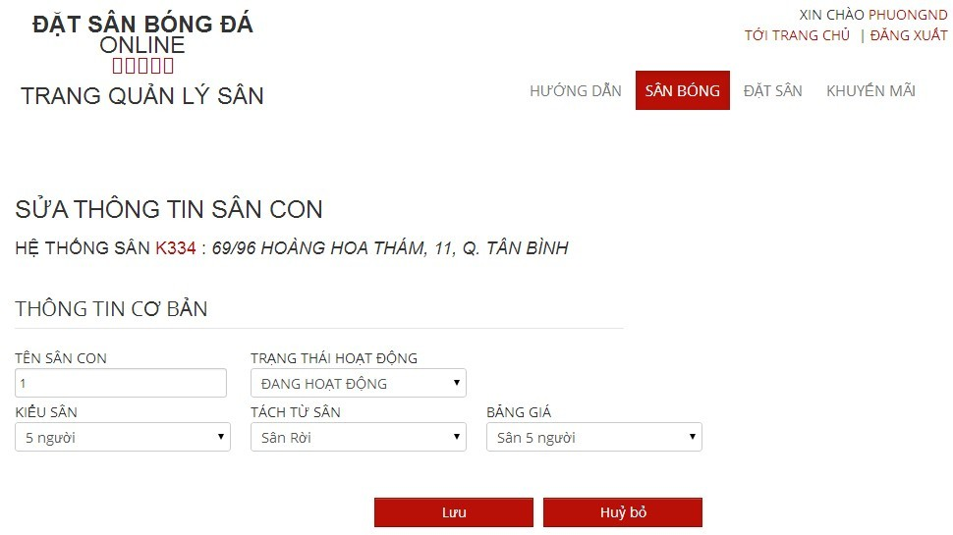

Figure 85: Edit Child Field

###### View Price List of Child Filed

- Step 1 : Click “ Bảng Giá “ link of the child field which you want to see

###### View Price List

- Step 1 : Click “ Bảng Giá “ link to see all child fields of this stadium

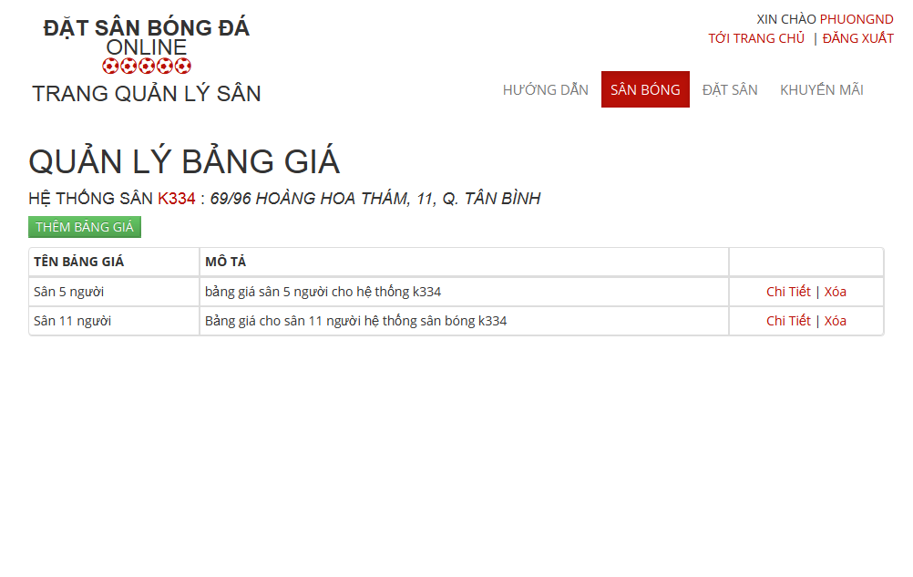

Figure 86: View Child Fields

###### Add Price Table

- Step 1 : Click “ Thêm Bảng Giá “ button in “ Quản Lý Bảng Giá“ Page

- Step 2: Input in all required fields

- Step 3: Click “ Lưu” button to add new price list or click “ Hủy Bỏ “ button to cancel

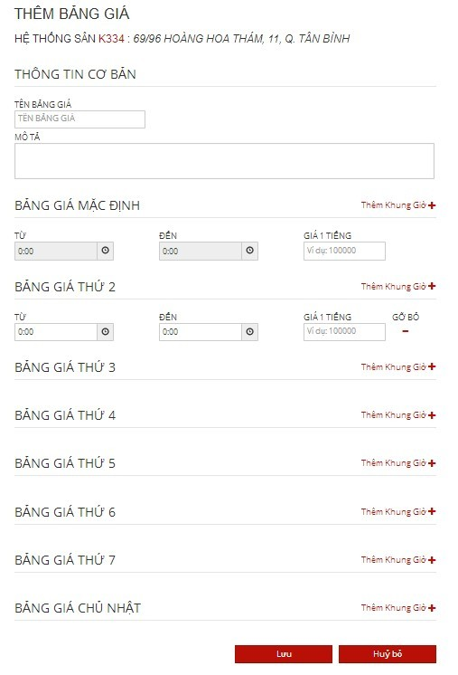

Figure 87: Add Price Table

##### Promotion Management

###### View Promotions List

- Step 1: Click “Khuyến mãi” link in “ Quản lý sân “ page

- Step 2: Choose Stadium to view promotions of that stadium

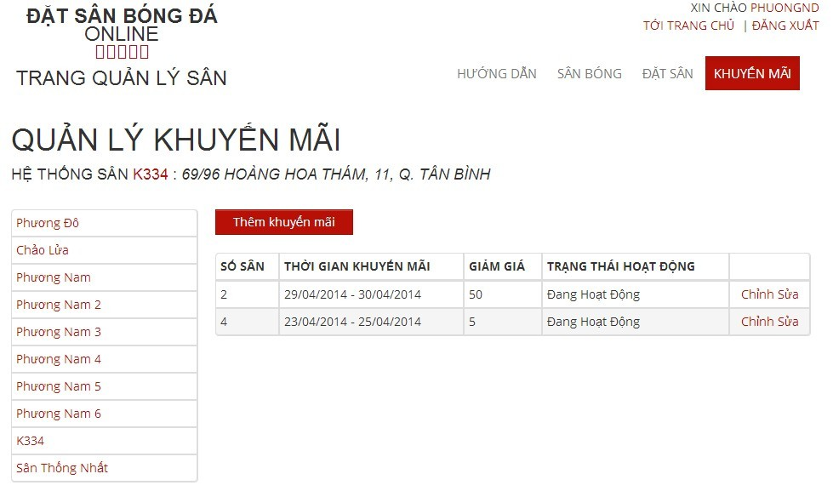

Figure 88: View Promotions List

###### Add New Promotion

- Step 1: Click “Thêm khuyến mãi” button from “ Thêm khuyến mãi “page

- Step 2: Input information about promotion

- Step 3: Click “Lưu” button to save or click “Hủy bỏ” to cancel

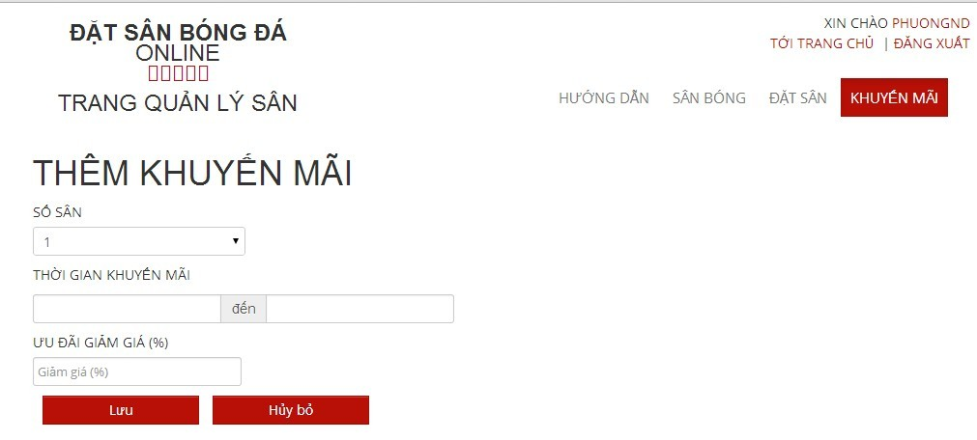

Figure 89: Create Promotion

###### Edit Promotion

- Step 1: Click “Chỉnh sửa” link on which promotion you want to edit

- Step 2: Change information about that promotion

- Step 3: Click “Lưu” button to save or click “Hủy bỏ” to cancel

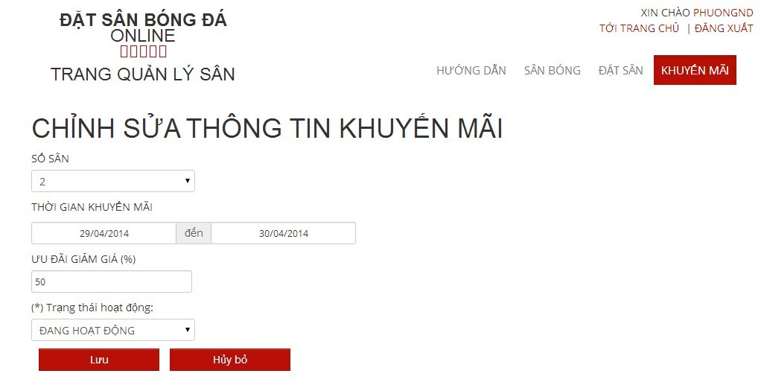

Figure 90: Edit Promotion

##### Reservation Management

###### View All Reservations :

- Step 1 : Click “ Đặt Sân “ link to view all reservations



Figure 91: View Reservations

###### Add New Reservation

- Step 1 : Click “ Thêm Đơn Đặt Sân “ button in “ Quản Lý Đặt Sân “ page

- Step 2: Input in all required fields

- Step 3: Click “ Lưu” button to add new price list or click “ Hủy Bỏ “ button to cancel



Figure 92: Create Reservation

###### Confirm Reservation

- Step 1 : Click “ Chi tiết “ link of the reservation which you want to examine

- Step 2 : Click “Xác Nhận” button to confirm or Click “Từ Chối” to deny or Click “ Chỉnh Sửa “ to edit reservation or Click “ Quay Lại “ to cancel



Figure 93: Confirm Reservation

###### Edit Reservation

- Step 1 : Click “ Chỉnh Sửa “ button to edit reservation which you want to change

- Step 2: Change information about that reservation

- Step 3: Click “Lưu” button to save or click “Hủy bỏ” to cancel



Figure 94: Edit Reservation

#### Member

##### Find Available Stadium

- Step 1: Click “Tìm sân nhanh” link or open “Tìm sân nhanh” drop down list at “ Trang chủ “ page

- Step 2: Choose information

- Step 3: Click “Tìm kiếm” button to find available stadium

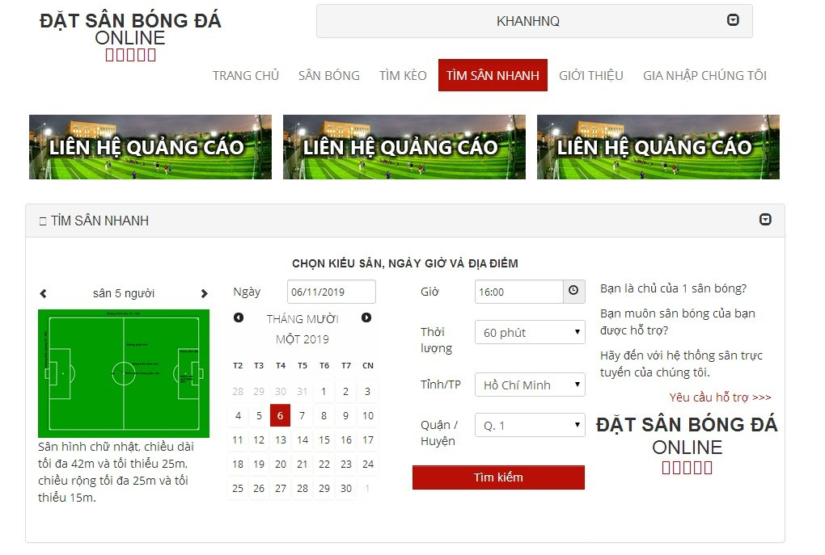

Figure 95: Find Available Stadium

##### Find Stadium

- Step 1 : Click “ Sân bóng “ link in “ Trang chủ “ page

- Step 2 : Input all information about the stadium you want to find

- Step 3 : Click “ Tìm Kiếm “ button to find

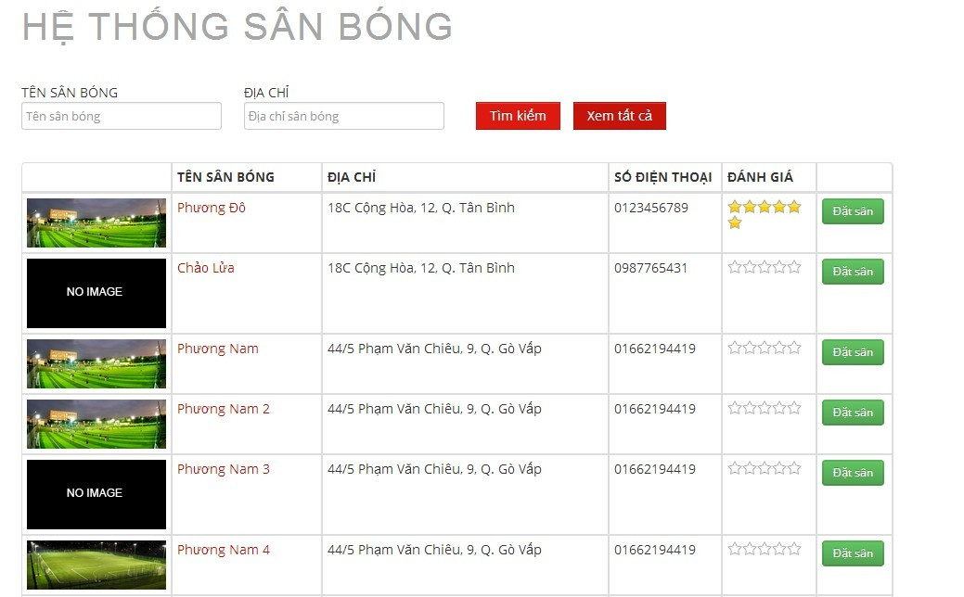

Figure 96: Find Stadium

##### Book Field

- Step 1 : Click “ Sân Bóng “ link in Homepage

- Step 2 : Click “ Đặt Sân “ button on the stadium you want to book or Click the stadium which you want to book and Click “ Đặt Sân “ button

- Step 3 : Input all require information about stadium you want to book

- Step 4 : Click “ Đặt Sân “ button to book stadium or “ Hủy Bỏ “ button to cancel or “ Lưu “ button to edit “ Thông Tin Cập Nhật “

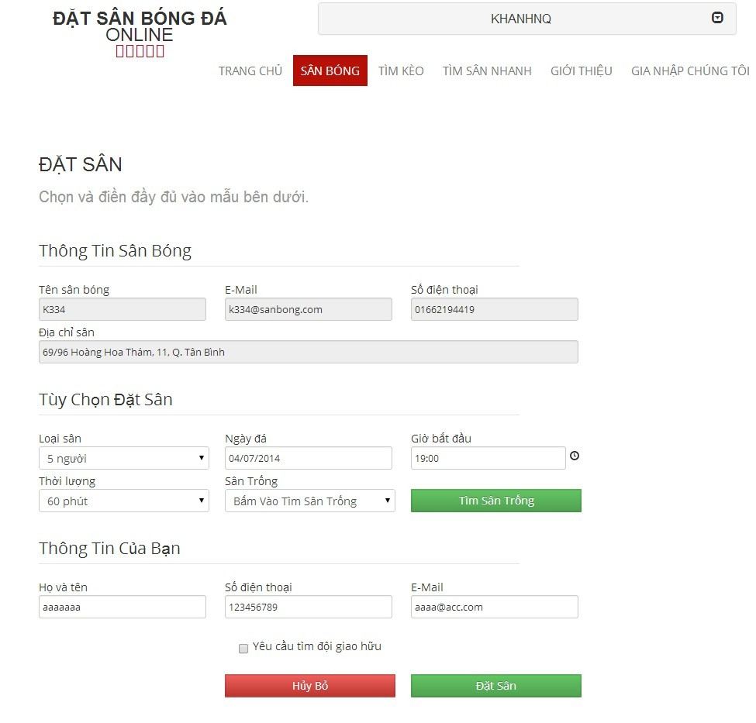

Figure 97: Book Field

##### Request Join System

- Step 1: Click “Gia nhập chúng tôi” link from home page

- Step 2: Input all require information

- Step 3: Click “Gửi yêu cầu” link to send this request or click “Trang chủ” link to back to home page

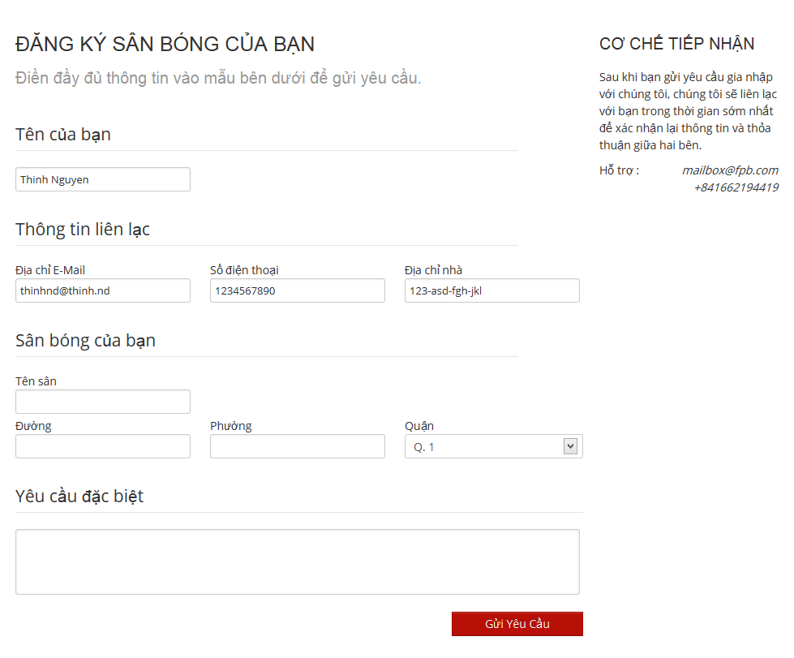

Figure 98: Request Join System

##### Join Rival

- Step 1 : Click “ Sân bóng “ link on “ Trang chủ “ page

- Step 2 : Click " Đặt Sân " button in one stadium in list stadium or lick on one stadium and click “ Đặt sân “ button

- Step 3 : Input all information

- Step 4 : Check on “ Yêu cầu tìm đội giao hữu “ drop down list

- Step 5 : Click “ Đặt sân “ button

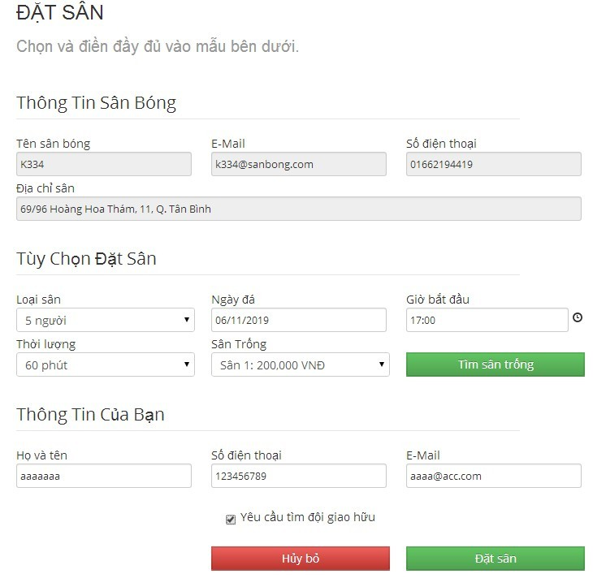

Figure 99: Join Rival

#### Reference Guide:

The following User guides are reference to:

**Website Master:**

* View Ranks List
* Create Rank
* Edit Rank
* Delete Ranks

**Website Staff:**

* View All Advertises
* Add New Advertises

**Stadium Staff:**

* View List Promotions
* Add New Promotion
* Edit Promotion

**Member:**

* Register
* Login
* View Account Profiles
* Edit Account Profiles
* View Stadium Details
* Rate Stadium
* Review Stadium
* Cancel Reservation
* Find Rival
* View Booking History
* ForgotPassword
* Resend mail to activate Account
* FeedbackWebsite

#### Other [Optional]